FINAL PROJECT – Model Appendix

OPIM 5604 – Fall, 2016

TEAM # **6**

CLASS SECTION – **Afternoon**

TEAM MEMBERS:

Anita Sivakumar Jinsheng Wang

Neha Telagubanajigara Niharika Srivastava

Yuhang Wu

Table of Contents

1. Classification Models 1

2. Regression Models 58

3. Logistic Regression 65

## 

## 1. Classification Models

The classification models were built on three datasets divided based on different time periods -

1. The entire dataset (5043 rows)
2. Movies with title_year <2004
3. Movies with title_year >= 2004

We also built the models with the outliers removed (based on Mahalanobis distance (α=0.05 and UCL=5.37)) to check if they have any impact on the accuracy of the models was

Also, since majority of the predictor variables are based on Facebook likes and since Facebook was launched in the year 2004, we wanted to check if the advent of Facebook has had any effects on the IMDB scores associated with the movies.

Before we start to build a model, we need to determine the training, validation and test dataset.

Since the size of the dataset is 5043 only, we decided to divide the data as training and test only. (**correction**: in the screenshots below “Validation” refers to the test dataset)

Also as the dataset is unbalanced, we have used stratified sampling to create a balanced train and unbalanced test datasets.

Dataset 1: All rows included

First, we built the models taking all 5043 rows included.

Stratified sampling

We created a stratified sample based on the classification of movies and considered ‘0’ as the focal group with the proportions set as following.

1. Training Set: 0.6
2. Test Set: 0.4

Since the number of 0s are less as compared to 1’s and 2’s we selected that as the focal group and created a balanced training sample and unbalanced test sample.

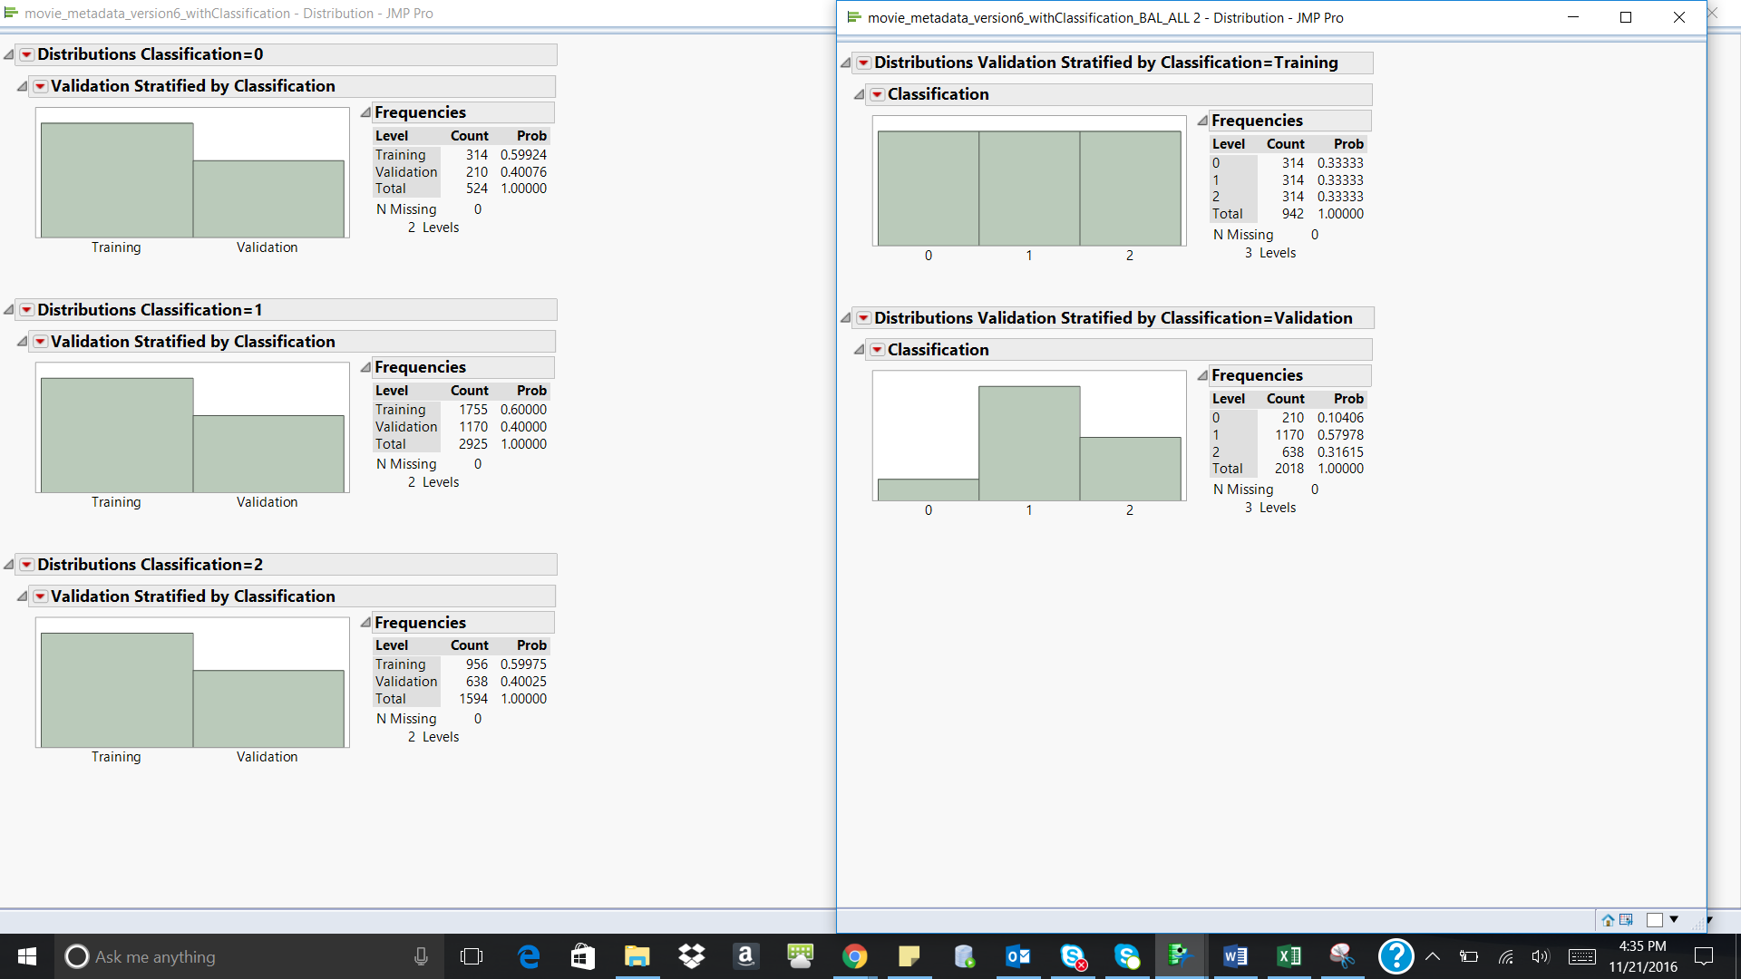

**Figure 12.5**

Classification Techniques

We have used three different classification techniques-

1. Neural networks
2. Discriminant analysis
3. Decision trees

Neural Networks Analysis

Using the Neural options under Analyze-> Model, we ran the model for ‘classification’ using all the predictor variables. Below is the screenshot of the neural diagram

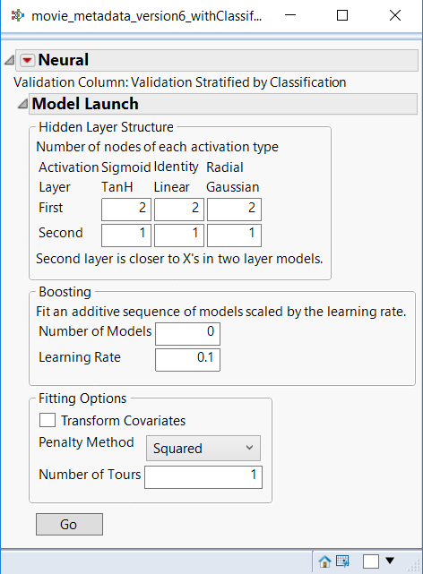 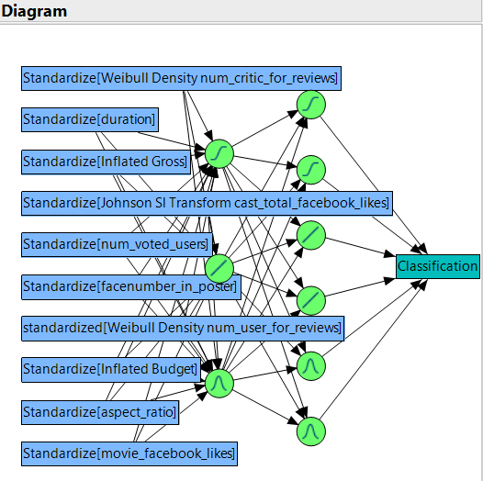

We ran the model for higher level of complexity but it performed at the same level as the model above. Based on this, the above model was the final selected model. The model consists of 4 layers – 1 input layer, 2 hidden layers and 1 output layer.

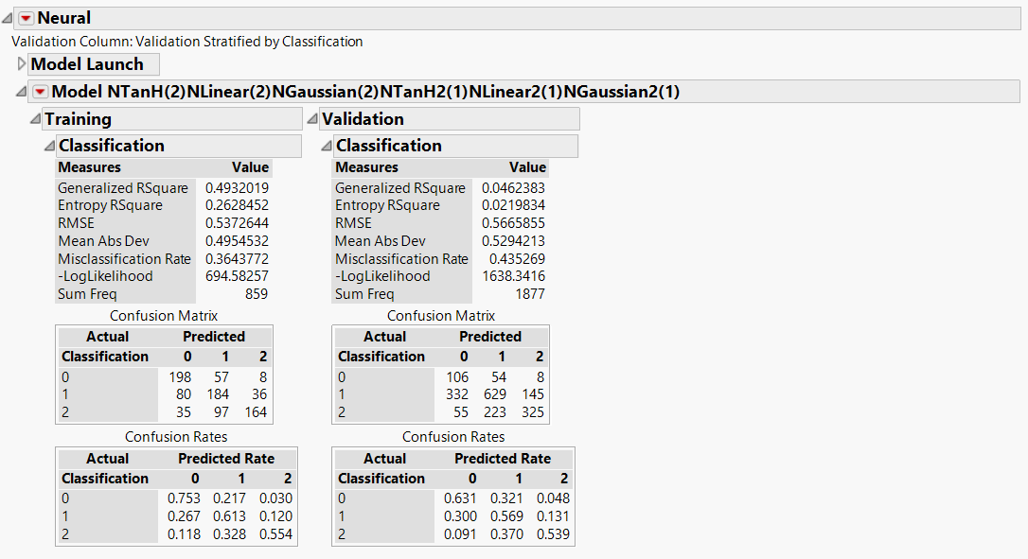

The model performs almost equally good on the training and validation data with an accuracy of 64% on the training data and 56.4% on the validation data.

|  |  |  |  |
| --- | --- | --- | --- |
| Dataset/Misclassification Rate | 0 | 1 | 2 |
| Training | 25% | 39% | 45% |
| Validation | 37% | 43 | 46% |

Below are the ROC and the Lift curves for the selected model

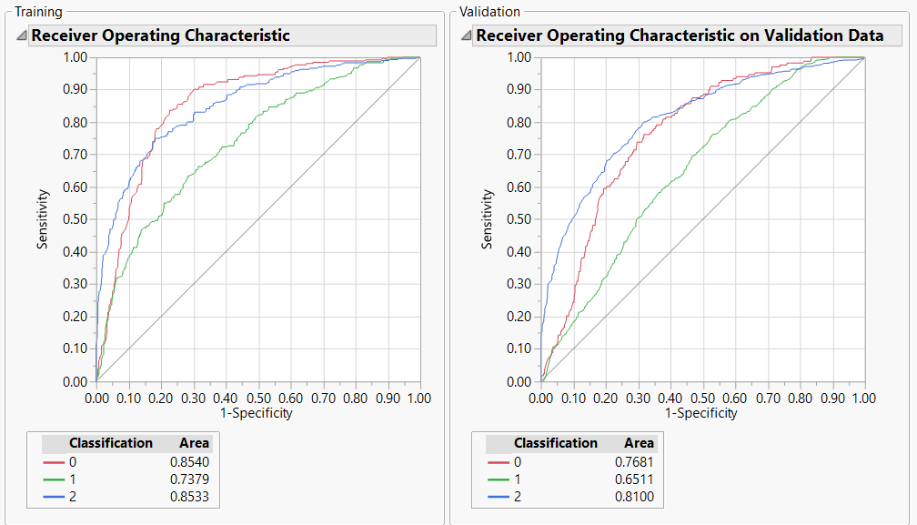

In the validation data, the AUC is higher for the 2s (‘Good) when compared to 1s(‘Average’) and 0s (‘Poor’) . Hence, the model seems to predict the Good movies with more accuracy when compared to ‘Average’ and ‘Poor’ ones.

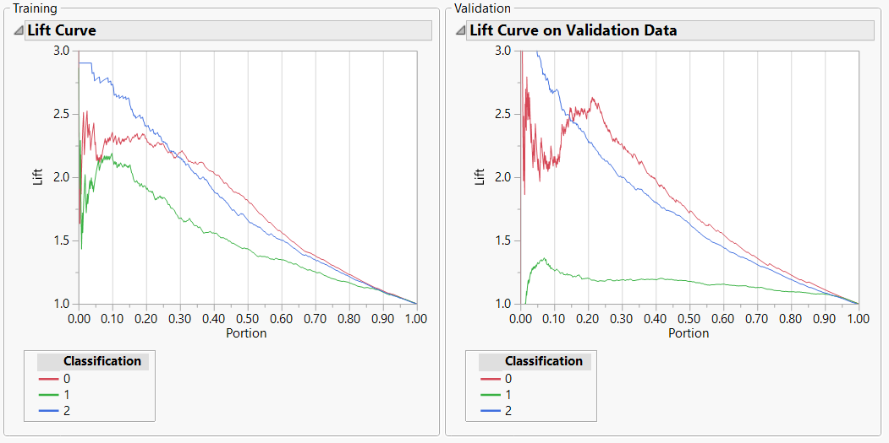

From the lift curve above the following observations were made:

|  |  |  |
| --- | --- | --- |
| Classification | Training data | Validation data |
| 0 | The lift value is around 2.25 on an average across the first three deciles and then constantly decreases across the other deciles | The lift value is constant for the second and the third decile and then constantly decreases across the other deciles.It varies from 2 to 2.75 in the first decile. |
| 1 | The lift value ranges from 1 to 2.1 in the first decile and then constantly decreases across all the other deciles. | Even though the lift value is low when compared to 0s and 2s, it is consistent till the seventh decile and then slowly reduces |
| 2 | The lift value is very high in the first decile but reduces consistently across all the other deciles | The lift value is more than 3 in the first decile but reduces consistently in all the other deciles |

* + - * 1. Discriminant Analysis

Using the Discriminant option under Analyze->Multivariate, we ran the discriminant analysis for the variable ‘classification’ using only the continuous predictors (covariates). Below is the canonical plot for the analysis

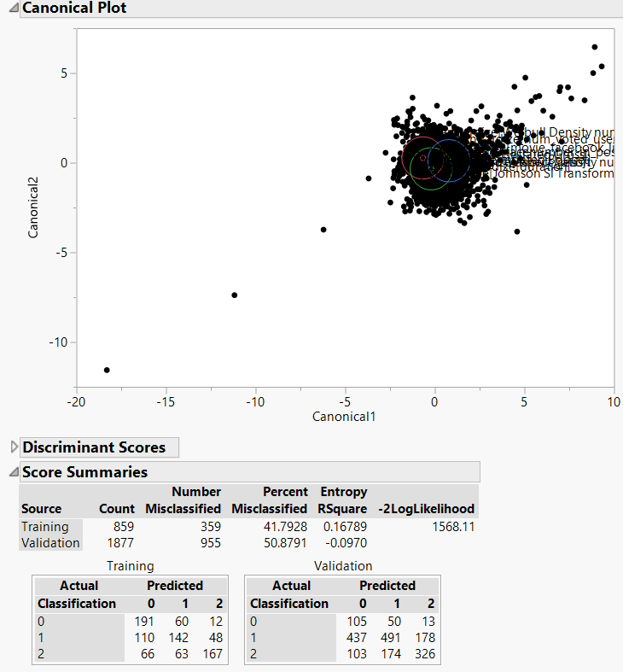 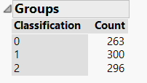

Below are the ROC curves for the 2 models.

Confusion matrix is as follows

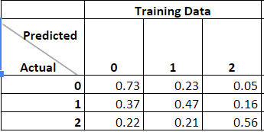 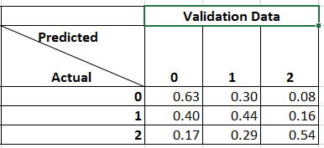

|  |  |  |  |
| --- | --- | --- | --- |
| Dataset/Misclassification Rate | 0 | 1 | 2 |
| Training | 27% | 53% | 44% |
| Validation | 38% | 56% | 46% |

From the observations above, the model seems to perform equally well in both the Training and the validation dataset.

The accuracy rate in the training data set is 58.20% and the validation data set is 49.12%. Since the performance of the model across the training and validation datasets are almost the same, ‘overfitting’ has not occurred. Hence, this model can be used for classification

Decision Trees

Using the Partition option under Analyse -> Modeling, we ran the decision tree model for the given data set. Since the validation dataset was not being recognized by JMP, we manually went about splitting the tree.

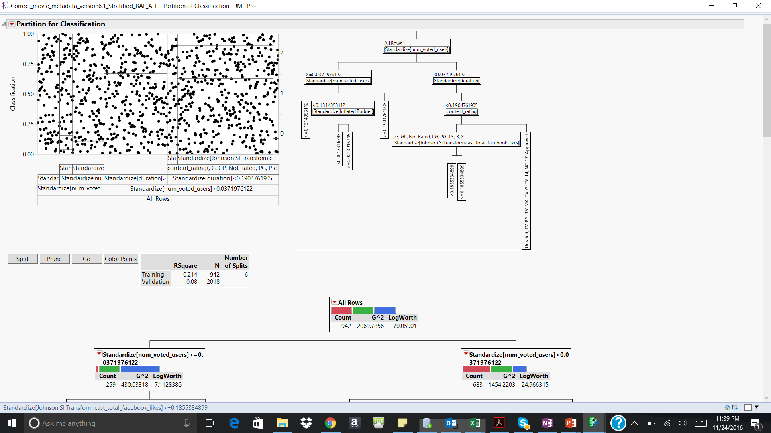

For the given decision tree, the first level of split is done using num_voted_users, followed by duration and content rating. After the split on the variable budget there is no more contribution from the other variables. After this point the misclassification rate in the validation data also increases. Hence, there are no more splits that are executed.

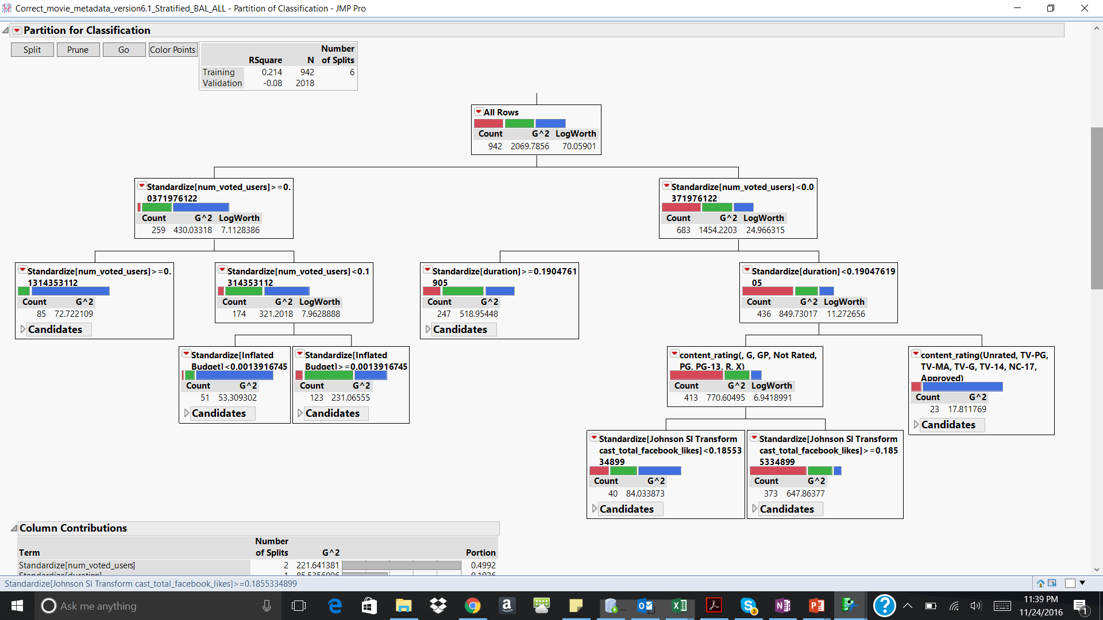

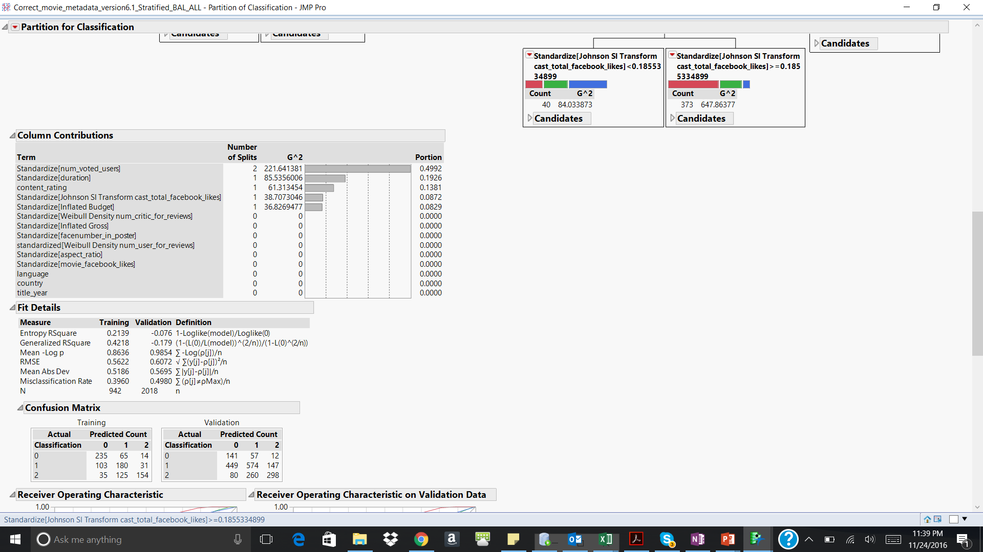

The accuracy of the model in the training data is 60% and in the validation data is 50%.

|  |  |  |  |
| --- | --- | --- | --- |
| Dataset/Misclassification Rate | 0 | 1 | 2 |
| Training | 25% | 43% | 51% |
| Validation | 33% | 51% | 53% |

Below are the ROC and the lift curves for training and validation. In the validation data, the AUC for the Good(2), Average(1) and Poor(0) movies is almost comparable. Hence, the model seems to predict each of these categories at a comparable accuracy rate.

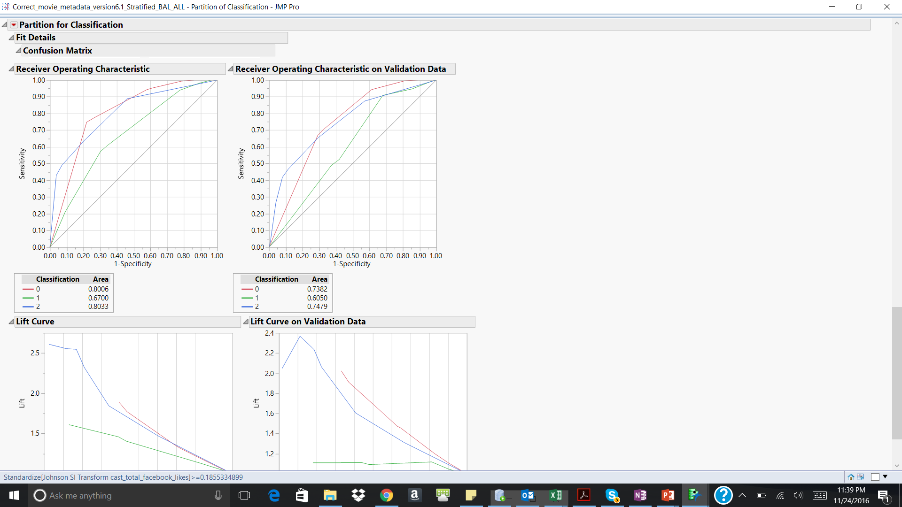 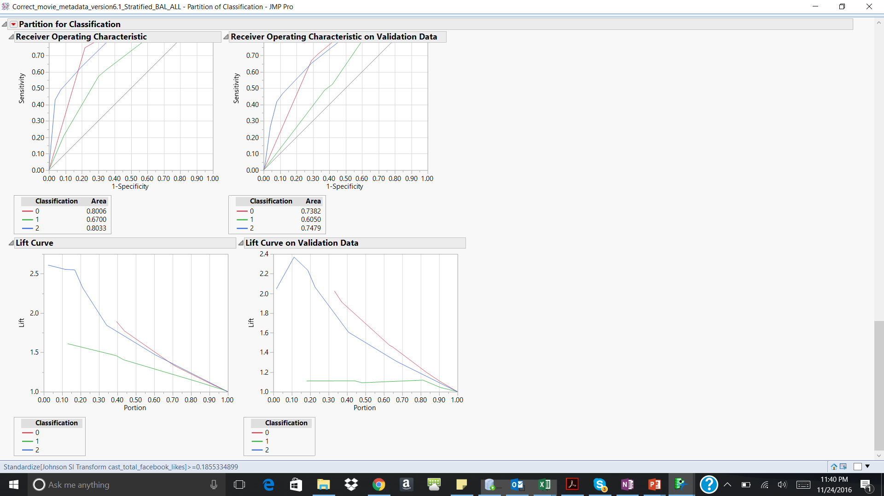

In the validation data, the model seems to perform well for 2s in the first decile and then the performance constantly decreases in the other deciles. The lift value for 1s is negligible in the 1st two deciles, after which there is a lift of around 1.1 which remains constant thereafter for the next two deciles and decreases. The lift value for 0s is negligible in the 1st three deciles, after which there is a lift of around 2 which decreases thereafter.

Ensemble using Neural networks

Choosing the Neural network to build the ensemble model, below is the screenshot of the same.

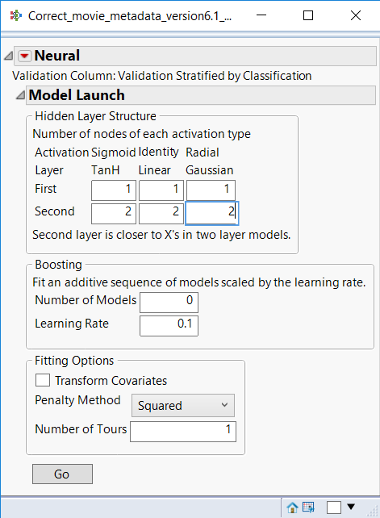 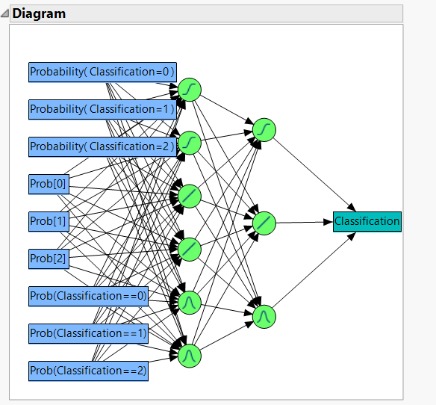

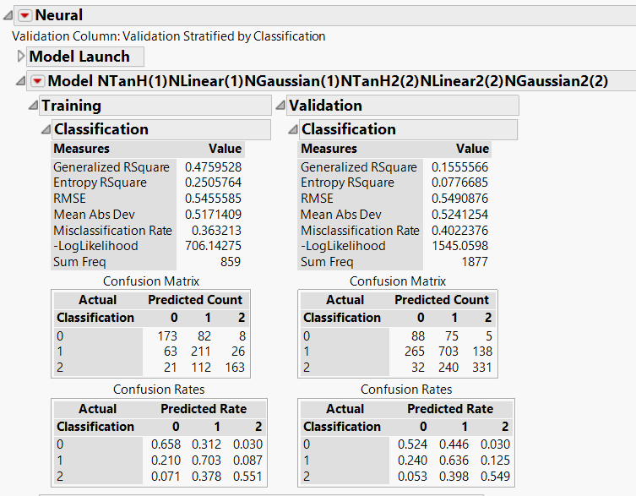

|  |  |  |  |
| --- | --- | --- | --- |
| Dataset/Misclassification Rate | 0 | 1 | 2 |
| Training | 34% | 30% | 45% |
| Validation | 48% | 36% | 45% |

The accuracy of the model on the training data is 64% and on the validation data is 60%.

This model performs better when compared to discriminant analysis, neural networks, and decision tree individually.

Below are the ROC and the lift curves for the model

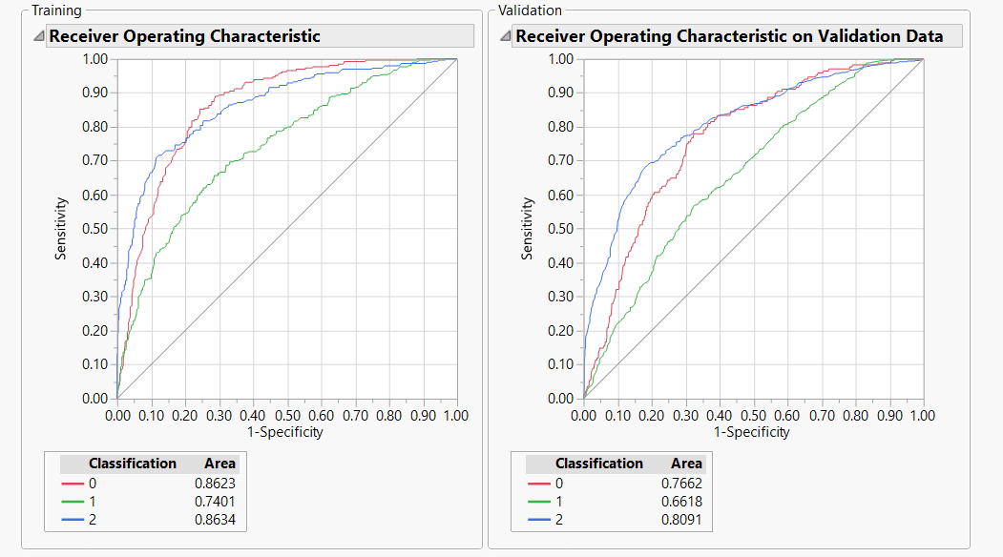

In the validation data, the AUC is higher for the 2s (‘Good) when compared to 1s(‘Average’) and 0s (‘Poor’) . Hence, the model seems to predict the Good movies with more accuracy when compared to ‘Average’ and ‘Poor’ ones.

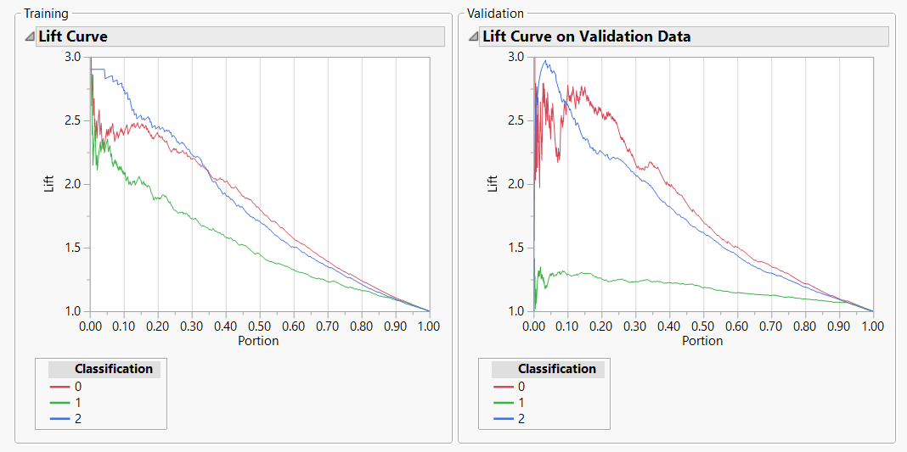

In the validation data, the model seems to perform well for 0s and 1s in the first decile and then the performance constantly decreases in the other deciles. The lift value for 1 seems to increase in the 1st decile after which it remains constant.

Dataset 2: Movies with title_year < 2004

We selected the movies with title_year < 2004, checked the distribution of the ‘classfifcation’ column and then stratified the sample. Since the number of 0s are less as compared to 1’s and 2’s we selected ‘0’ as the focal group and created a balanced training sample and unbalanced validation sample

 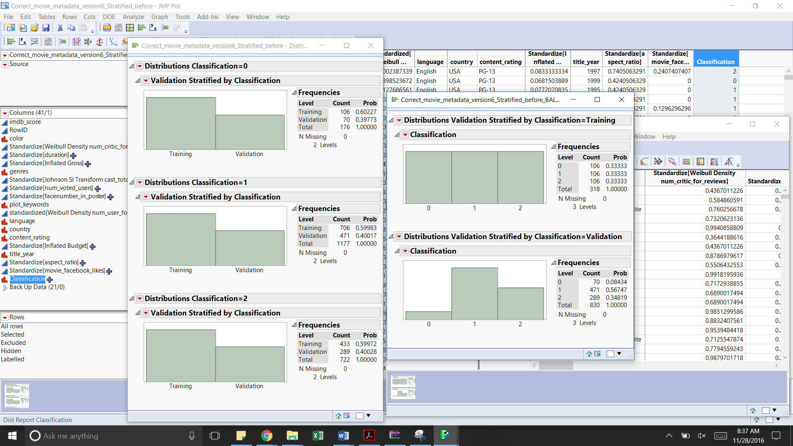

**Classification Techniques -**

1. Neural network –

Below is the confusion matrix obtained after building the neural networks.

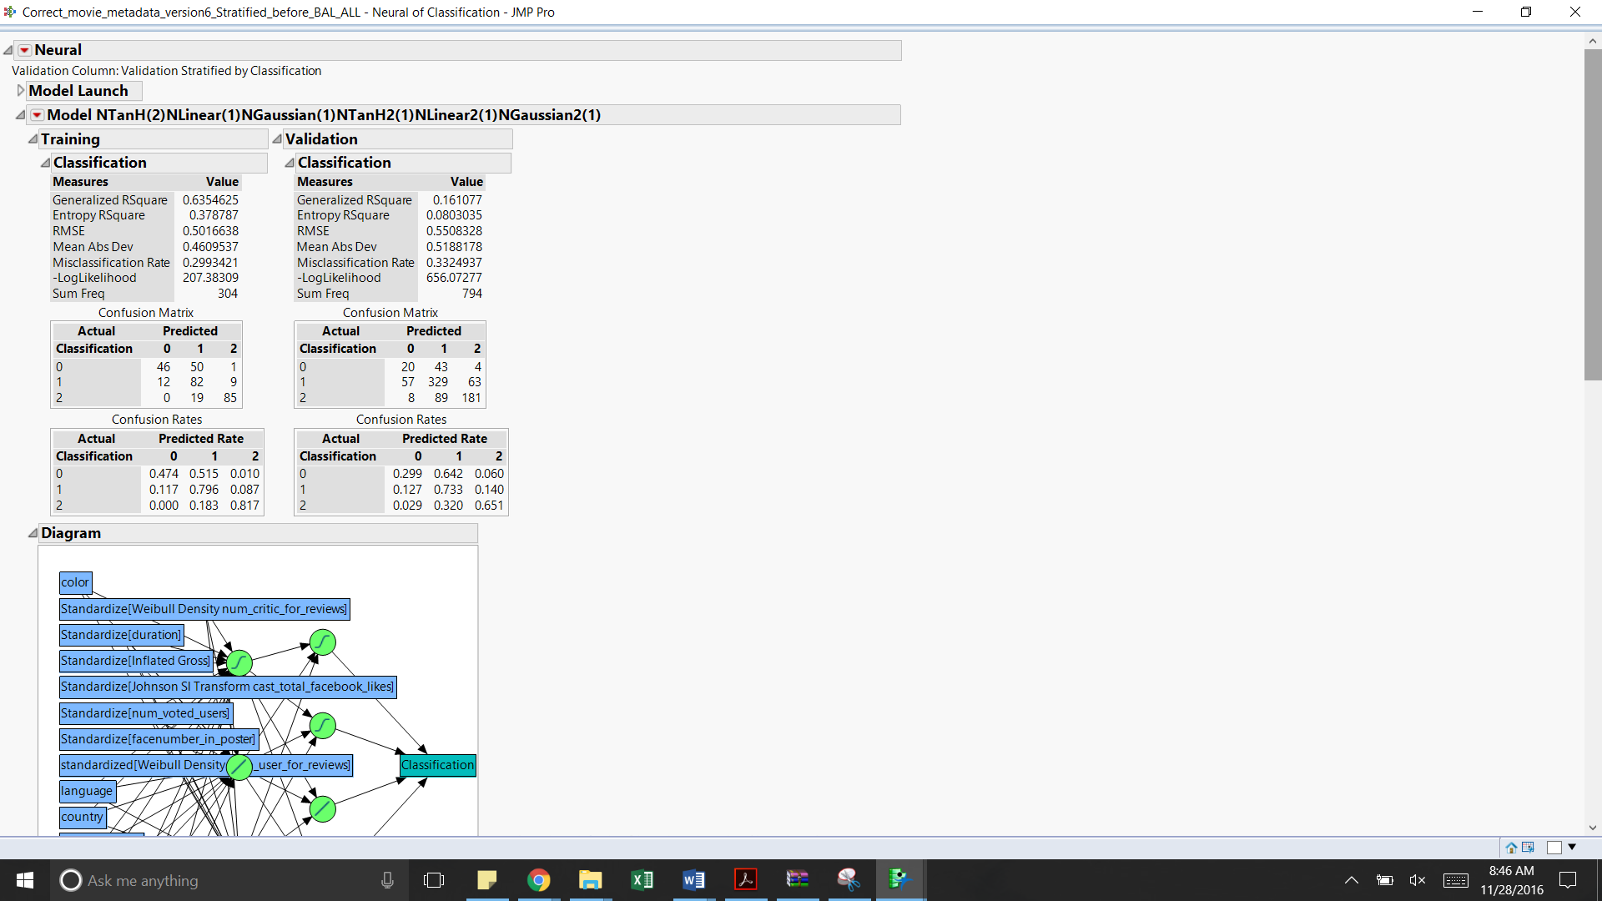

Accuracy obtained -

Training dataset - 70.06%

Validation dataset has an accuracy of 66.76%

|  |  |  |  |
| --- | --- | --- | --- |
| Misclassification Rate | 0 | 1 | 2 |
| Training | 53% | 20% | 18% |
| Validation | 70% | 27% | 35% |

Simple neural network with 4 and 3 nodes in the first and the second layer respectively -

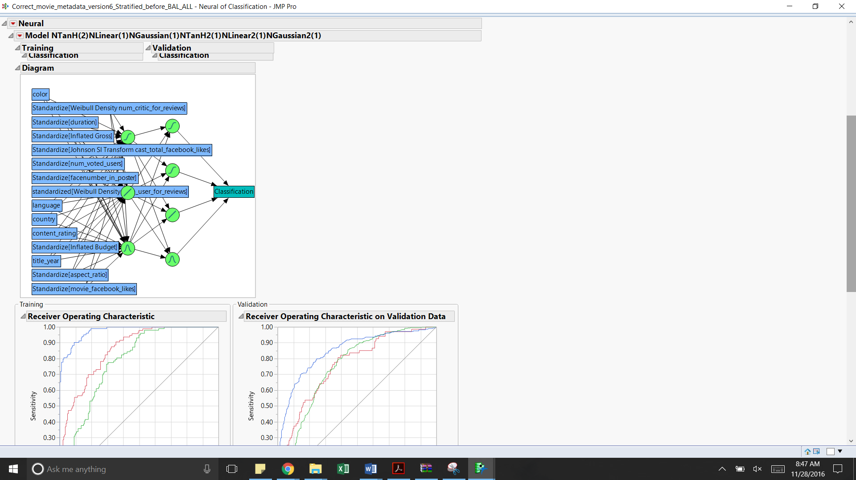

ROC Curve -

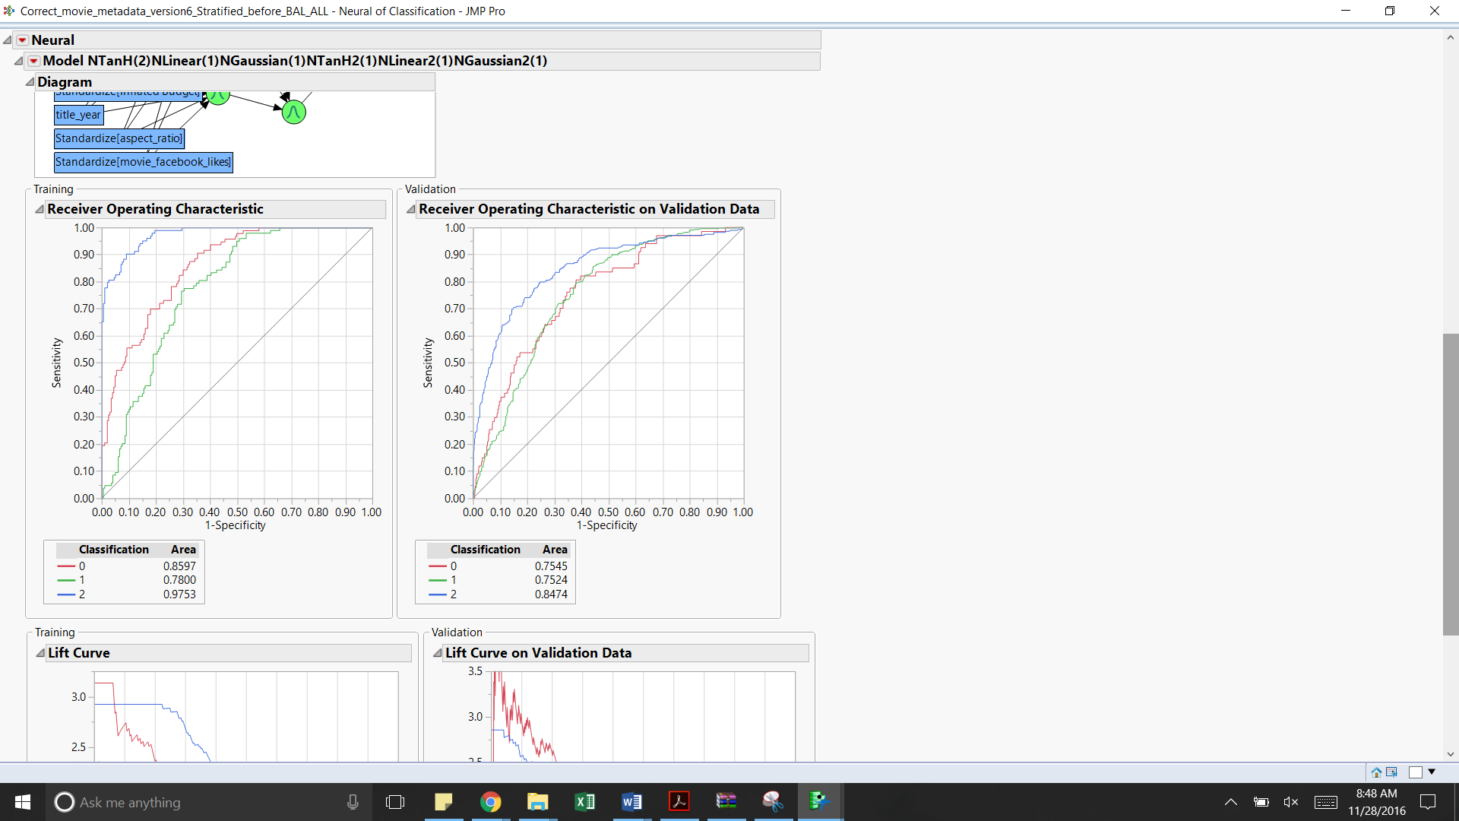

From the ROC curve above it is observed that the model more accurately classifies the movies as poor(0) and good(2) as compared to the average(1) rated movies

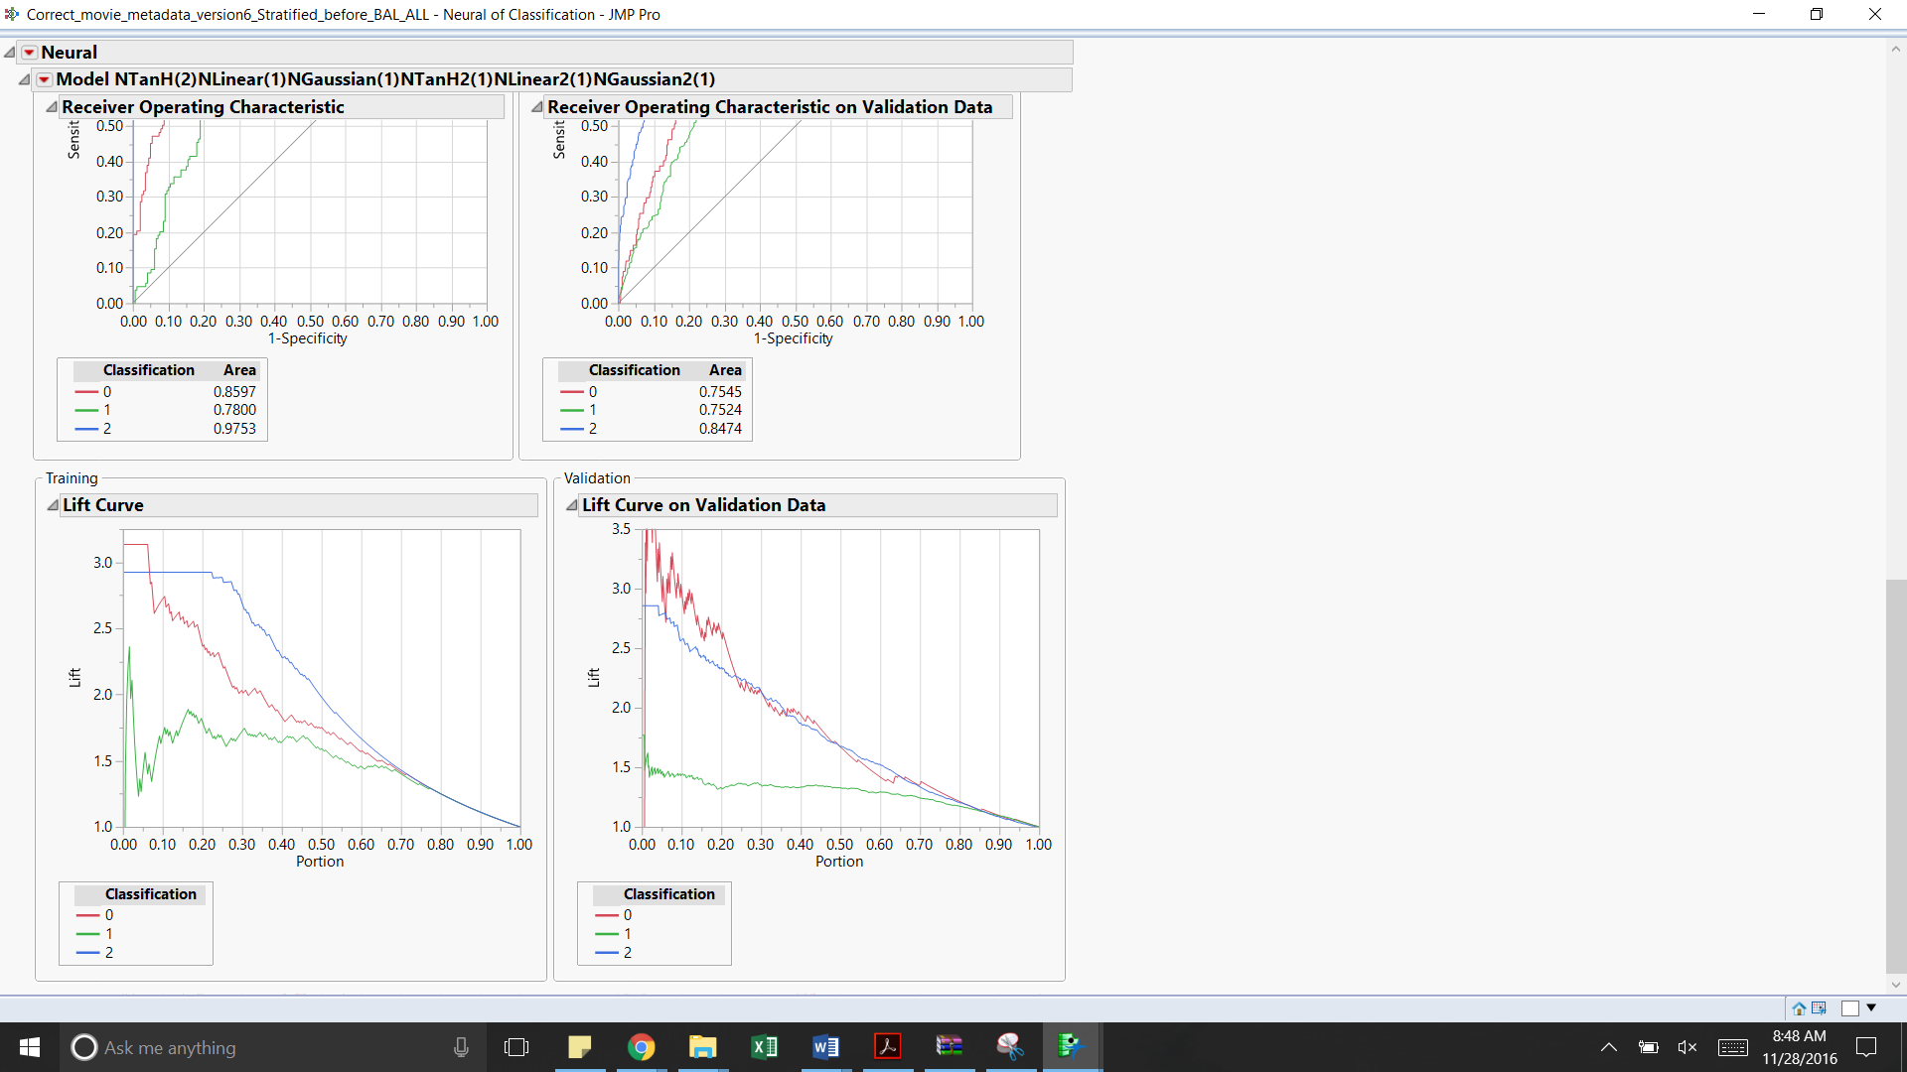

|  |  |  |
| --- | --- | --- |
| Classification | Training data | Validation data |
| 0 | The lift value is around 3 in the first decile and then constantly decreases across the other deciles | The lift value is on an average 3.25 in the first decile and then constantly decreases across the other deciles. |
| 1 | The lift value is around 1.75 in the first decile but is almost constant till the fifth decile | Even though the lift value is low, it is consistent till the sixth decile |
| 2 | The lift value is around 2.75 in the first two deciles and then constantly decreases across all the other deciles. | The lift value starts from 2.75 in the first decile and then constantly decreases across the other deciles |

**Complex Neural Network with 7 and 6 nodes in the first and the second layer respectively –**

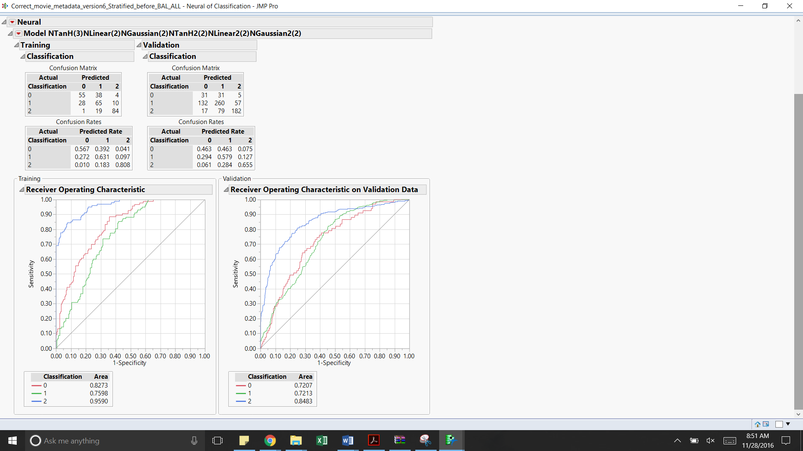 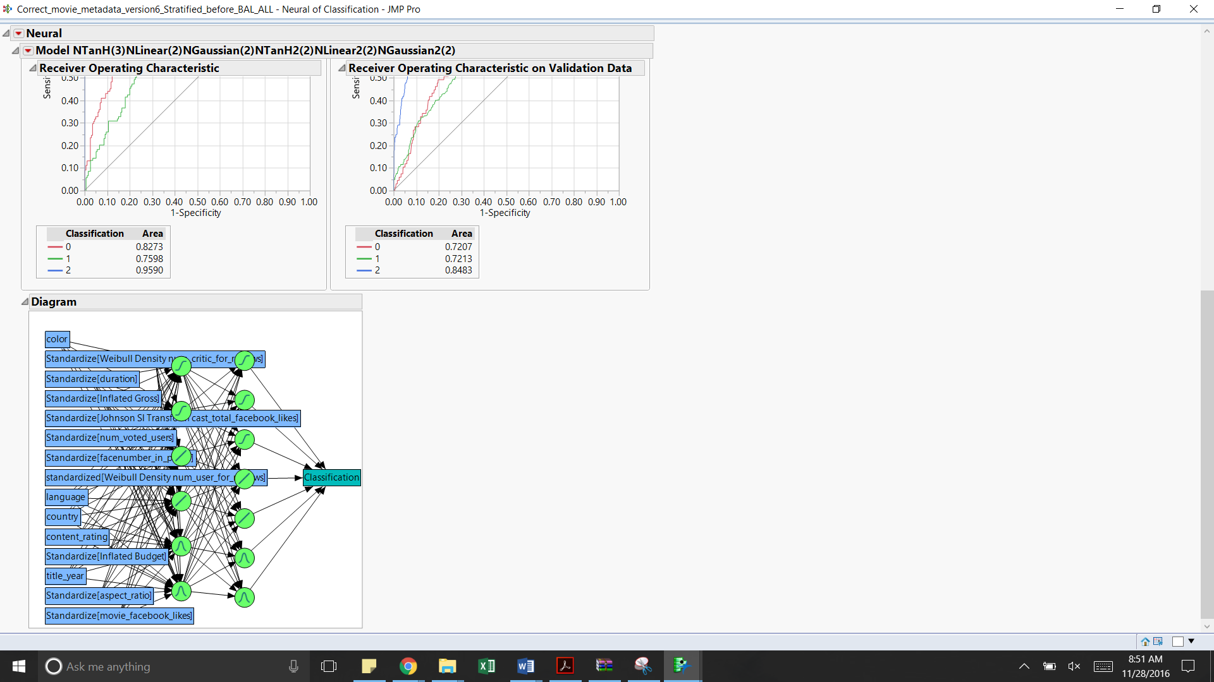

|  |  |  |  |
| --- | --- | --- | --- |
| Misclassification Rate | 0 | 1 | 2 |
| Training | 43% | 37% | 19% |
| Validation | 54% | 42% | 35% |

Accuracy –Training: 67%,V alidation: 60%



From the ROC curve above it is observed that the model more accurately classifies the movies as poor(0) and good(2) as compared to the average(1) rated movies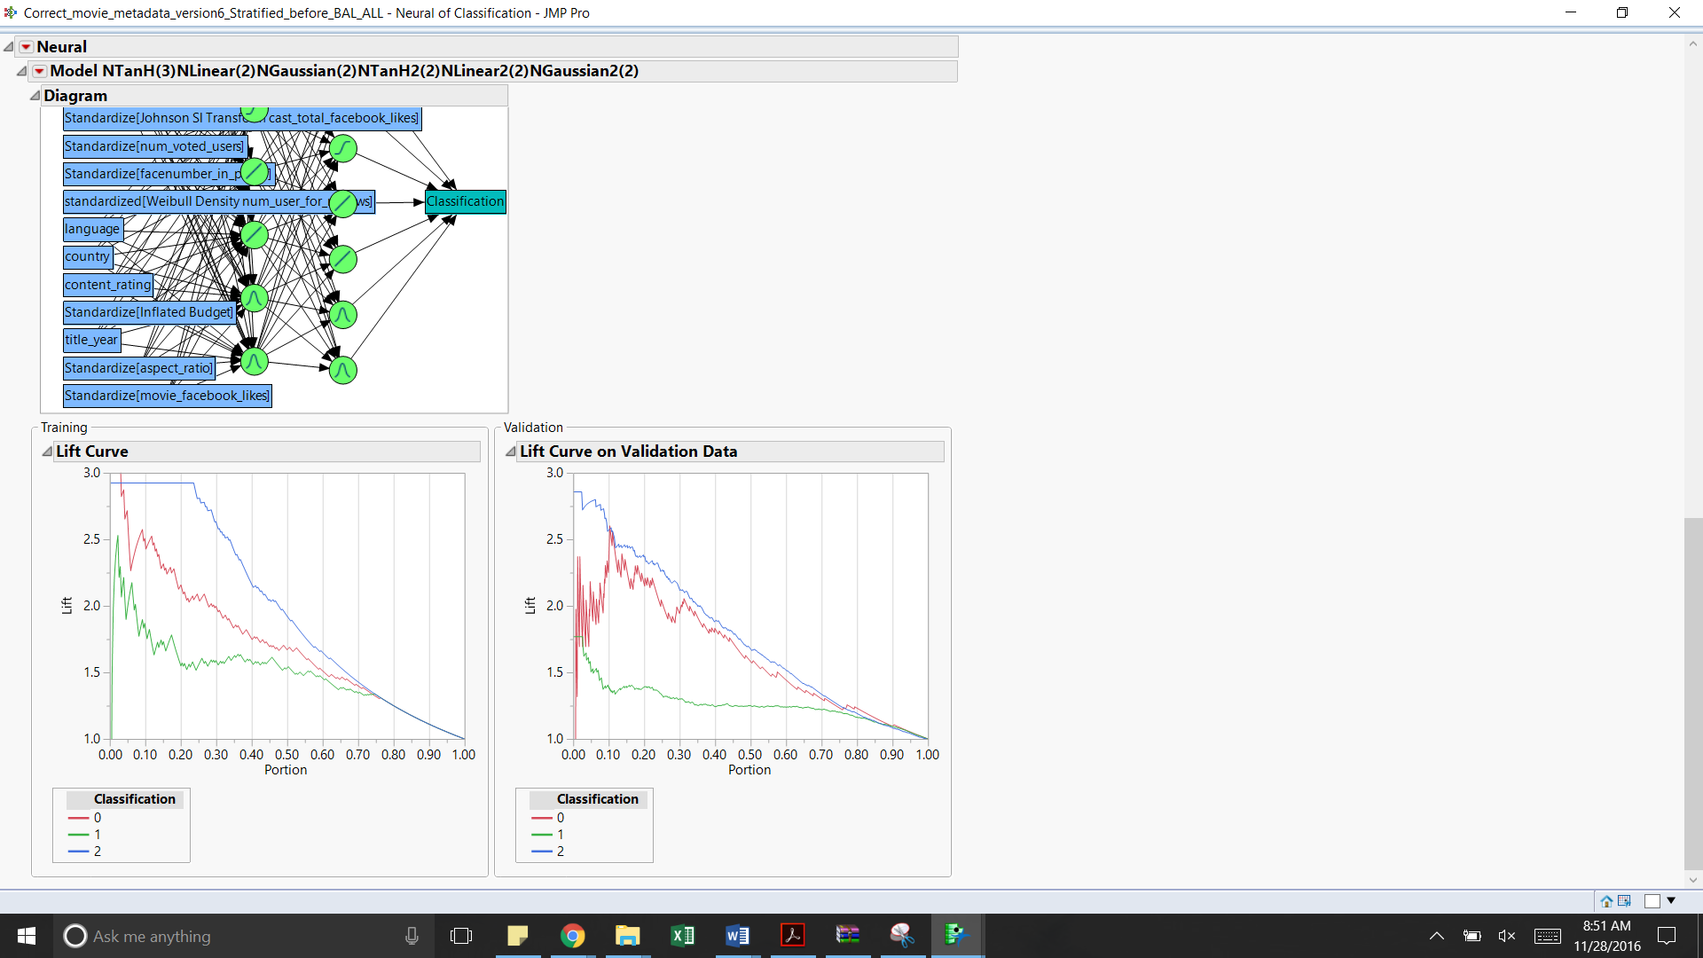

|  |  |  |
| --- | --- | --- |
| Classification | Training data | Validation data |
| 0 | The lift value is around 3 in the first decile and then constantly decreases across the other deciles | The lift value is on an average 2.25 in the first decile and then constantly decreases across the other deciles. |
| 1 | The lift value is around 2.25 in the first decile but has a constant lift value of 1.5 till the fifth decile | Even though the lift value starts from1.75, it is consistent till the eighth decile for a lift value of 1.35 approximately |
| 2 | The lift value is around 2.9 in the first two deciles and then constantly decreases across all the other deciles. | The lift value starts from 2.85 in the first decile and then constantly decreases across the other deciles |

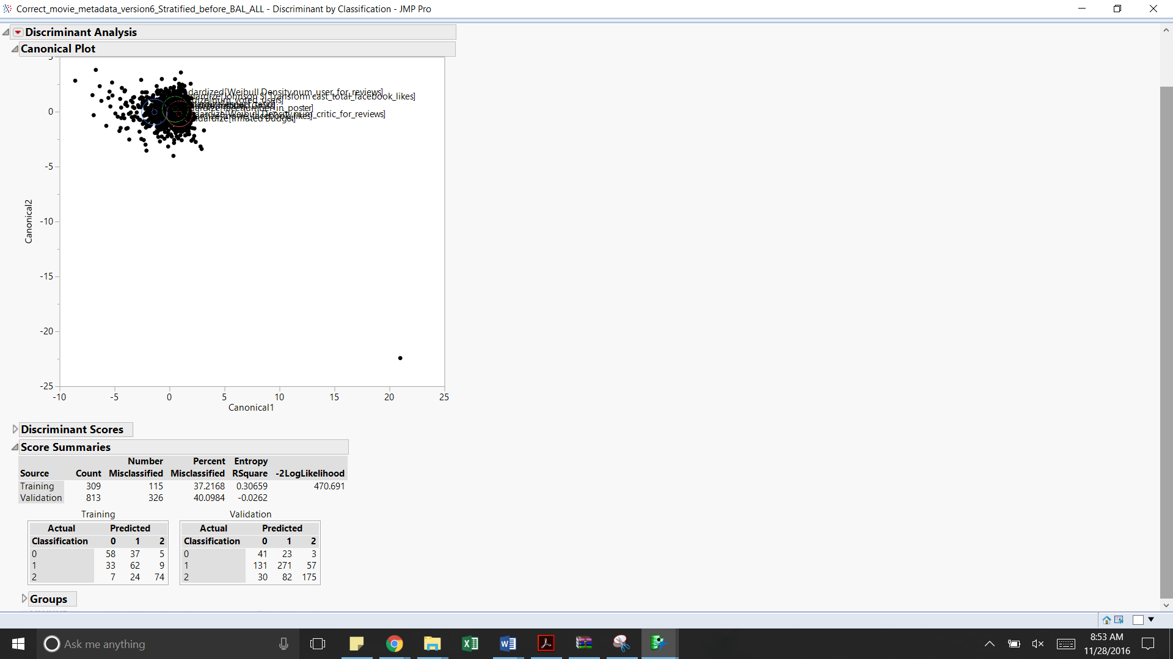**Discriminant Analysis -**

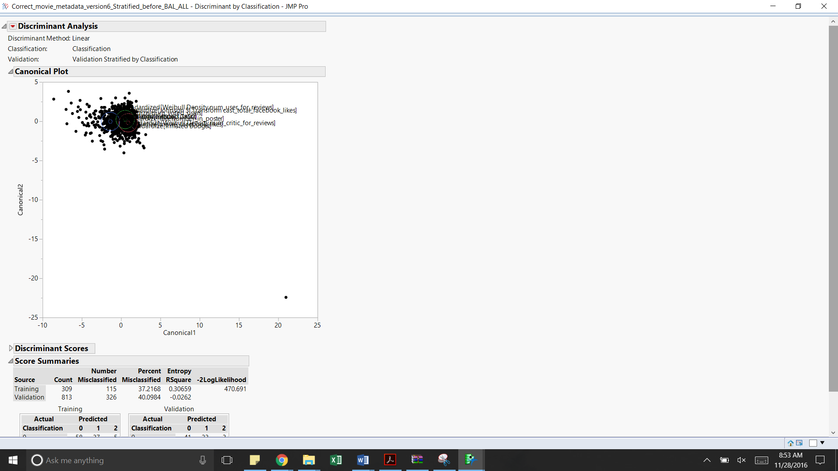

|  |  |  |  |
| --- | --- | --- | --- |
| Misclassification | 0 | 1 | 2 |
| Training | 42% | 40% | 30% |
| Validation | 39% | 41% | 39% |

Accuracy –Training -63%, Validation – 60%

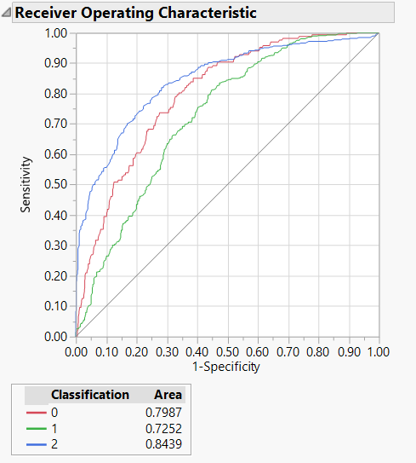

From the ROC curve above it is observed that the model more accurately classifies the movies as poor(0) and good(2) as compared to the average(1) rated movies

**Decision Trees**

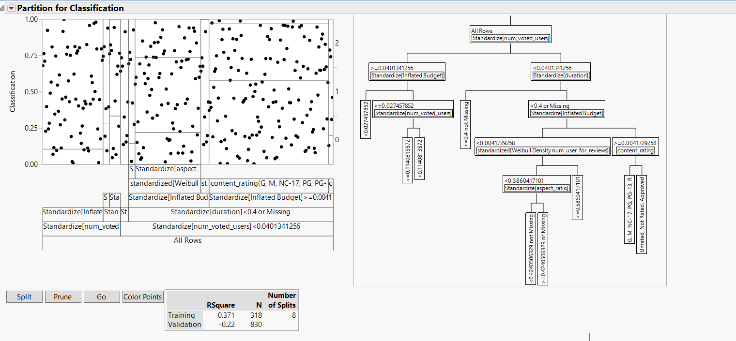

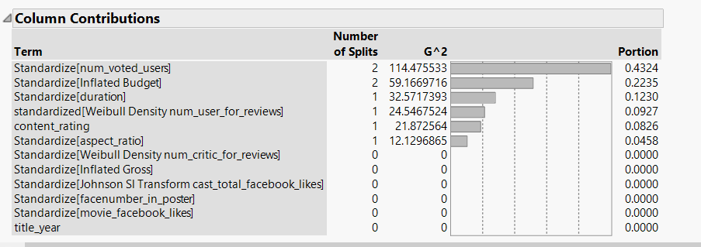

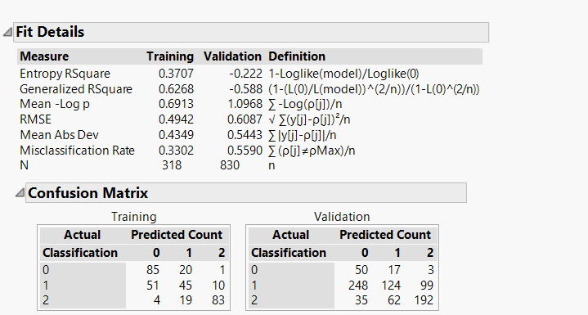

This model has an accuracy of 67% on the training data and 56% on the validation data.

|  |  |  |  |
| --- | --- | --- | --- |
| Dataset/Misclassification Rate | 0 | 1 | 2 |
| Training | 20% | 58% | 22% |
| Validation | 29% | 74% | 34% |

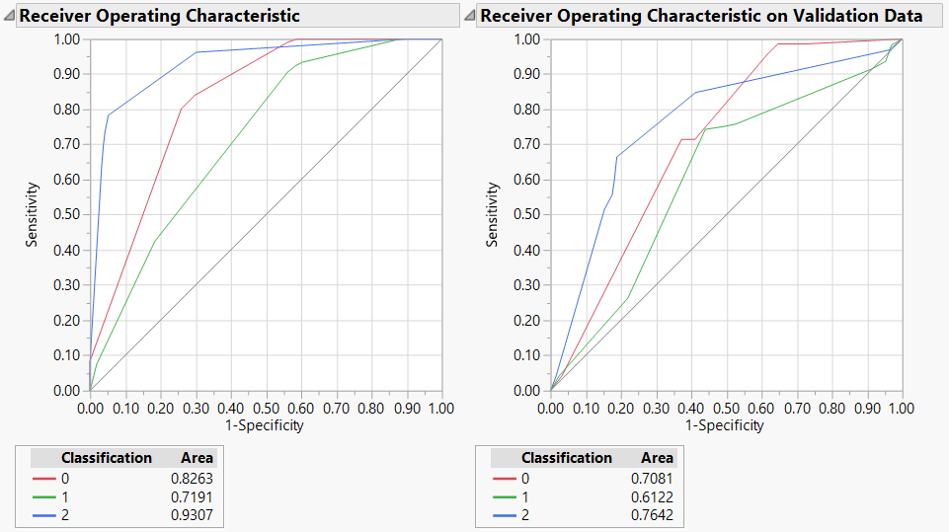

**Ensemble- Discriminant Analysiss**

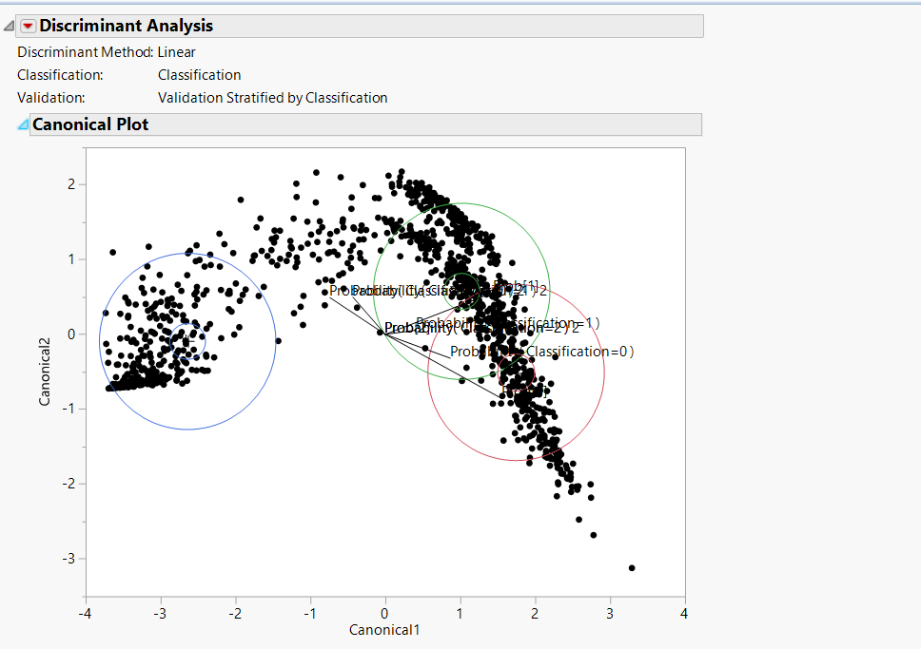

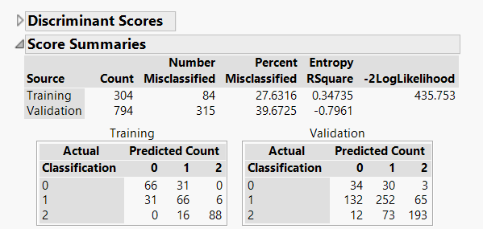

The model has an accuracy of 72% on the training data and 60% on the validation data.

|  |  |  |  |
| --- | --- | --- | --- |
| Dataset/Misclassification Rate | 0 | 1 | 2 |
| Training | 32% | 36% | 15% |
| Validation | 49% | 44% | 31% |

Dataset 3: Movies with title_year >= 2004

|  |  |  |  |  |
| --- | --- | --- | --- | --- |
|  | **Actual dataset** | **After Stratification** | **Training dataset** | **Validation dataset** |
| **Number of Rows** | **2076** | **1763** | **618** | **1145** |

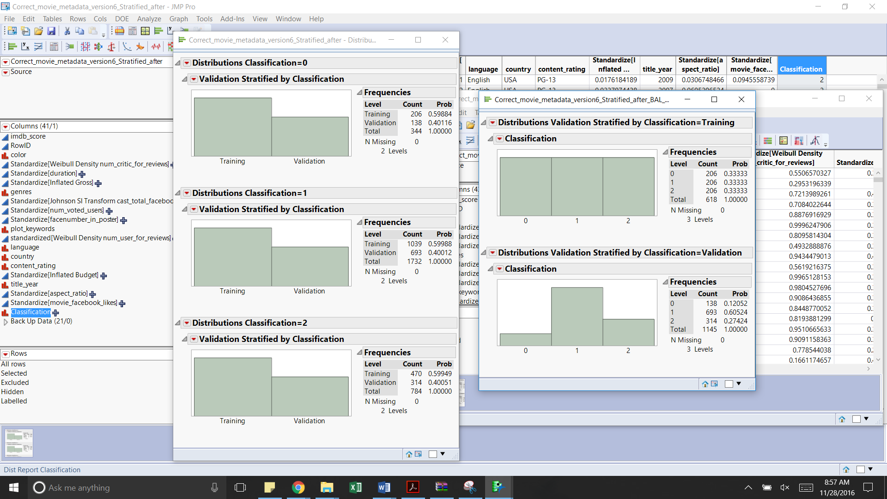

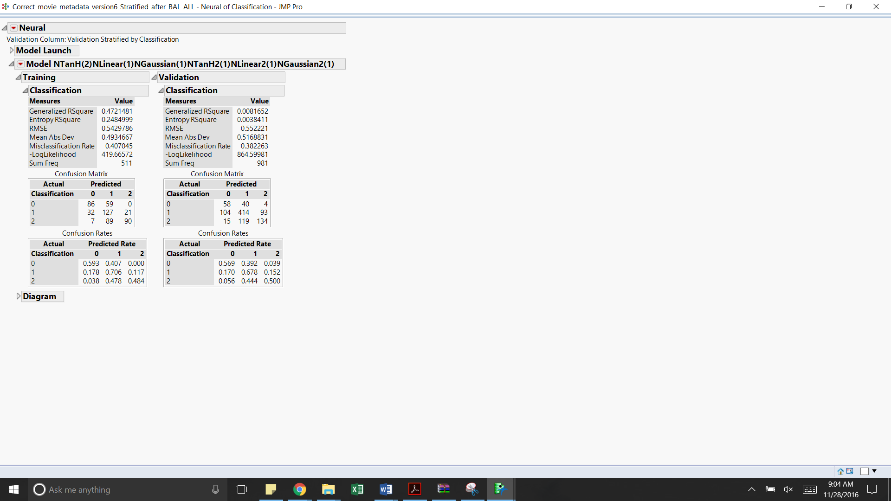

|  |  |  |  |
| --- | --- | --- | --- |
| Misclassification | 0 | 1 | 2 |
| Training | 41% | 29% | 52% |
| Validation | 43% | 32% | 50% |

Accuracy:Training = 59%, Validation = 62%

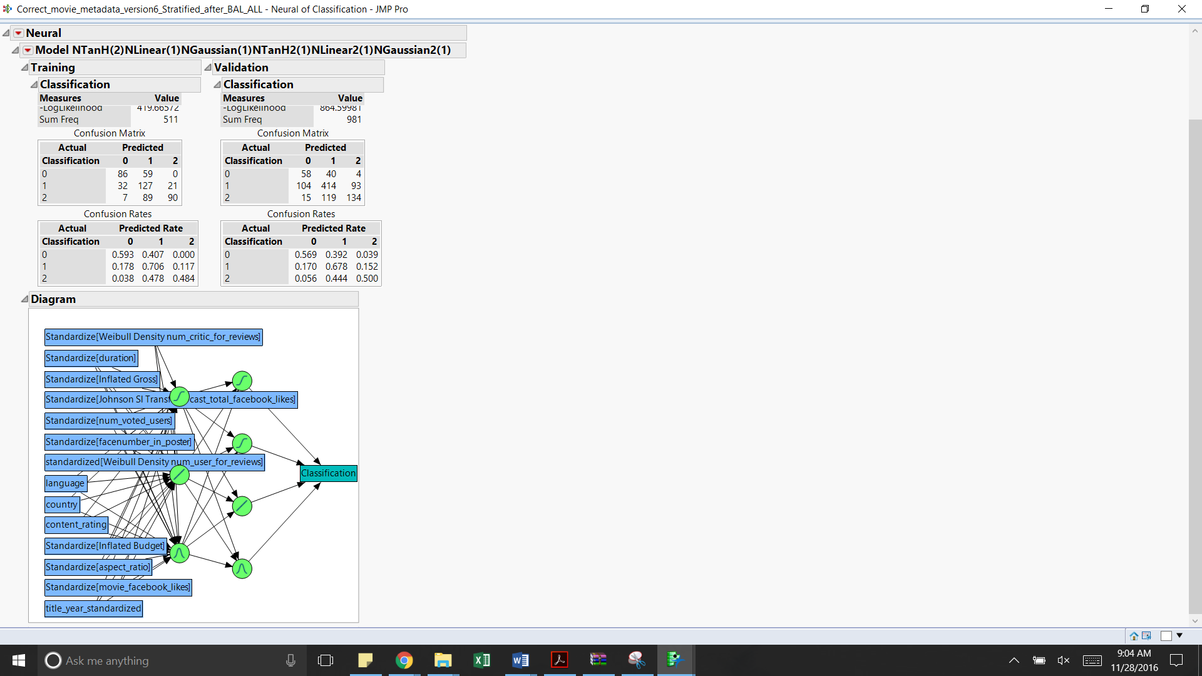 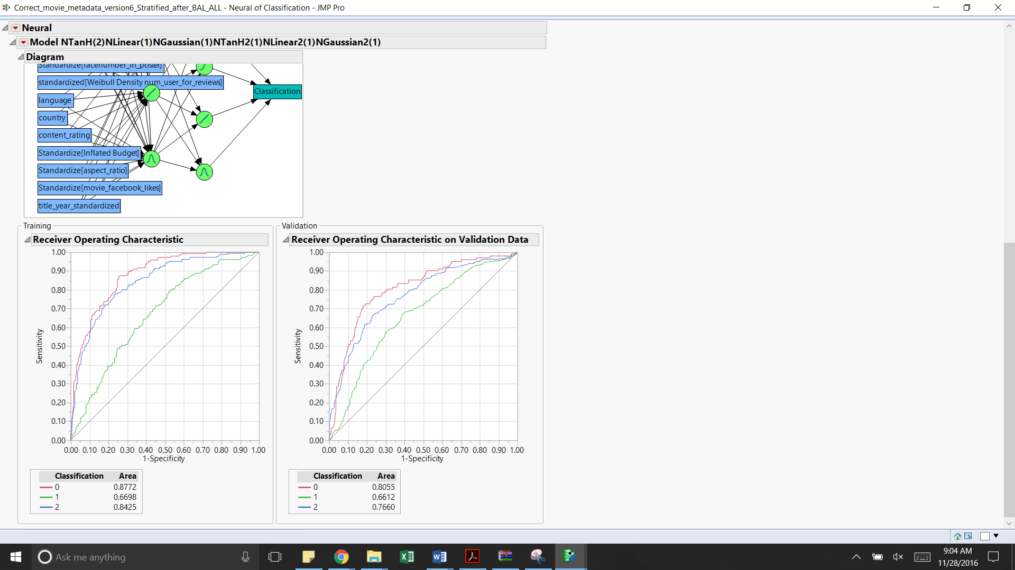

From the ROC curve above it is observed that the model more accurately classifies the movies as poor(0) and good(2) as compared to the average(1) rated movies

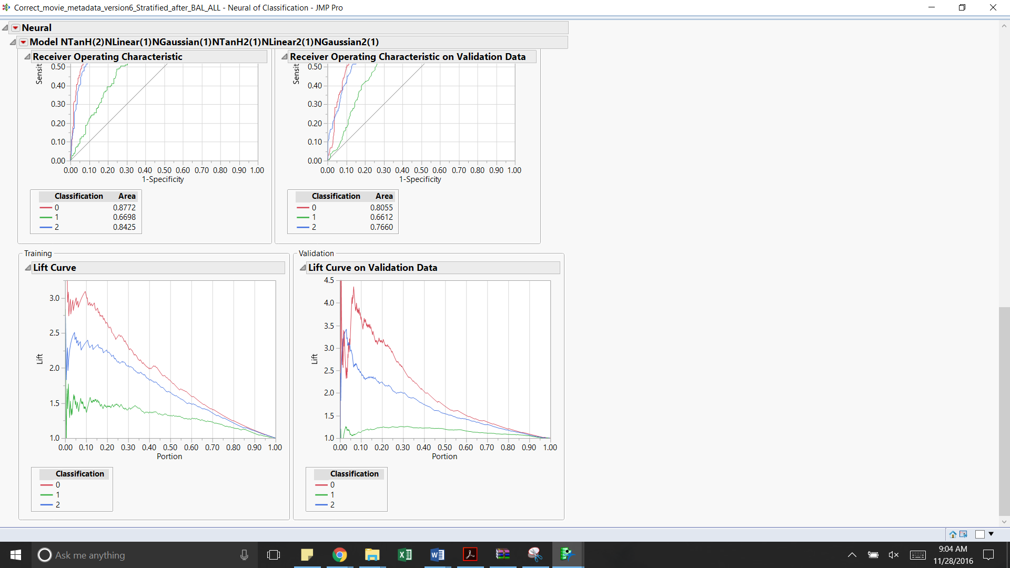

|  |  |  |
| --- | --- | --- |
| Classification | Training data | Validation data |
| 0 | The lift value is around 3 in the first decile and then constantly decreases across the other deciles | The lift value is on an average 2.25 in the first decile and then constantly decreases across the other deciles. |
| 1 | The lift value is around 1.5 in the first decile and then it is almost constant till the fourth decile | Even though the lift value starts from 1, it is consistent from the second to the sixth decile |
| 2 | The lift value is around 2.25 in the first decile and then constantly decreases across the other deciles | The lift value starts from 2.85 in the first decile and then constantly decreases across the other deciles |

**Complex Neural Network with 7 and 6 nodes in the first and the second layer respectively –**

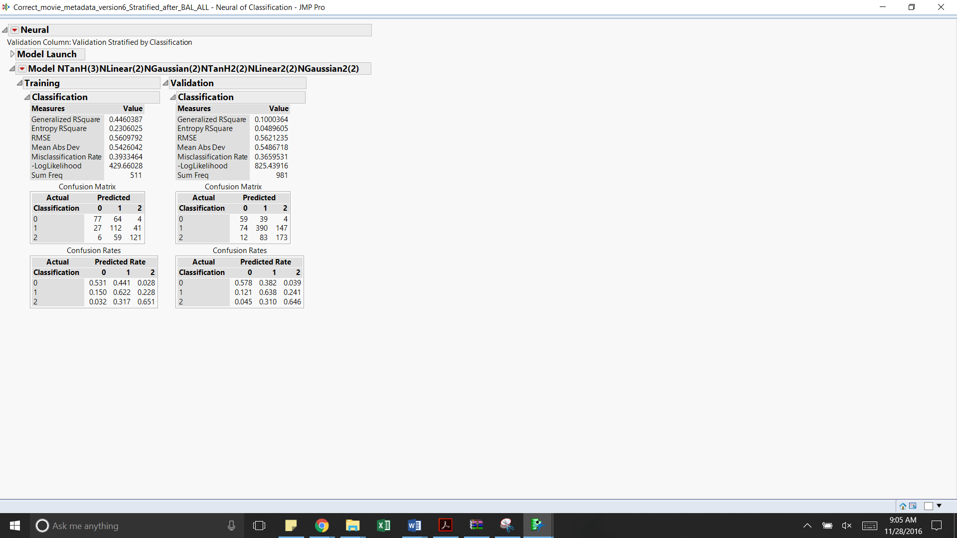

|  |  |  |  |
| --- | --- | --- | --- |
| Misclassification | 0 | 1 | 2 |
| Training | 47% | 38% | 35% |
| Validation | 42% | 36% | 35% |

Accuracy:Training = 61%, Validation = 63%

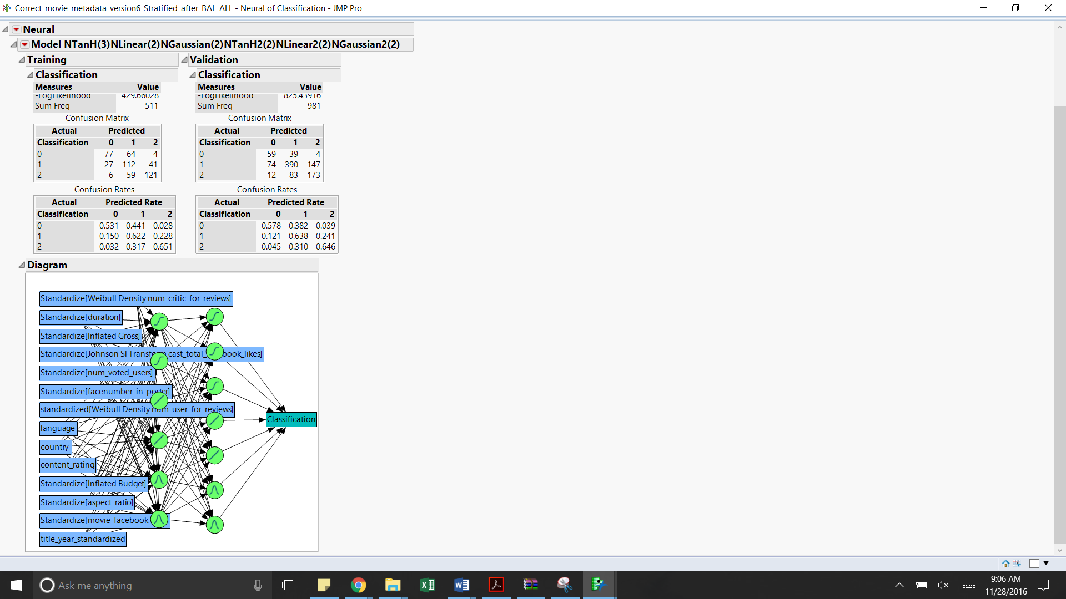 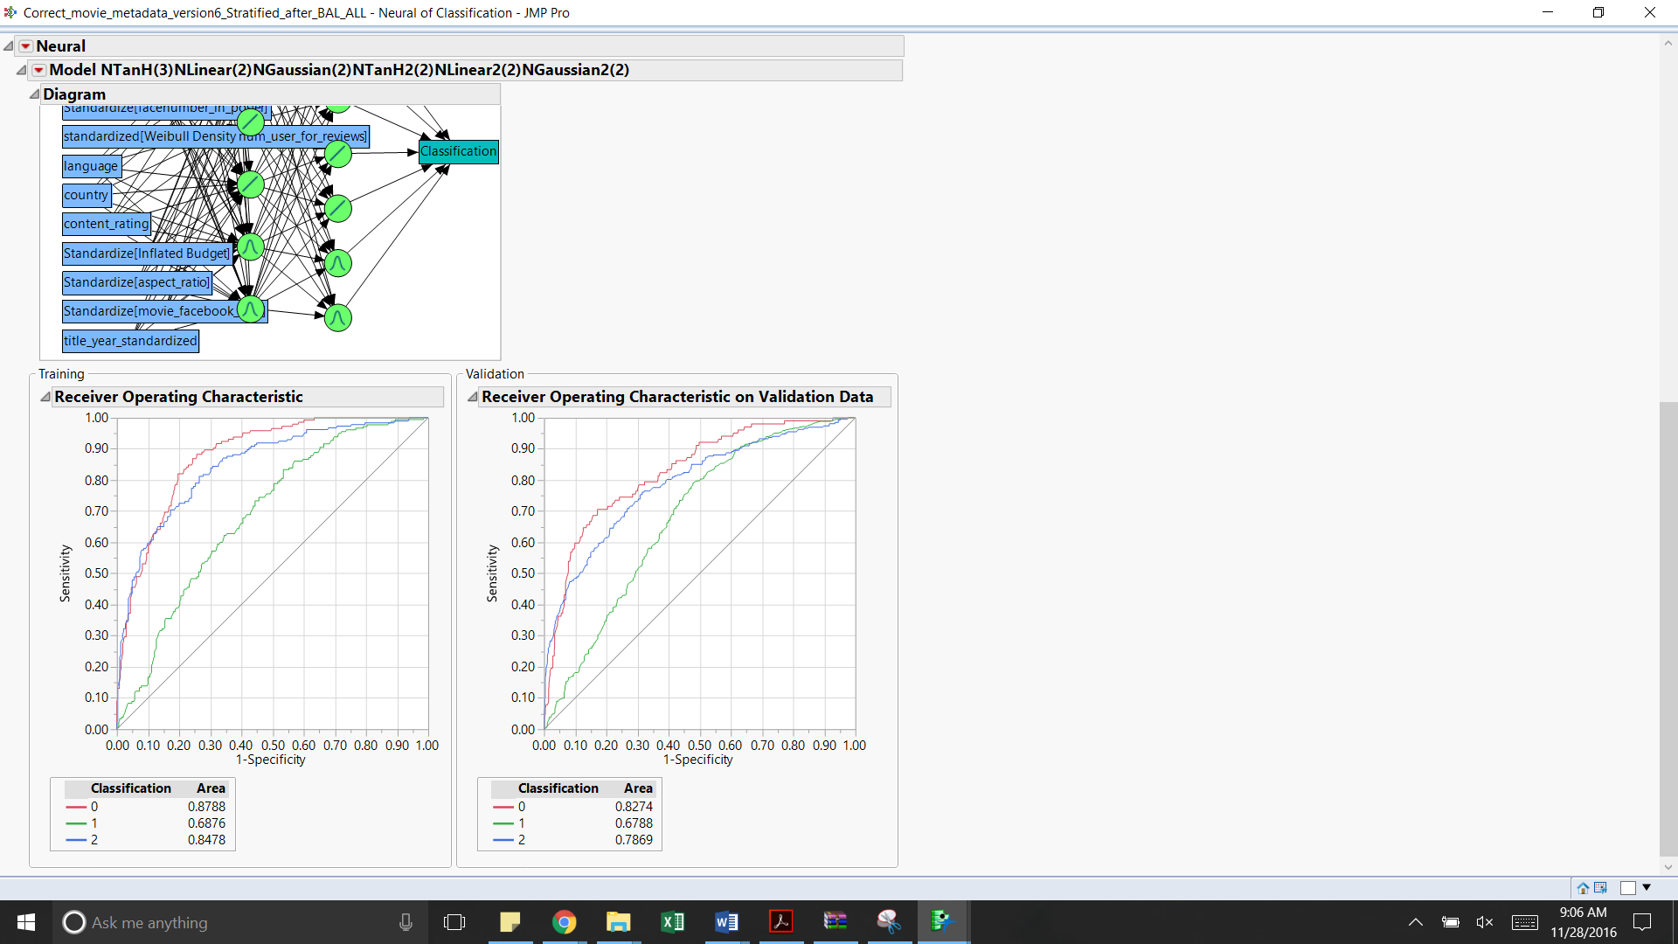

From the ROC curve above it is observed that the model more accurately classifies the movies as poor(0) and good(2) as compared to the average(1) rated movies

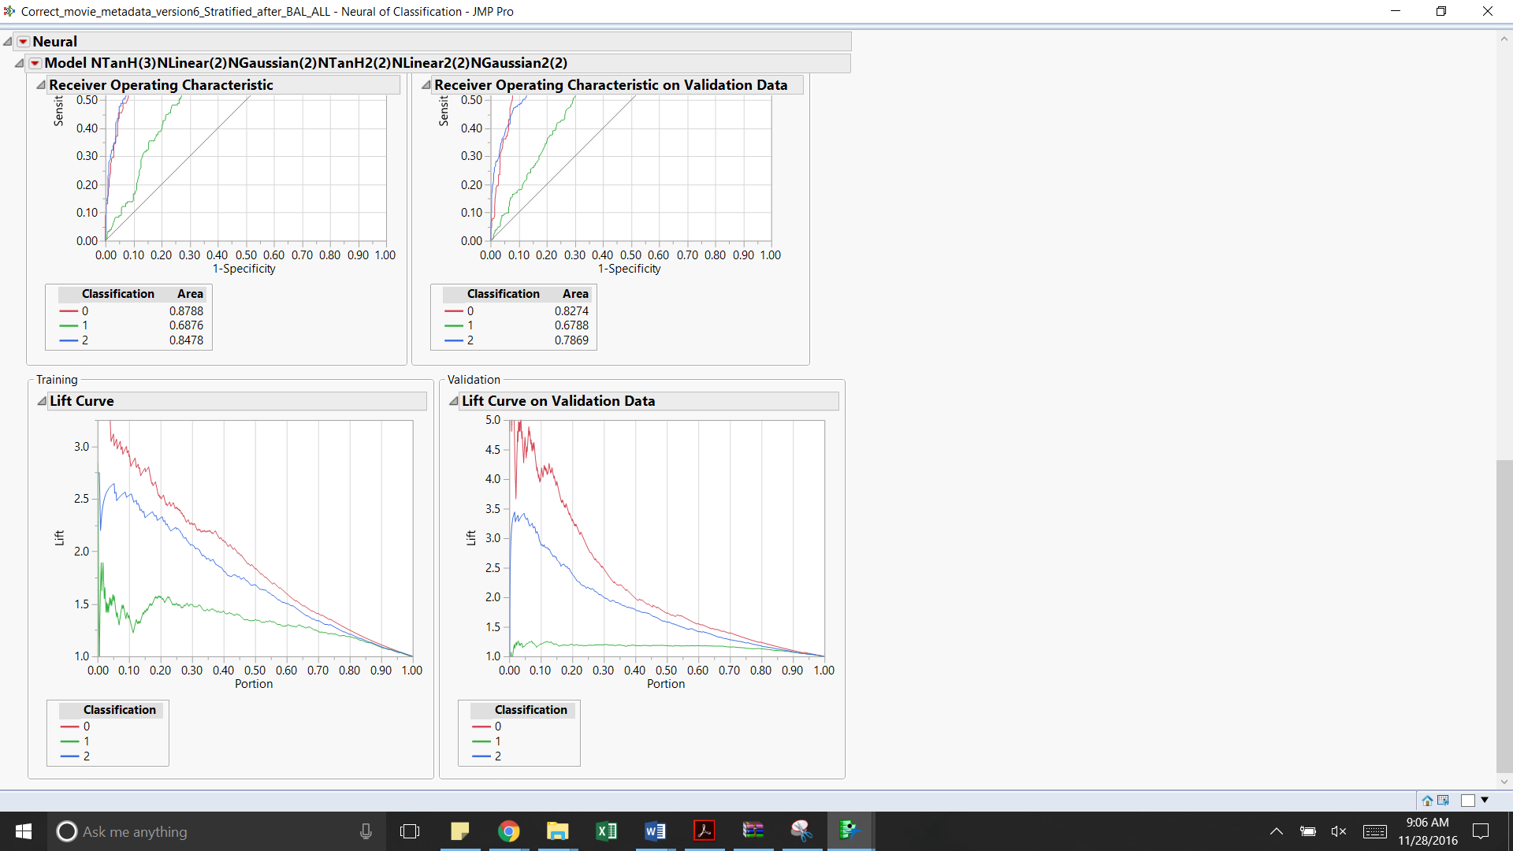

|  |  |  |
| --- | --- | --- |
| Classification | Training data | Validation data |
| 0 | The lift value is above 3 in the first decile and then decreases across the other deciles | The lift value is on an average 2.25 in the first decile and then constantly decreases across the other deciles. |
| 1 | The lift value is around 1.5 in the first decile and then it gradually decreases across the other deciles | Even though the lift value starts from 1, it is consistent from the second to the eighth decile |
| 2 | The lift value is around 2.5 in the first decile and then constantly decreases across the other deciles | The lift value starts from 3.25 in the first decile and then constantly decreases across the other deciles |

**Discriminant Analysis -**

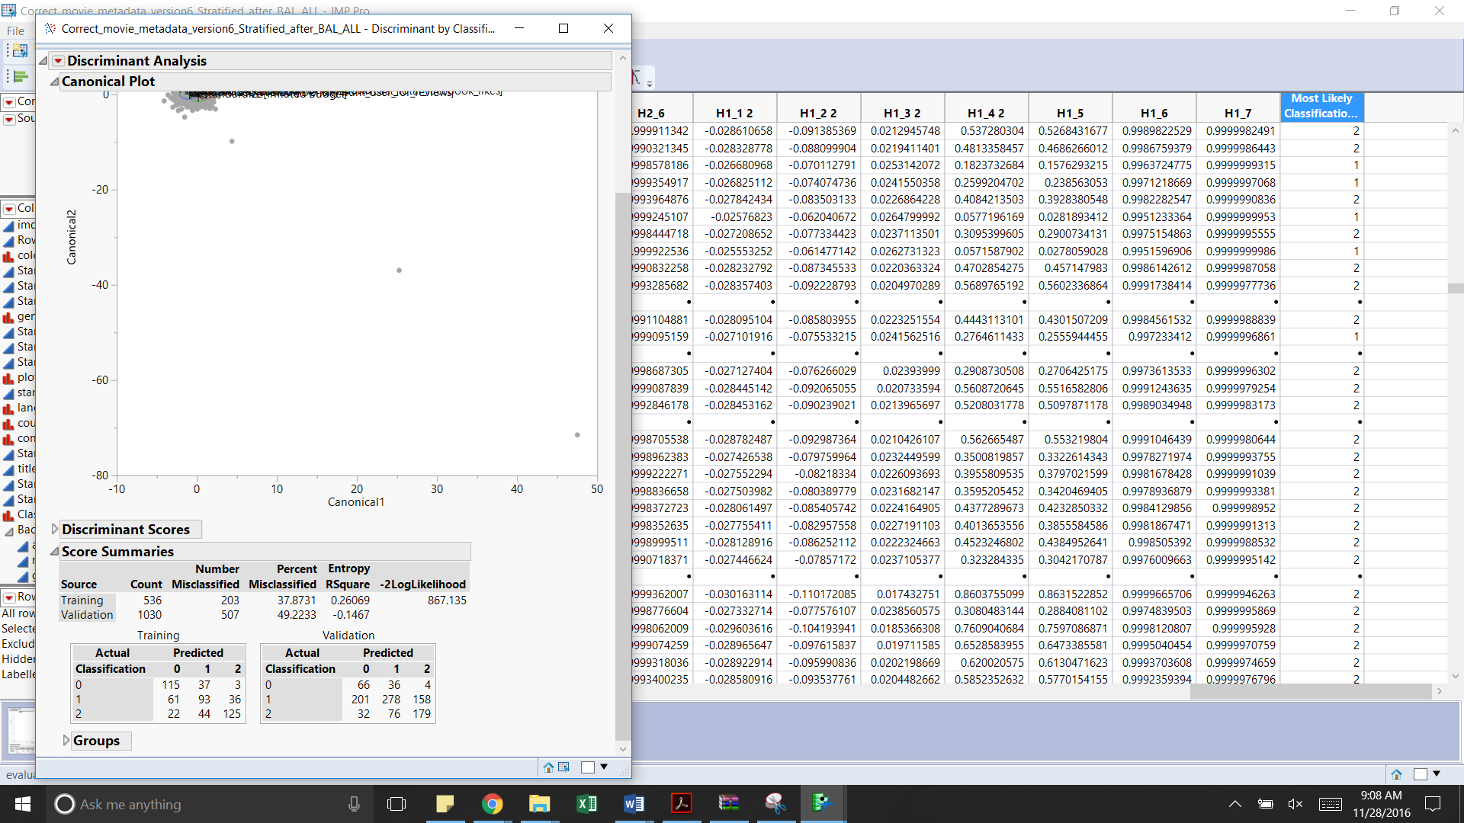

|  |  |  |  |
| --- | --- | --- | --- |
| Misclassification | 0 | 1 | 2 |
| Training | 26% | 51% | 35% |
| Validation | 38% | 56% | 38% |

Accuracy: Training = 62%, Validation = 51%

**Decision Trees**

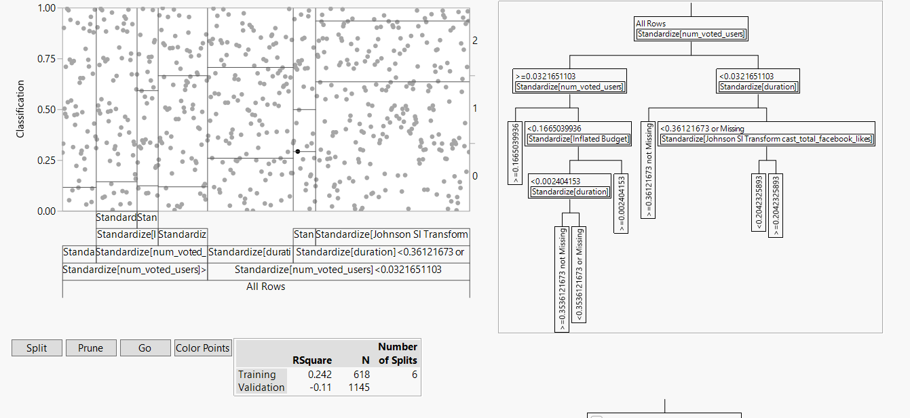

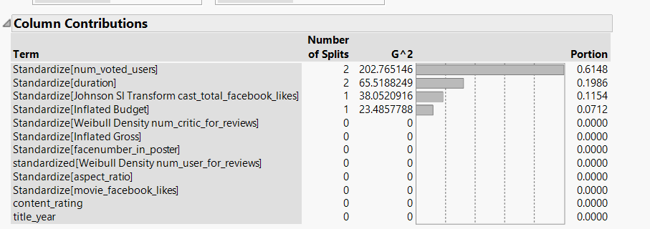

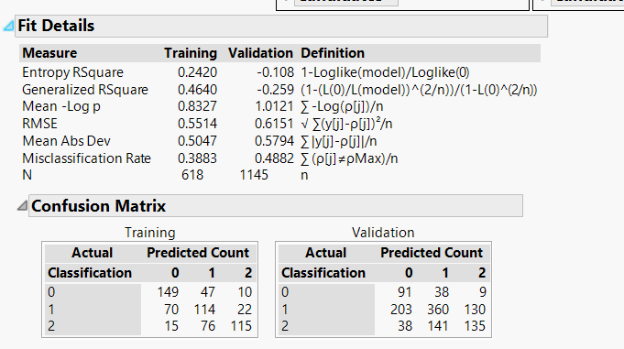

This model has an accuracy of 61% on the training data and 51% on the validation data.

|  |  |  |  |
| --- | --- | --- | --- |
| Dataset/Misclassification Rate | 0 | 1 | 2 |
| Training | 28% | 45% | 44% |
| Validation | 34% | 48% | 57% |

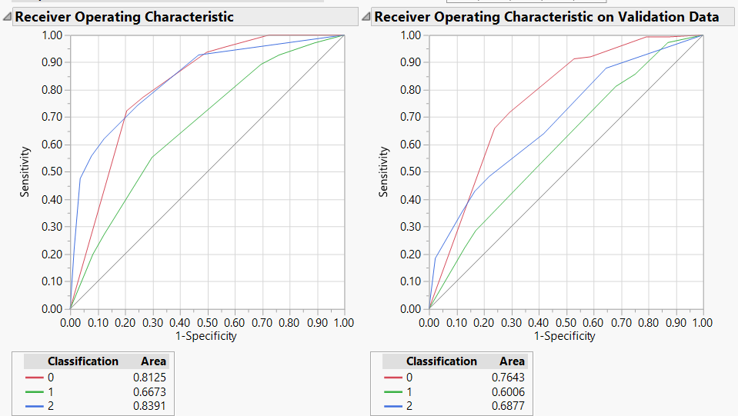

**Ensemble Discriminant Analysis**

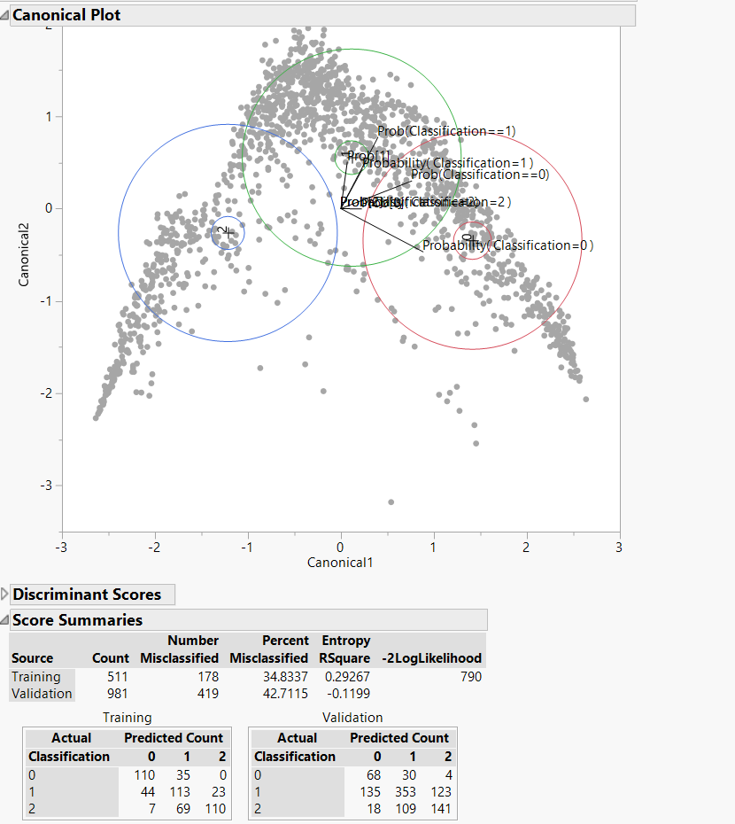

This model has an accuracy of 66% on the training data and 58% on the validation data

|  |  |  |  |
| --- | --- | --- | --- |
| Dataset/Misclassification Rate | 0 | 1 | 2 |
| Training | 24% | 37% | 41% |
| Validation | 33% | 42% | 47% |

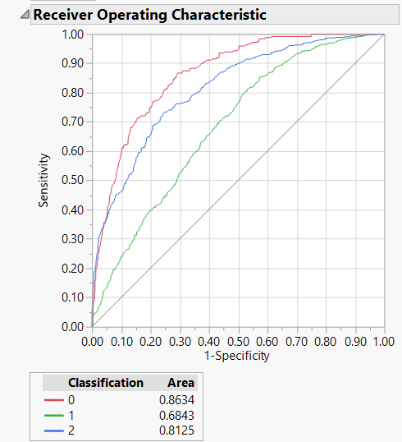

Classification models built on Dataset with outliers removed

We built the same classification models as done before for dataset with the outliers removed in order to check if the outliers play a significant role

Entire Dataset with outliers removed

The classification model was built using the entire dataset with outliers based on the UCL value (5.37) removed. (4584 rows). Like the previous section, we created the balanced train (0.6) and unbalanced validation (0.6) using stratified sample.

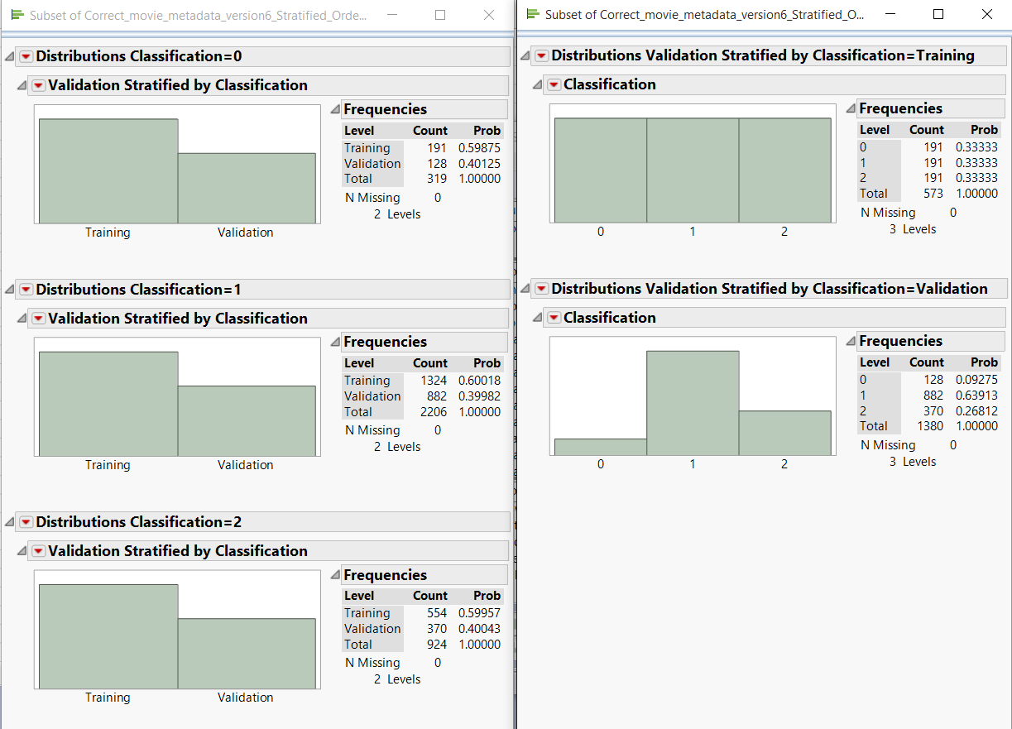

Post this, following the similar steps as the previous sections, below are the results of the various models.Below are the results of the neural network model for the given data

 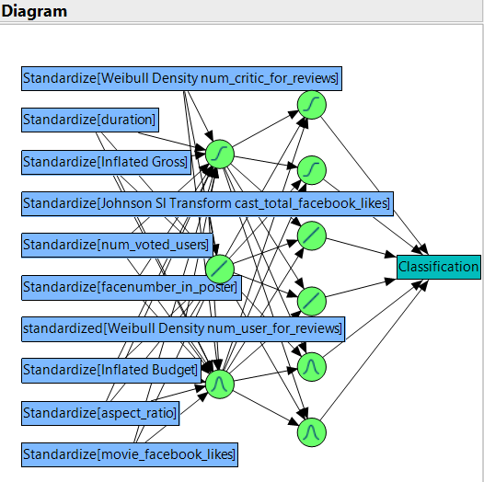

The below figure shows the confusion rates for each predictions

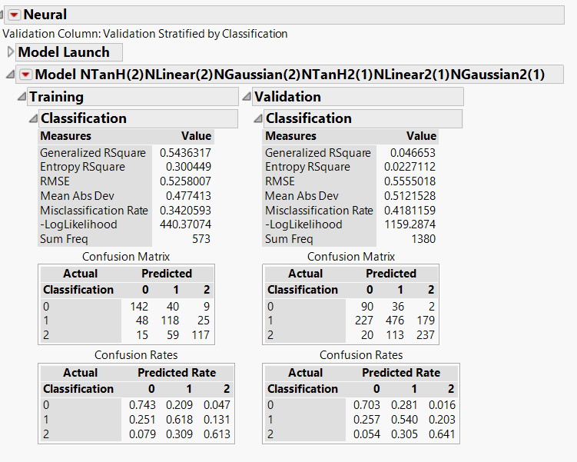

|  |  |  |  |
| --- | --- | --- | --- |
| Dataset/Misclassification Rate | 0 | 1 | 2 |
| Training | 26% | 38% | 39% |
| Validation | 30% | 46% | 36% |

The model performs almost equally good on the training and validation data with an accuracy of 58.2% on the validation data and 66% on the training data. Below are the ROC and the lift curves for the given model.

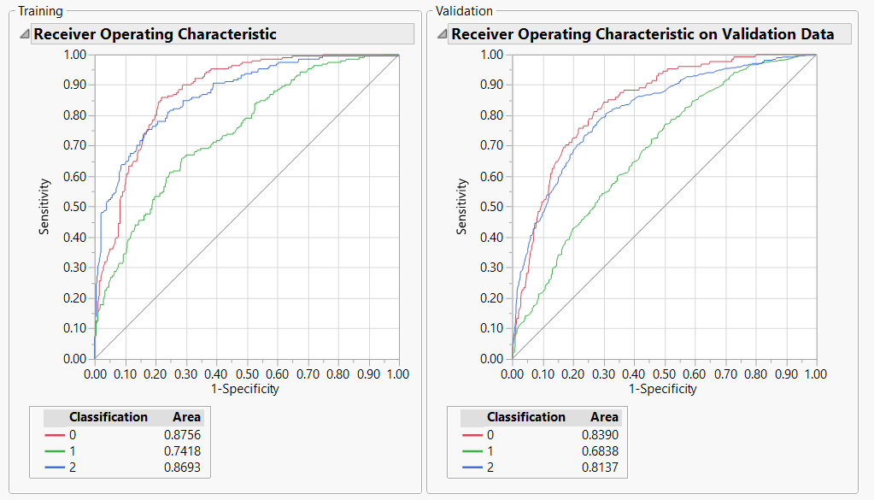

From the ROC curve above it is observed that the model more accurately classifies the movies as poor(0) and good(2) as compared to the average(1) rated movies

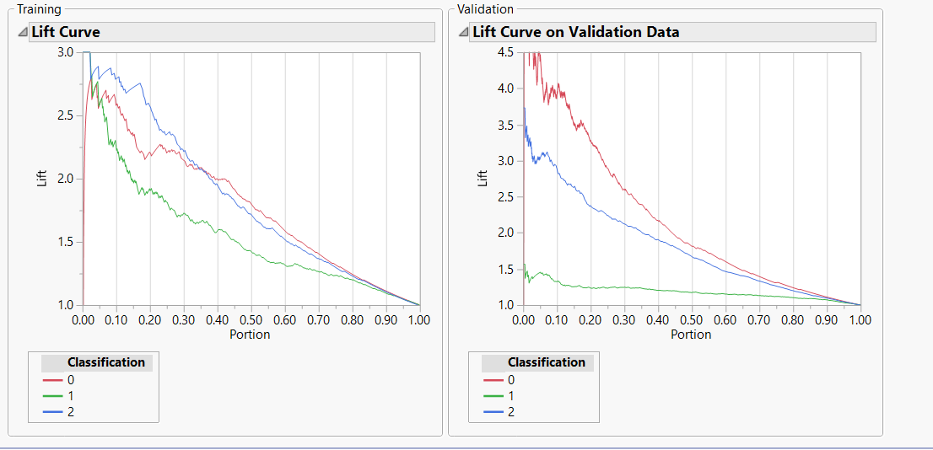

From the lift curve above the following observations were made:

|  |  |  |
| --- | --- | --- |
| Classification | Training data | Validation data |
| 0 | The lift value is around 2.5 in the first decile and then constantly decreases across the other deciles | The lift value is very high in the first decile and then constantly decreases across the other deciles |
| 1 | The lift value ranges from 2.2 to 3 in the first decile and then constantly decreases across all the other deciles. | Even though the lift value is low when compared to 0s and 2s, it is consistent till the fifth decile and then reduces |
| 2 | The lift value is very high in the first two deciles but reduces consistently across all the other deciles | The lift value rages from 4 to 4.5 in the first decile but reduces consistently in all the other deciles |

Like the above analysis, below are the results from the discriminant analysis.

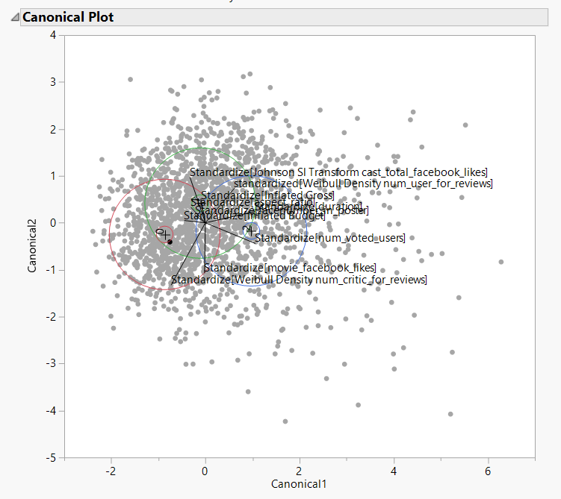

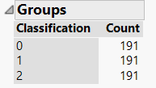 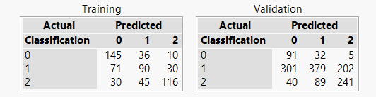

Below is the confusion matrix for the given model.

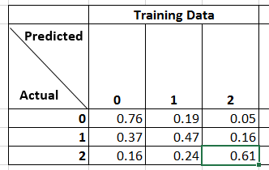 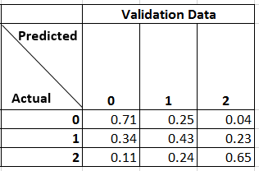

|  |  |  |  |
| --- | --- | --- | --- |
| Dataset/Misclassification Rate | 0 | 1 | 2 |
| Training | 24% | 53% | 39% |
| Validation | 29% | 57% | 35% |

From the observations above, the model seems to perform equally well in both the Training and the validation dataset.

The accuracy rate in the training data set is 61.25% and the validation data set is 51.52%.

Since the performance of the model across the training and validation datasets do not have a big difference, ‘overfitting’ has not occurred. Hence, this model can be used for classification

Similar to the other models, below are the results of the decision tree model.

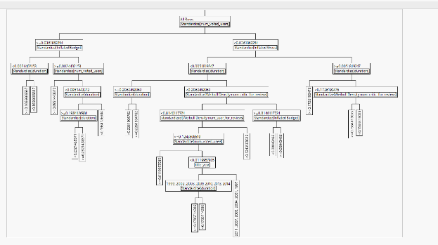

The figure above represents a small tree view of the splits

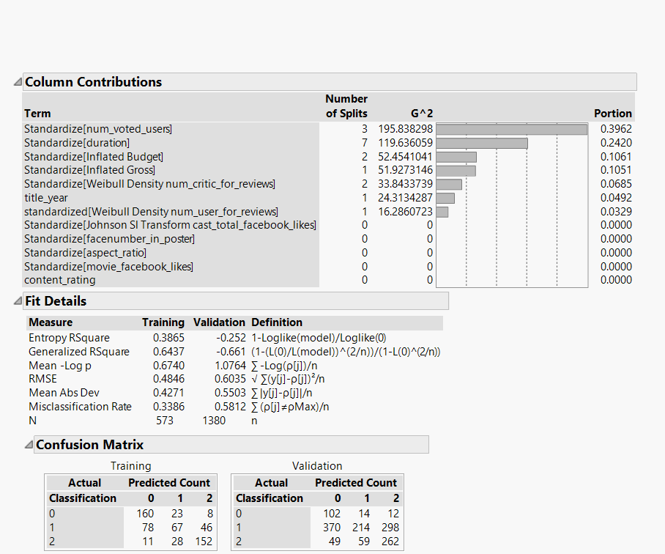

|  |  |  |  |
| --- | --- | --- | --- |
| Dataset/Misclassification Rate | 0 | 1 | 2 |
| Training | 16% | 65% | 20% |
| Validation | 20% | 76% | 29% |

A manual split is done to check the misclassification rate at the end of each split and the predictor variable which is contributing the most to the target variable.

From the figure above it can be seen that the num_voted_user has the most influence on the target variable - hence the first split is on this variable.

After the split on the variable num_user_for_reviews there is no more contribution from the other variables. After this point the misclassification rate in the validation data also increases. Hence, there are no more splits that are executed.

This model gives an accuracy rate of 0.42 on validation data and an accuracy of 66% on the training data.

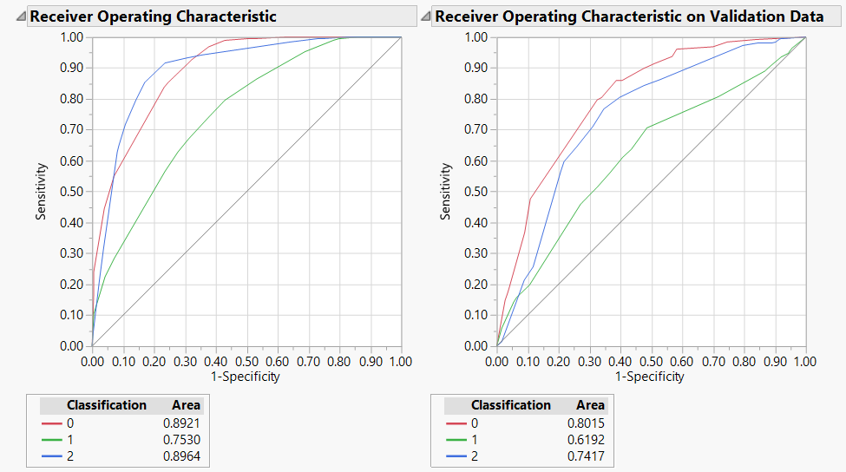

In the validation data, the AUC for Poor(0) movies is higher and that for the Average(1) movies is least. Hence, the model seems to predict movies with a poor rating with a better accuracy rate.

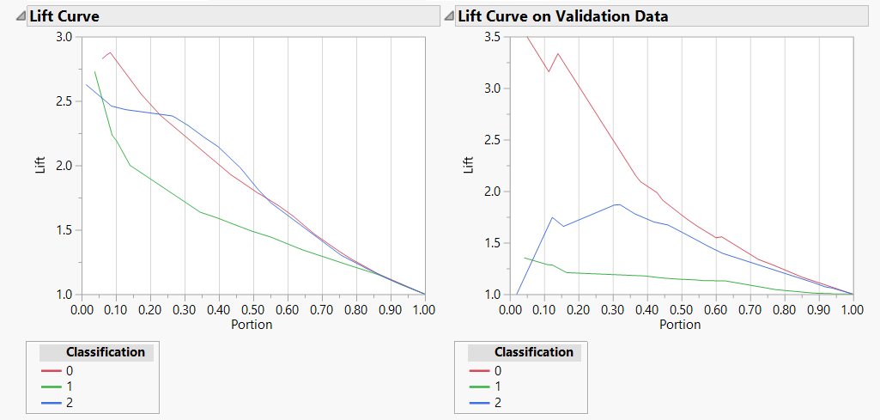

In the validation data, the model seems to perform well for 2s in the 1st decile,the lift value further increases to around 1.8 in the 4th decile after which it drops continuously. For Poor(0) movies there is a high value of lift of 3.5 in the 1st decile which then drops continuously across all deciles. For average(1) movies the lift value is close to 1.4 in the first decile, after which it decreases continuously across further deciles.

**Ensemble using Discriminant Analysis**

Since Discriminant Analysis had more accuracy when compared to Neural Network Analysis, we selected Discriminant Analysis for building an ensemble model.

Steps involved in doing ensembling using neural networks are as follows -

Analyze -> Multivariate Methods-> Discriminant

Select all the predictor variables and include them under the ‘Y,Covariates’ ,response variable ‘Classification’ under ‘X, Categories’ and the ‘Validation Stratified Classification’ under ‘Validation’ column and then ‘OK’.

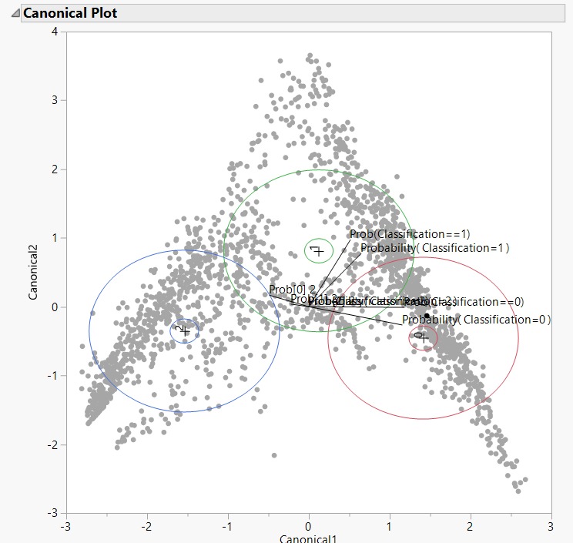

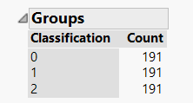

Confusion Matrix

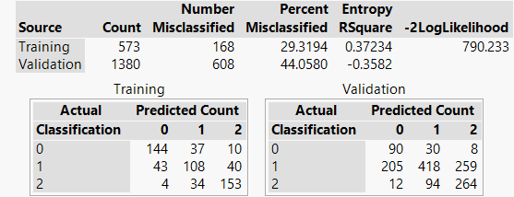

|  |  |  |  |
| --- | --- | --- | --- |
| Dataset/Misclassification Rate | 0 | 1 | 2 |
| Training | 25% | 43% | 20% |
| Validation | 30% | 53% | 29% |

From the observation above, the model seems to perform equally well in both the Training and the validation dataset.

The accuracy rate in the training data set is 71% and the validation data set is 60%.

Since the performance of the model across the training and validation datasets do not have a big difference, ‘overfitting’ has not occurred.

**However the Discriminant Analysis model has a marginally higher percent of accuracy(61.25%) than the Ensemble Model. Hence, the Discriminant Analysis Model can be used for classification for this dataset.**

Dataset with outliers removed and title_year < 2004

**Neural Network Analysis**

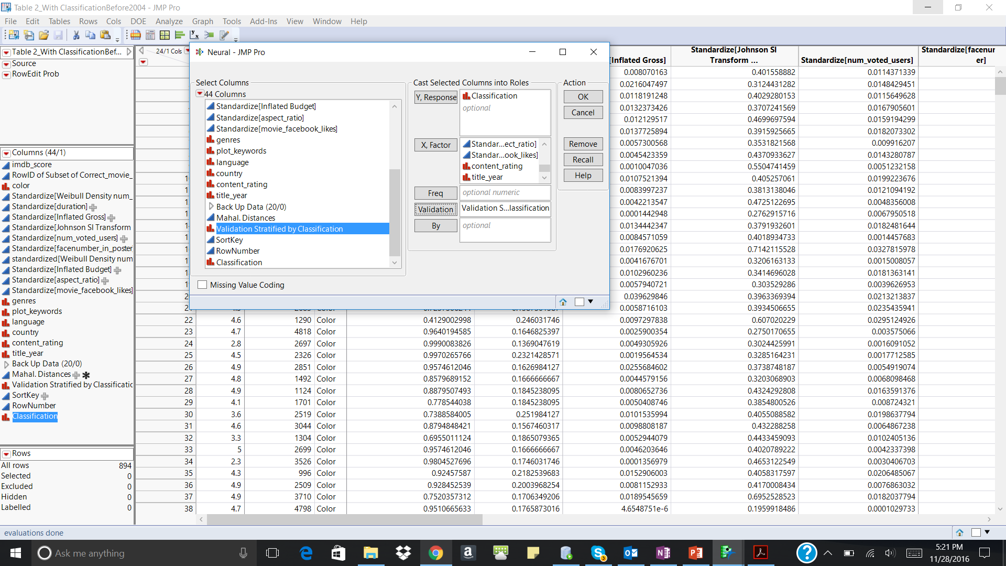

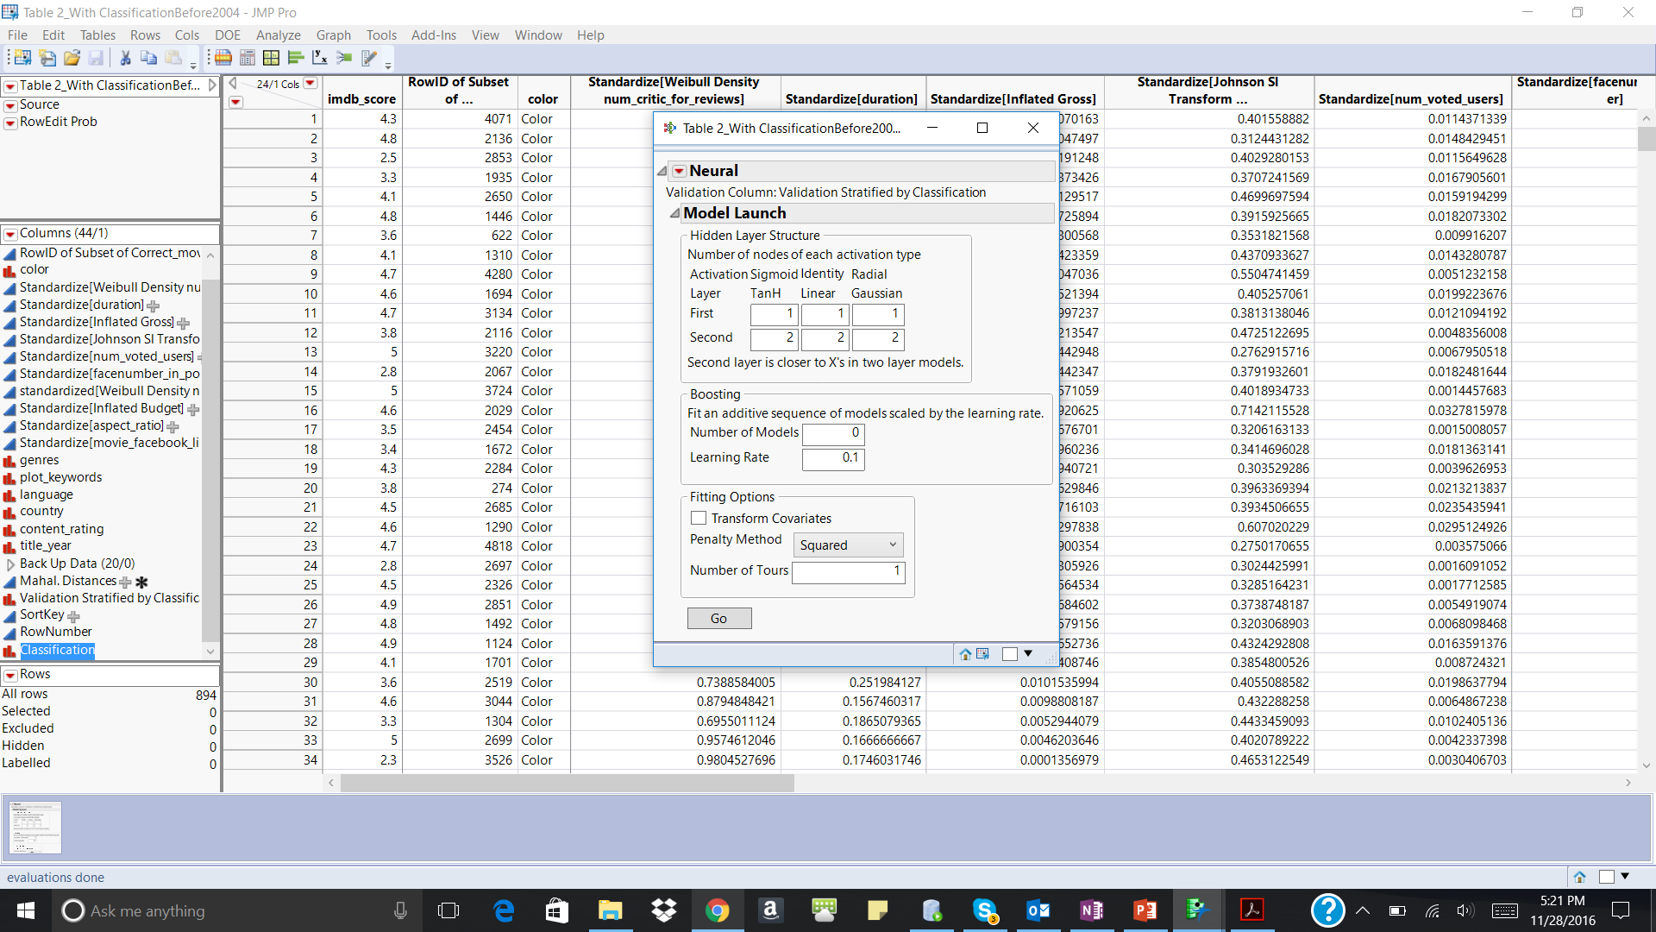

The model with the above complexity is chosen

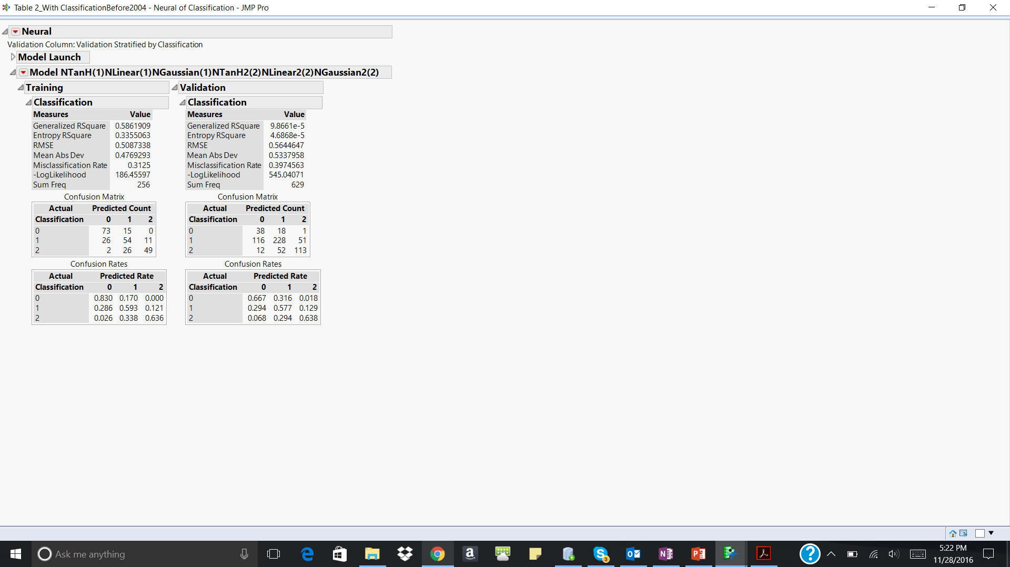

|  |  |  |  |
| --- | --- | --- | --- |
| Dataset/Misclassification Rate | 0 | 1 | 2 |
| Training | 17% | 41% | 36% |
| Validation | 33% | 42% | 36% |

The figure above shows the confusion rates for each prediction

The model performs almost equally good on the training and validation data with an accuracy of 60% and an accuracy of 69% for the training data.

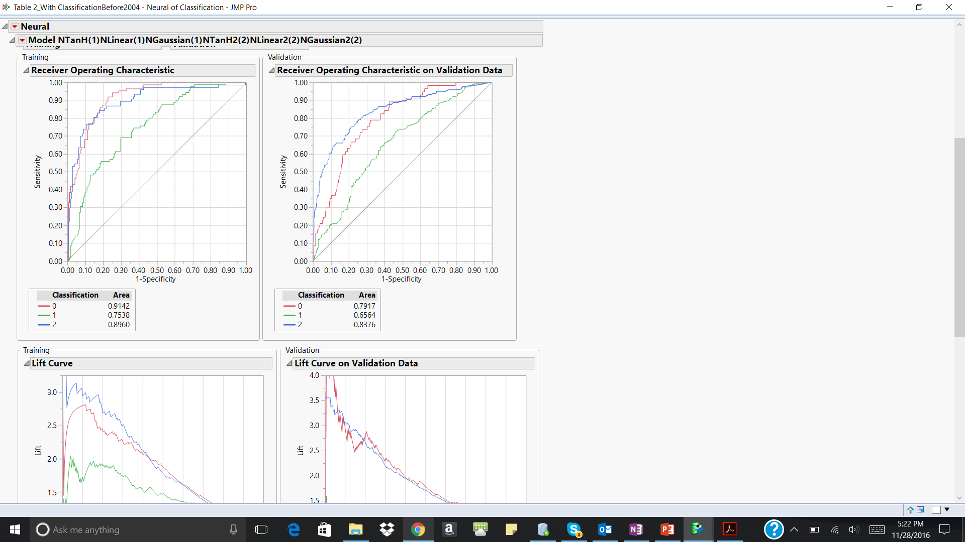

From the ROC curve above it is observed that the model more accurately classifies the movies as poor(0) and good(2) as compared to the average(1) rated movies

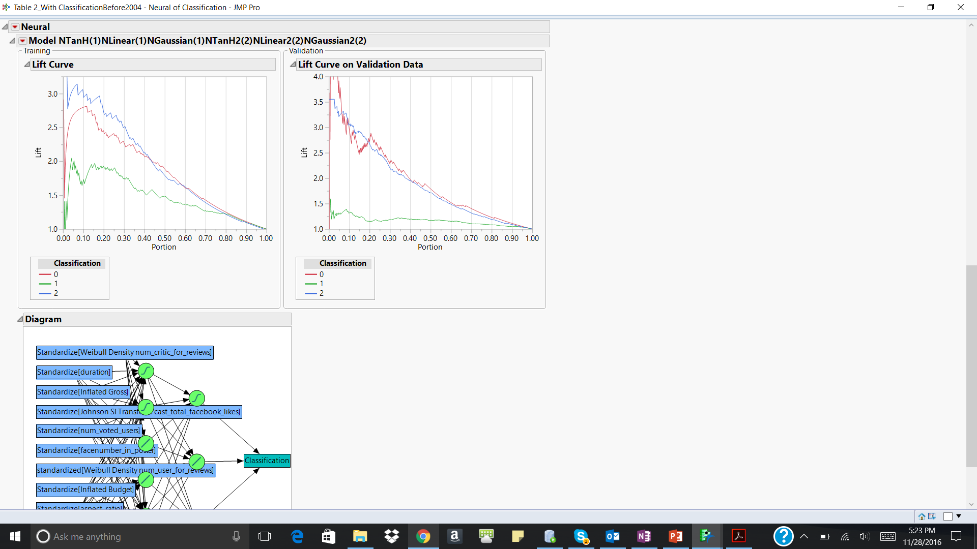

|  |  |  |
| --- | --- | --- |
| Classification | Training data | Validation data |
| 0 | The lift value is around 2.8 in the first decile and then constantly decreases across the other deciles | The lift value is very high(>4) in the first decile and then constantly decreases across the other deciles |
| 1 | The lift value ranges from 1.8 to 2.1 in the first decile and then constantly decreases across all the other deciles. | Even though the lift value is low when compared to 0s and 2s, it is consistent till the fifth decile and then reduces |
| 2 | The lift value is very high (>3) in the first decile but reduces consistently across all the other deciles | The lift value ranges from 3 to 3.5 in the first decile but reduces consistently in all the other deciles |

**Discriminant Analysis**

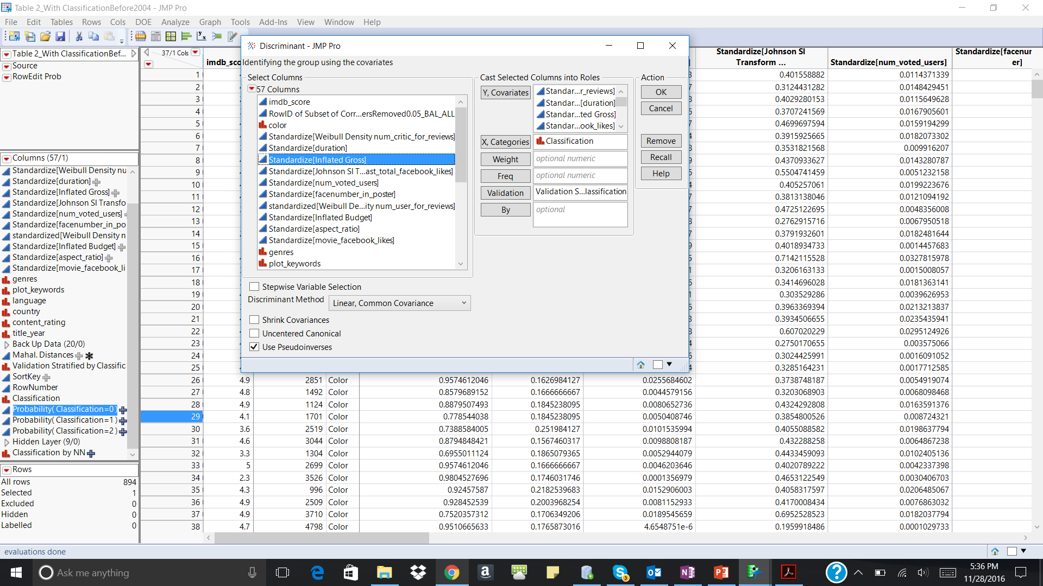

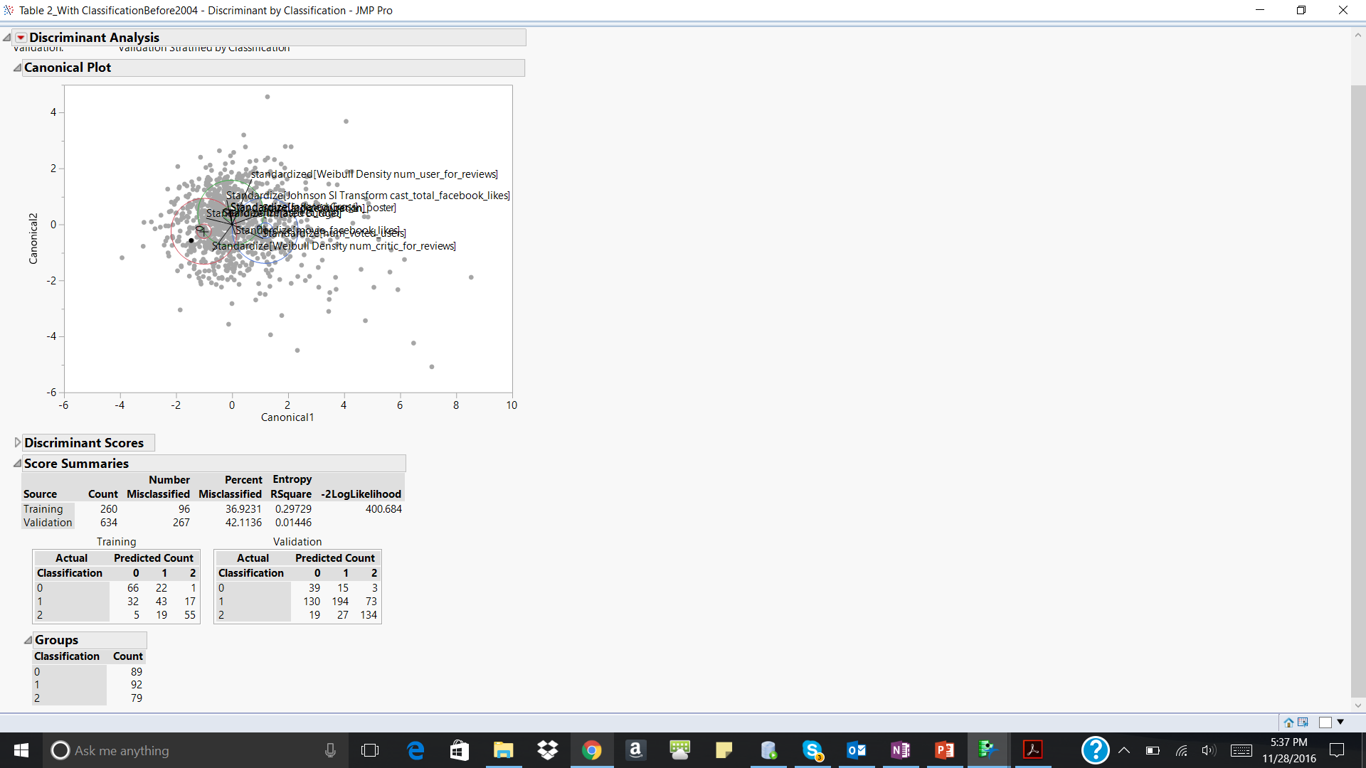

From the observation above, the model seems to perform almost equally well in both the Training and the validation dataset.

The accuracy rate in the training data set is 63% and the validation data set is 58%.

Since the performance of the model across the training and validation datasets do not have a big difference, ‘overfitting’ has not occurred. Hence, this model can be used for classification

**Decision Trees**

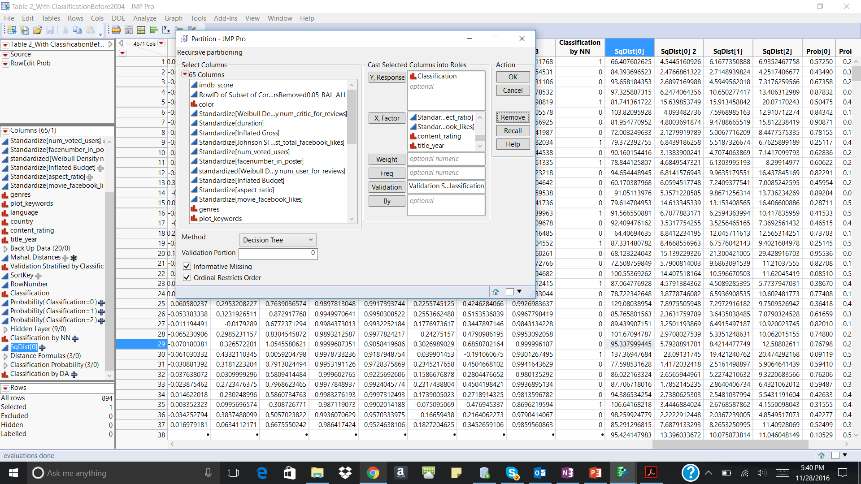

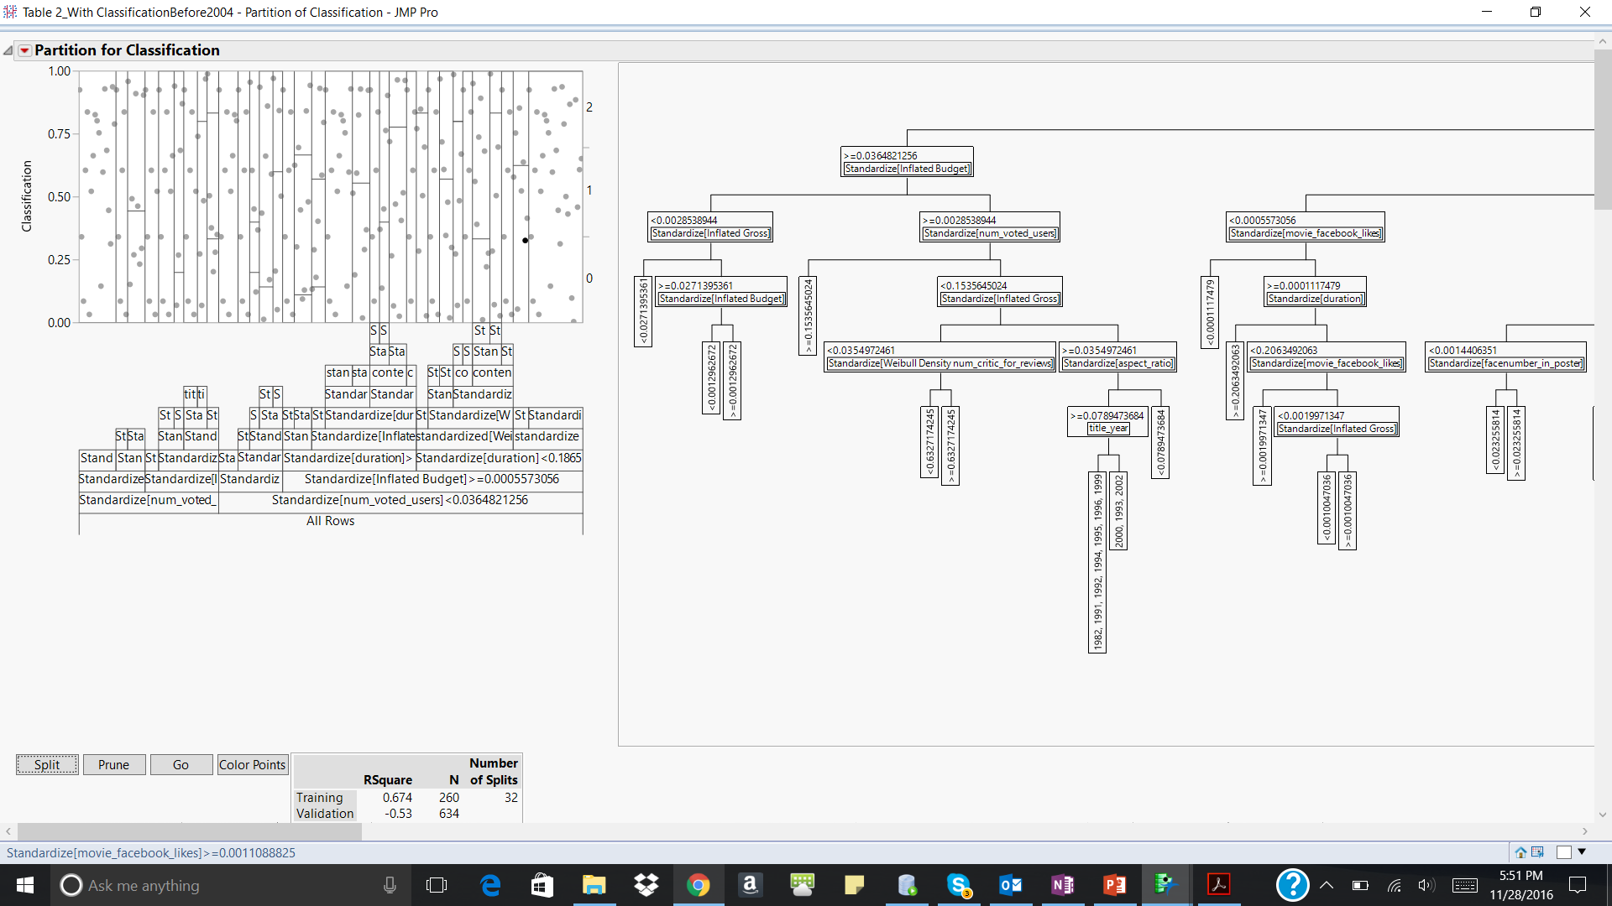

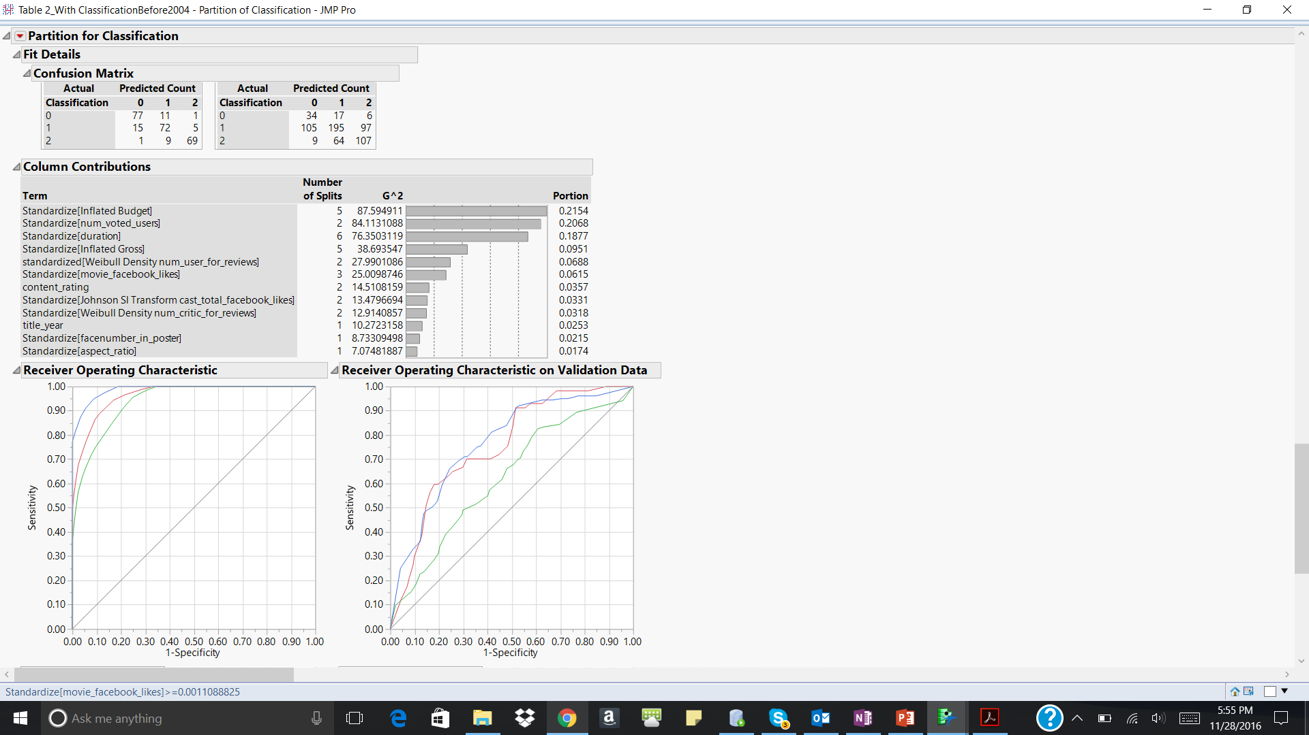 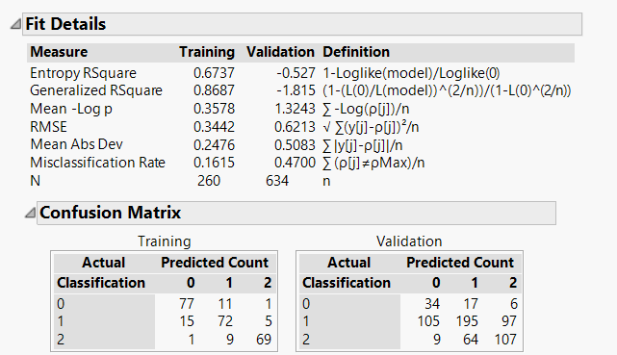

|  |  |  |  |
| --- | --- | --- | --- |
| Dataset/Misclassification Rate | 0 | 1 | 2 |
| Training | 13% | 22% | 13% |
| Validation | 40% | 51% | 41% |

A manual split is done to check the misclassification rate at the end of each split and the predictor variable which is contributing the most to the target variable.

From the figure above it can be seen that the budget has the most influence on the target variable - hence the first split is on this variable.

This model gives an accuracy rate of 0.53 and a misclassification rate of 0.47 on the validation data and it gives an accuracy rate of 0.84 and a misclassification rate of 0.16 on the training data.

There could be a case of overfitting in this scenario which can be seen from the ROC curve below.



Thus, we reduce the complexity of the model by not considering the predictor variables which do not have much influence on the target variable.

4 predictors which have the most contribution are considered for the analysis as shown below

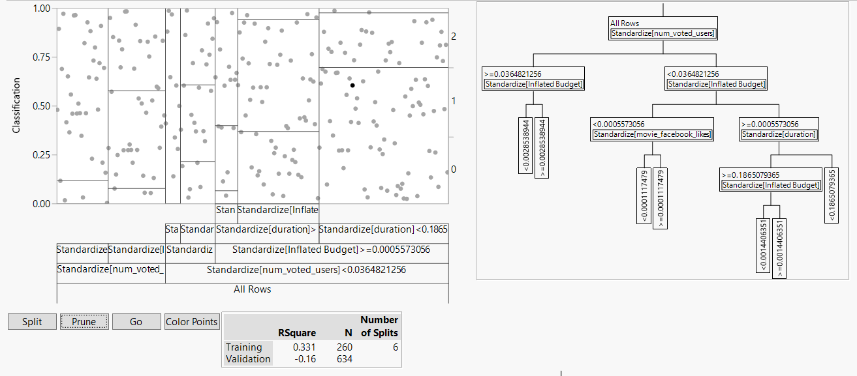

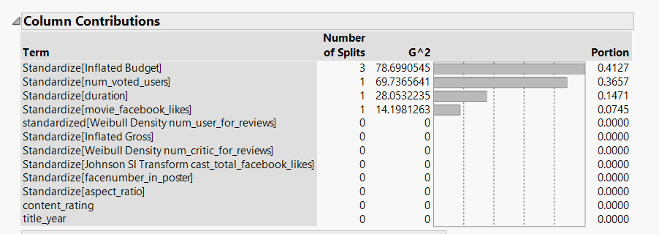

We get the below confusion matrix from the analysis

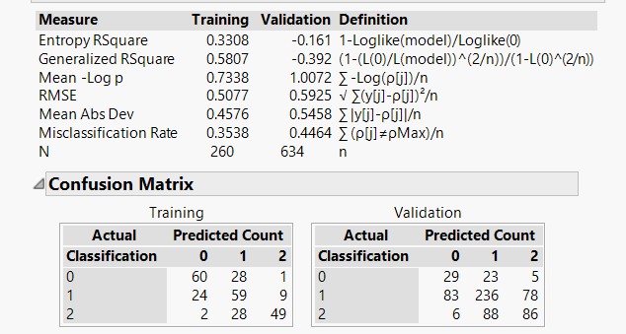

|  |  |  |  |
| --- | --- | --- | --- |
| Dataset/Misclassification Rate | 0 | 1 | 2 |
| Training | 33% | 36% | 38% |
| Validation | 49% | 41% | 52% |

This model gives an accuracy rate of 0.55 and a misclassification rate of 0.45 on the validation data and it gives an accuracy rate of 0.65 and a misclassification rate of 0.35 on the training data.

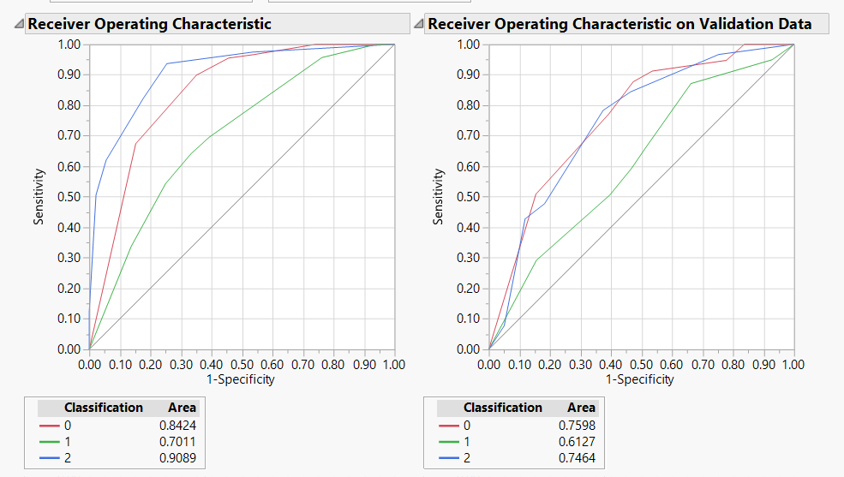

From the ROC curve above it can be seen that the model has a greater accuracy of classifying Poor(0) and Good(2) movies as compared to the Average(1) movies.

**Ensemble Neural Networks**

We consider the probabilities of the classifications from the previous models to build an ensemble model

The model with the below complexity is chosen

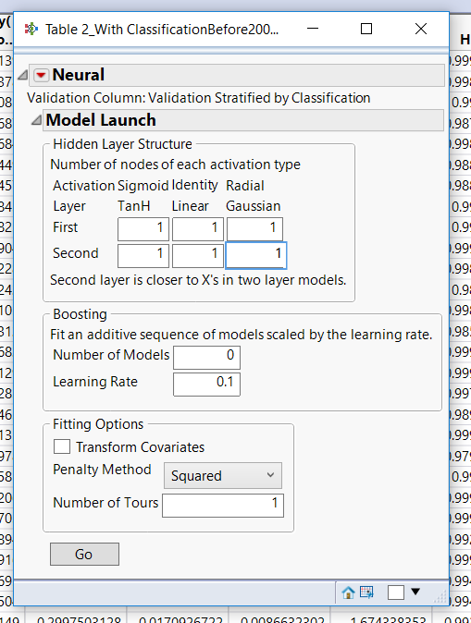 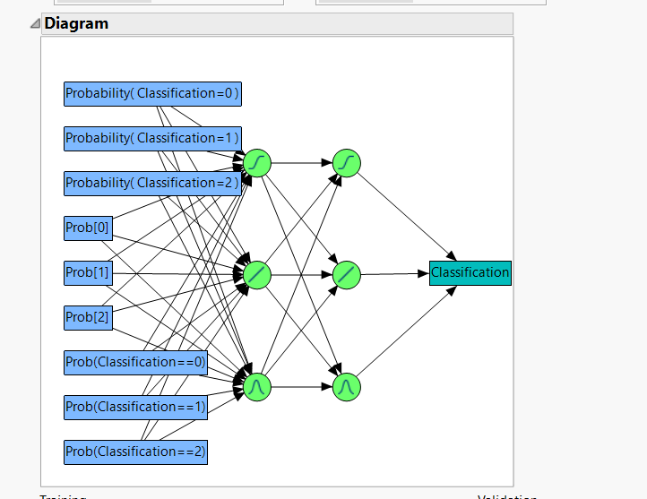

The confusion matrix is as below

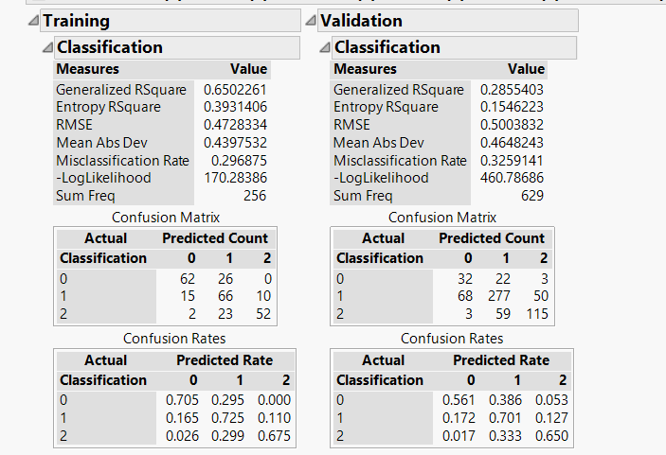

|  |  |  |  |
| --- | --- | --- | --- |
| Dataset/Misclassification Rate | 0 | 1 | 2 |
| Training | 30% | 28% | 33% |
| Validation | 44% | 30% | 35% |

The model performs almost equally well on the validation data as it does on the training data.

The model has an accuracy rate of 0.67and misclassification rate of 0.33 on validation dataset. It has an accuracy rate of 0.70 and misclassification rate of 0.30 on the training dataset.

**Since, the ensemble neural network analysis has a greater accuracy in classification as compared to the other analysis this model can be used for the dataset 3.**

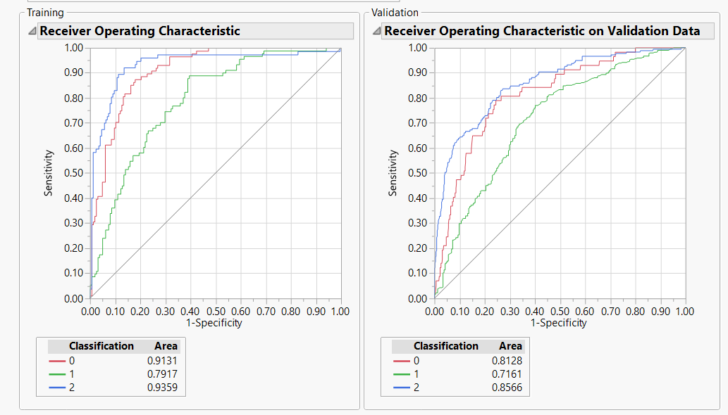

From the ROC curve above it can be seen that the model has a greater accuracy of classifying Poor(0) and Good(2) movies as compared to the Average(1) movies.

Dataset with outliers removed and title_year >=2004

**Neural Network Analysis**

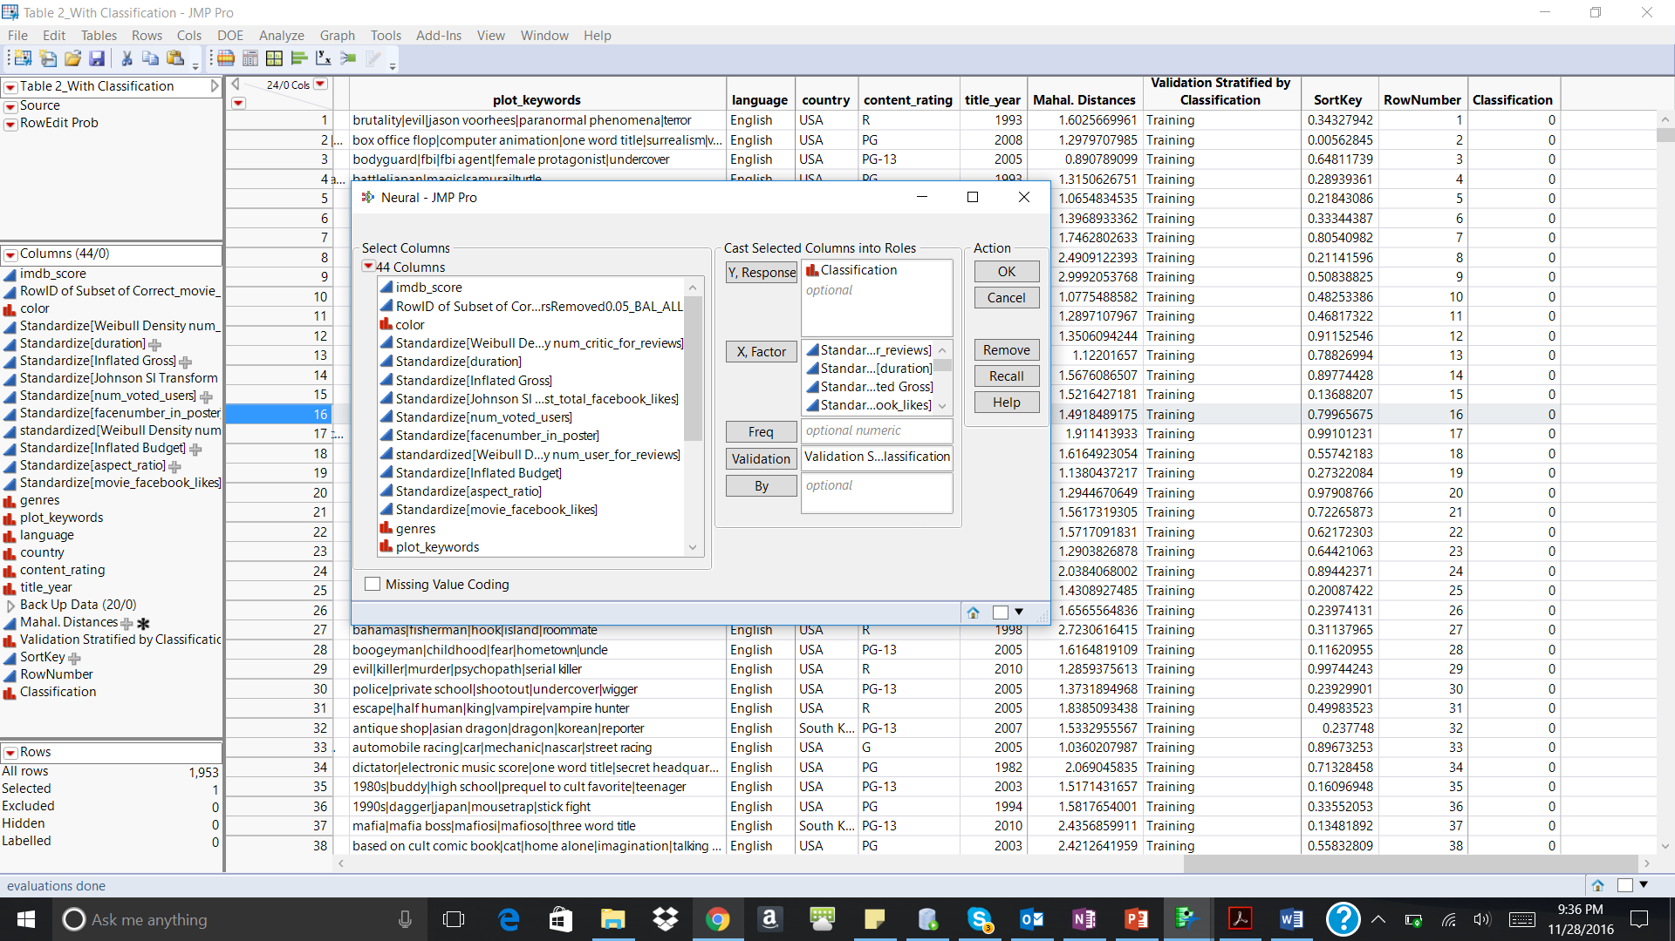

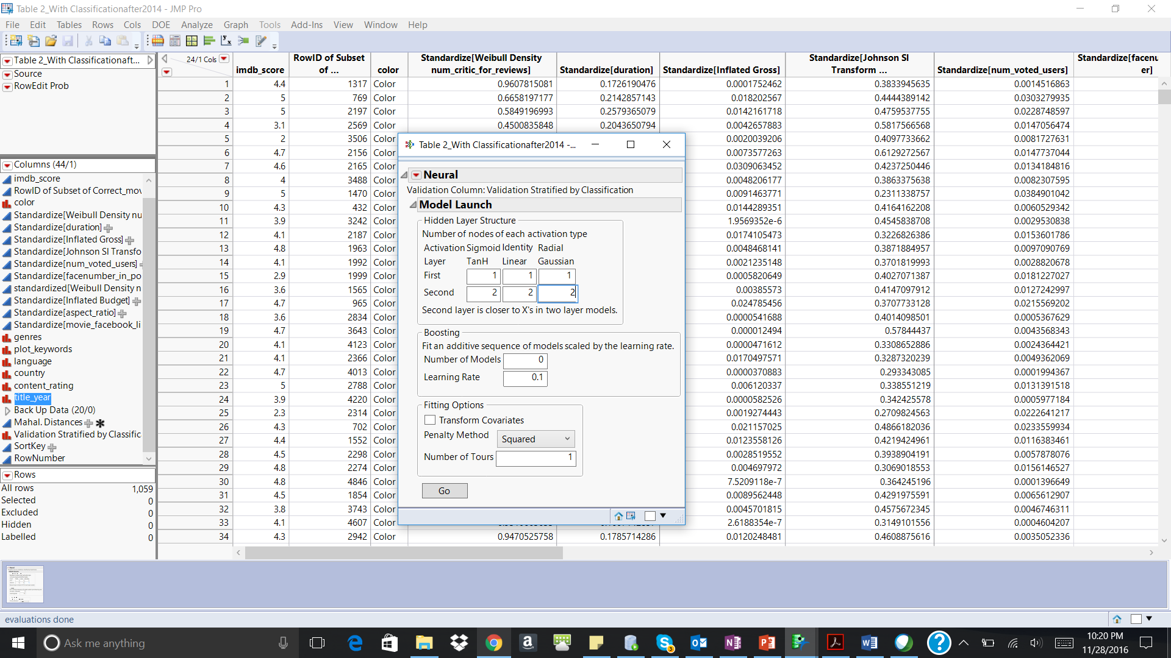

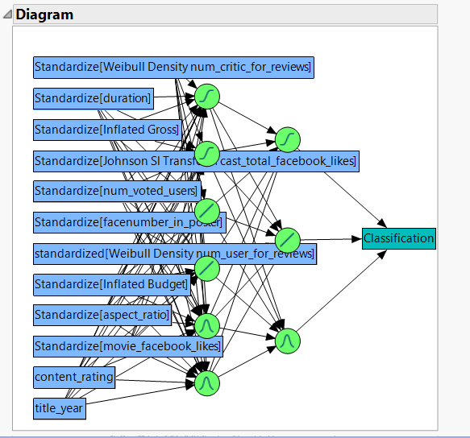

The model with the above complexity is chosen

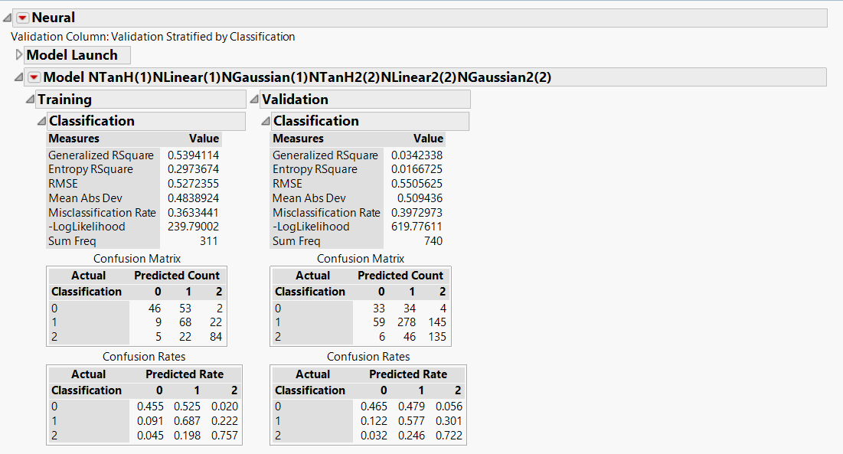

|  |  |  |  |
| --- | --- | --- | --- |
| Dataset/Misclassification Rate | 0 | 1 | 2 |
| Training | 54% | 31% | 24% |
| Validation | 54% | 42% | 28% |

The figure above shows the confusion rates for each prediction

The model performs almost equally good on the training and validation data with an accuracy of 60% on the validation data and an accuracy of 64% on the training data.

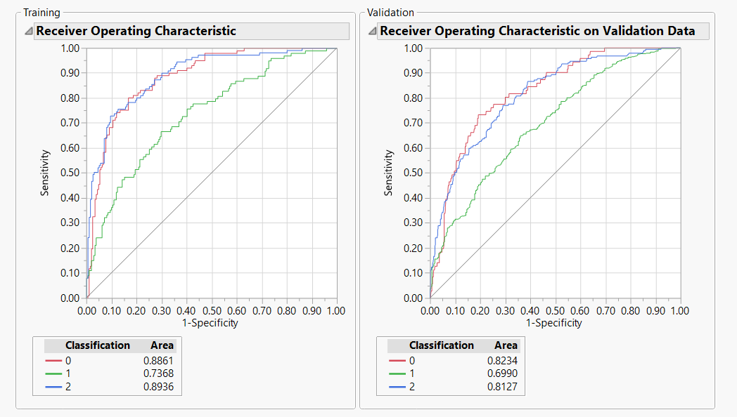

From the ROC curve above it is observed that the model more accurately classifies the movies as poor(0) and good(2) as compared to the average(1) rated movies

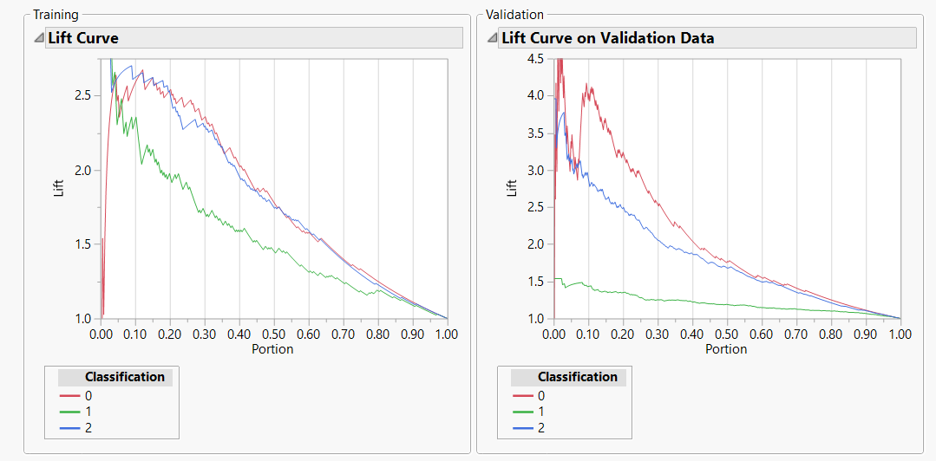

|  |  |  |
| --- | --- | --- |
| **Classification** | **Training data** | **Validation data** |
| 0 | The lift value varies between 1.5 to 2.6 in the first decile and then constantly decreases across the other deciles | The lift value varies between 4 - 4.5 in the first decile and then constantly decreases across the other deciles |
| 1 | The lift value ranges from 2.3 to over 2.5 in the first decile and then constantly decreases across all the other deciles. | The lift value reaches 1.6 in the first decile and then reduces constantly across all deciles |
| 2 | The lift value is very high (>2.5) in the first decile but reduces consistently across all the other deciles | The lift value ranges from 3.8 to 2.7 in the first decile but reduces consistently in all the other deciles |

**Discriminant Analysis**



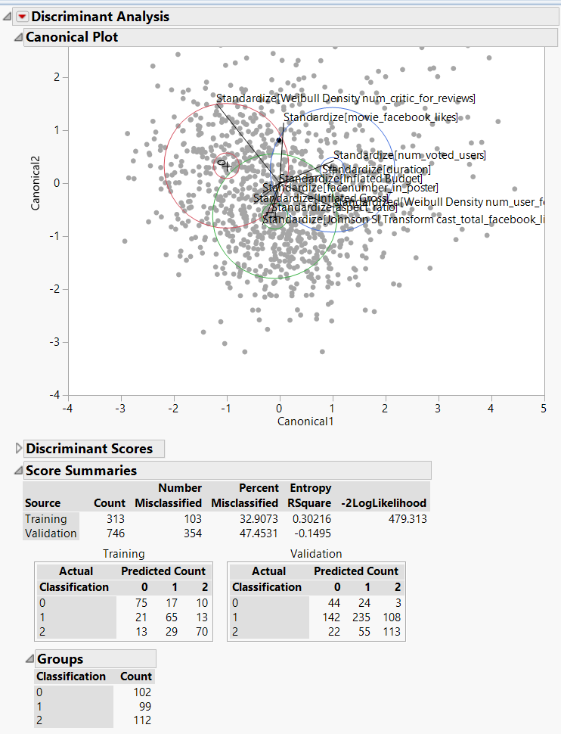

The confusion matrix is as shown above

|  |  |  |  |
| --- | --- | --- | --- |
| Dataset/Misclassification Rate | 0 | 1 | 2 |
| Training | 71% | 34% | 38% |
| Validation | 38% | 52% | 41% |

The accuracy rate in the training data set is 67% and the validation data set is 53%.

Since the model performs almost equally well on the training and validation data it can be considered for classification.

**Decision Trees**



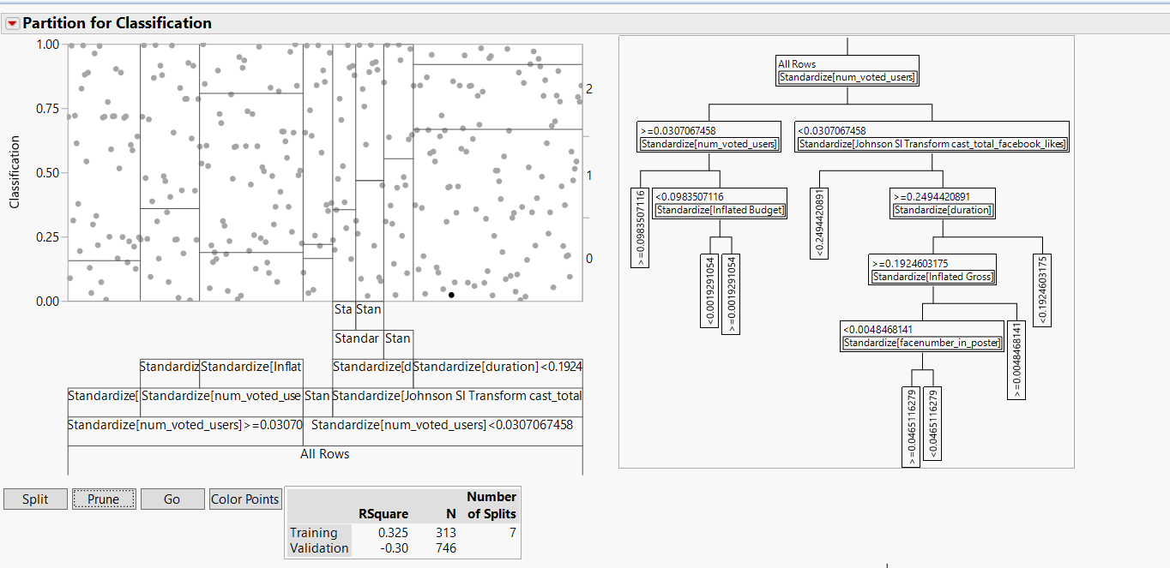

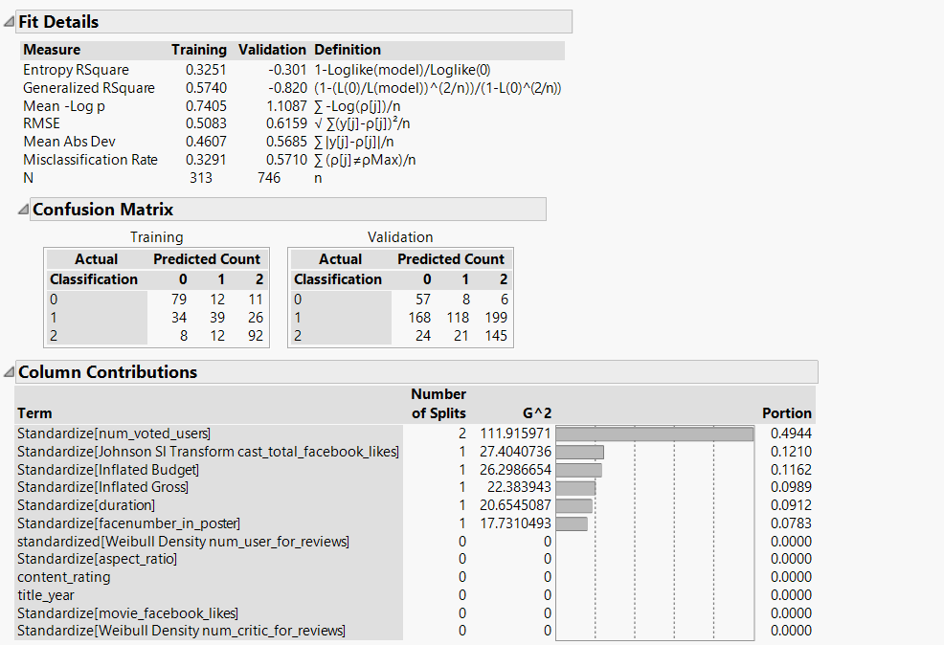

|  |  |  |  |
| --- | --- | --- | --- |
| Dataset/Misclassification Rate | 0 | 1 | 2 |
| Training | 23% | 61% | 18% |
| Validation | 20% | 76% | 24% |

A manual split is done to check the misclassification rate at the end of each split and the predictor variable which is contributing the most to the target variable.

From the figure above it can be seen that num_voted_users has the most influence on the target variable - hence the first split is on this variable.

This model gives an accuracy rate of 0.43 and a misclassification rate of 0.57 on the validation data and it gives an accuracy rate of 0.67 and a misclassification rate of 0.33 on the training data.

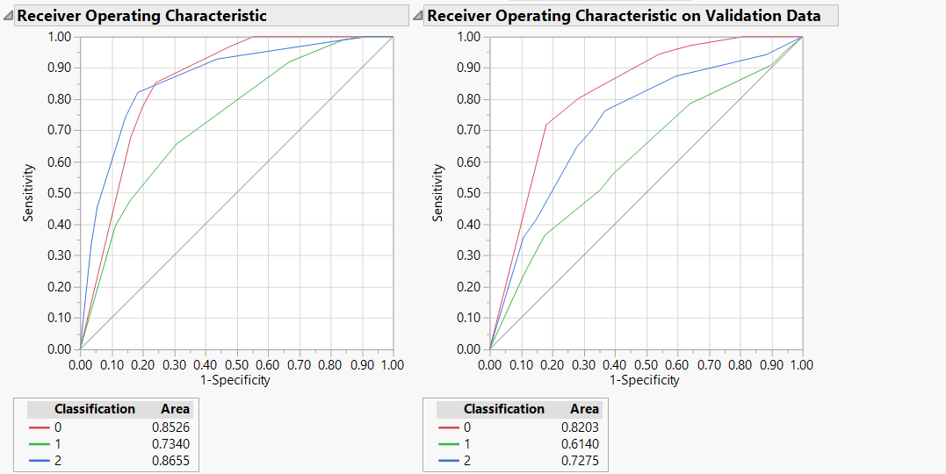

From the ROC curve above it is observed that the model more accurately classifies the movies as poor(0) and good(2) as compared to the average(1) rated movies

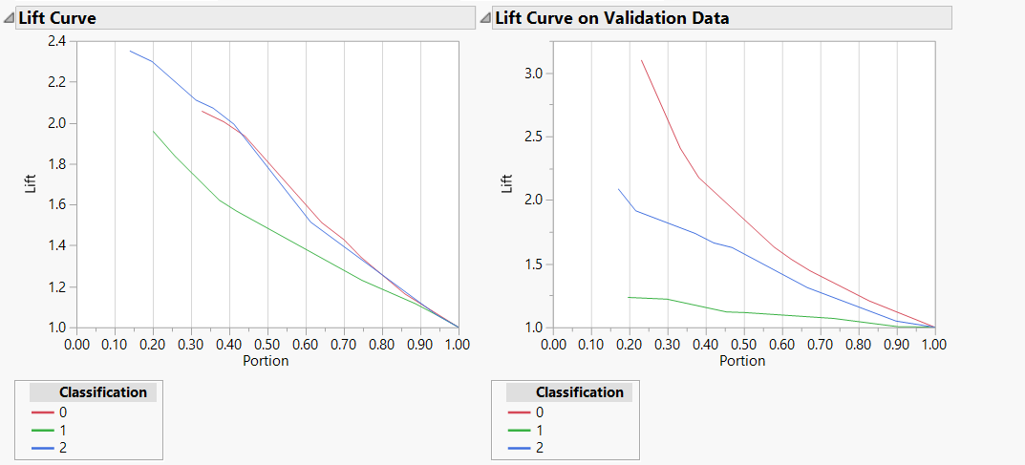

The lift value for the Average rated movies is over 1.2 in the 2nd decile and drops continuously after that. The lift value of the Good rated movies is over 2 in the 2nd decile and drops continuously post that . For the average rated movies the lift value is over 3 in the 3rd decile and drops continuously post that.

**Ensemble Neural Networks**

The model is built with the complexity below

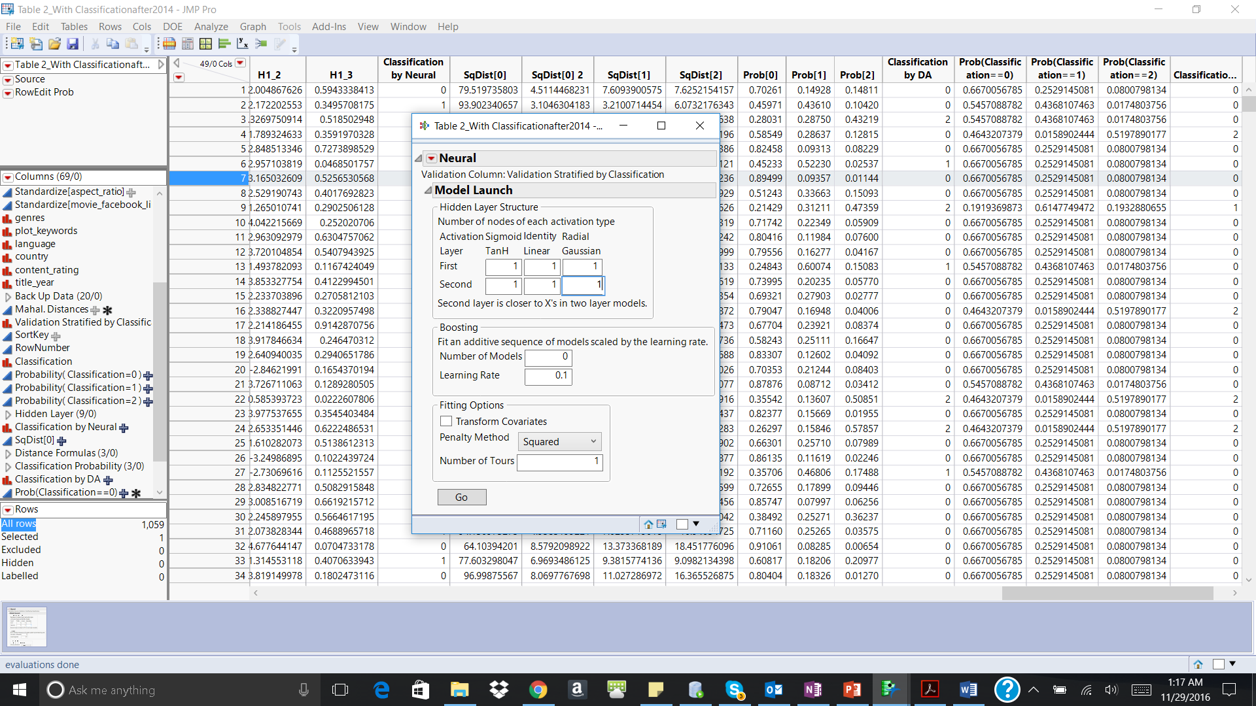

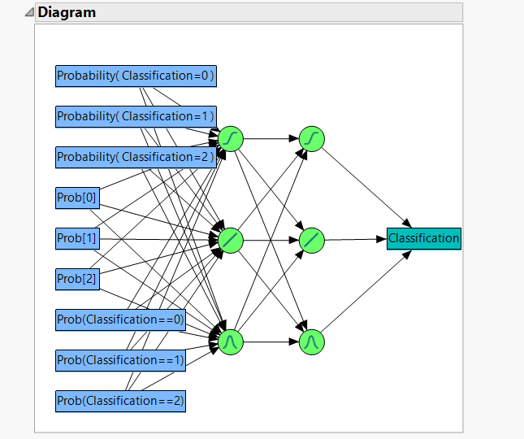

The below figure shows the confusion rates for each predictions

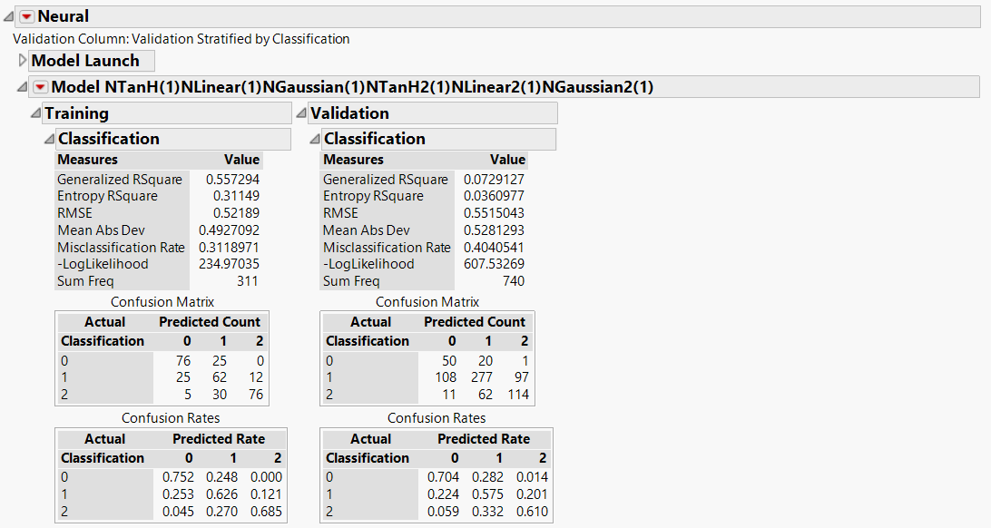

|  |  |  |  |
| --- | --- | --- | --- |
| Dataset/Misclassification Rate | 0 | 1 | 2 |
| Training | 71% | 34% | 38% |
| Validation | 38% | 52% | 41% |

The model performs almost equally good on the training and validation data with an accuracy of 60% on the validation data and 69% on the training data.

Since both the ensemble neural network model and the neural network model have the same accuracy rate, either of the models can be used for classification of dataset 3.

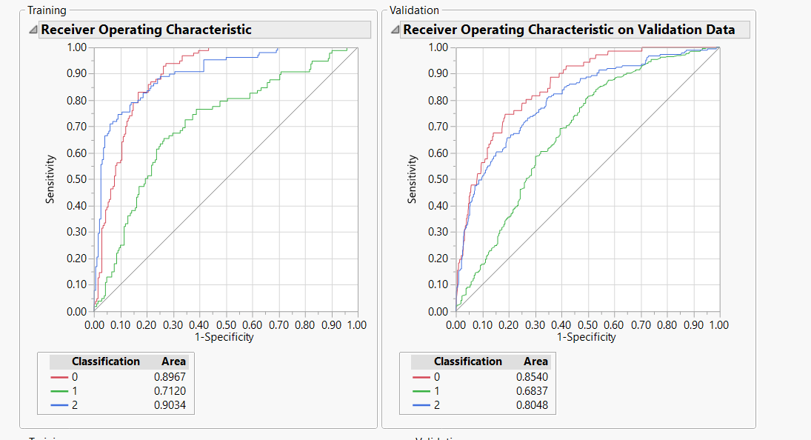

The accuracy of prediction of Poor(0) and Good(2) movies are comparatively high as compared to average(1) movies

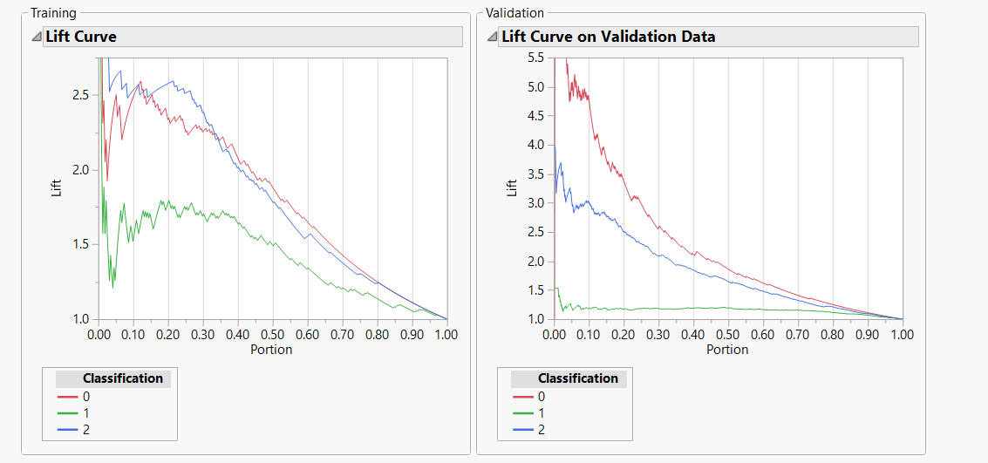

The lift value for the Average rated movies is between 1.6 and 1.2 in the first decile and drops post that and remains constant. The lift value for the Good rated movies is between 3 and 3.8 in the first decile and drops continuously post that.For the average rated movies the lift value is between 4.5 to 5.5 in the 1st decile and drops continuously post that.

## 2. Regression Models

Using the dataset created in the exploratory analysis, the following were selected as the explanatory variables.

**Figure 4.1:**

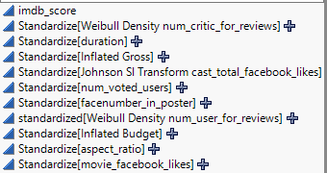

Firstly, we split dataset into two groups, Training and Testing and would adopt K-folder testing in stepwise to decrease the possibility of overfitting.

**Figure 4.2: dataset splitting:**

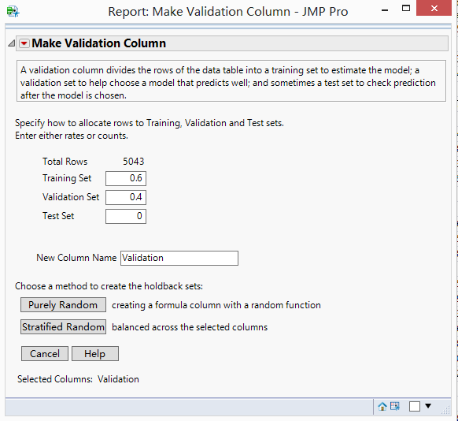 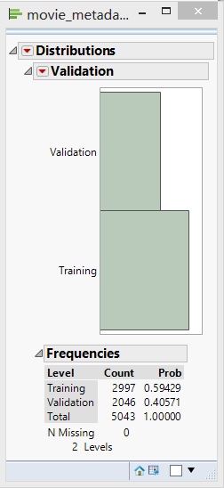

**Figure 4.3: distribution of “imdb_score”:**

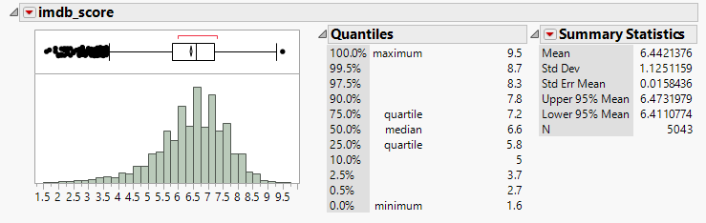

Given the distribution of imdb_score, the average mean is almost equal to median of population and upper 95% mean is similarly same as lower 95% mean. So, we can assume that the target variable follows normal distribution.

Based on that observation, we mainly check the three models for training and validation data,

1. Generalized Regression for Normal distribution target variable.(GR)
2. Standard Least Squares with minimal report. (SLS)
3. Neural Net (NN)

To increase accuracy of model, we use stepwise with k-folder cross validation to determine the variables which contribute most in model. Based on this analysis, all the variables were used for model building exercise. Using the **whole dataset with ouliers**, below are the summaries for the 3 models.

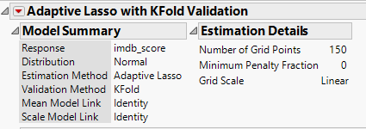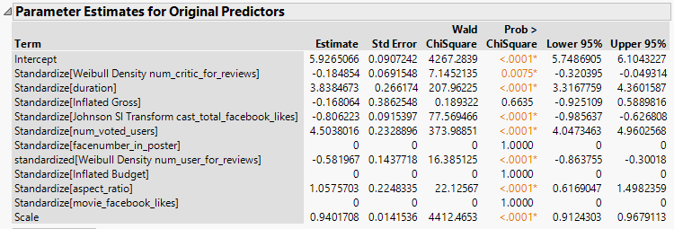

**Figure 4.7: Generalized Regression (3)**

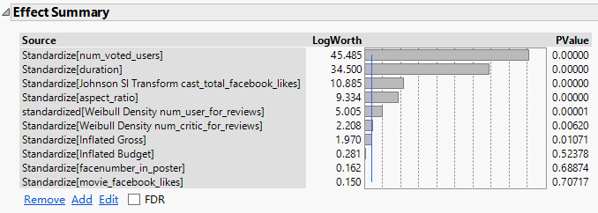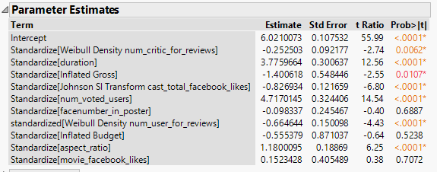

**Figure 4.8: Standard Least Squares (3):**

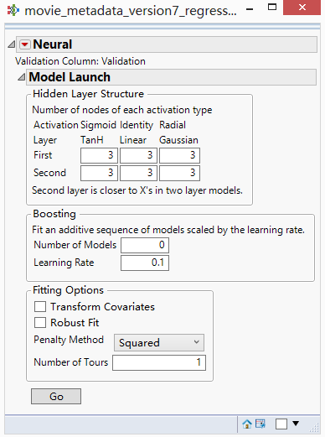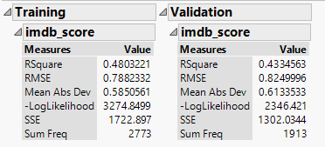

**Figure 4.9: Neural Net (3):**

**Figure 4.10 : Ensemble Generalized Regression (1):**

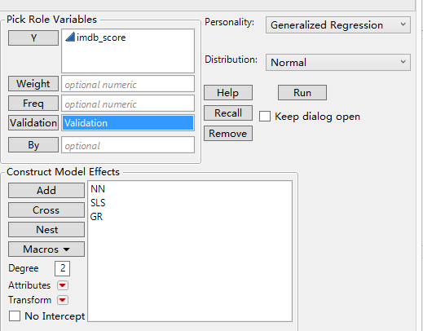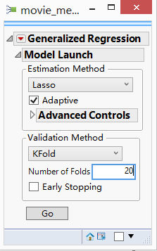

**Figure 4.10 : Ensemble Generalized Regression (2):**

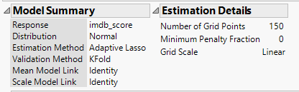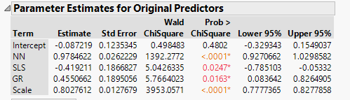

Below are the performance metrics of each of the model run:

|  |  |  |  |  |
| --- | --- | --- | --- | --- |
| **RSquare Calculation** | **GR** | **SLS** | **NN** | **Ensemble GR** |
| **Training** | 0.348972 | 0.352135 | 0.4954444 | 0.545071 |
| **Rank in Training** | 4 | 3 | 2 | 1 |
| **RSquare**  **Validation** | 0.341445 | 0.341058 | 0.43913 | 0.499421 |
| **Rank in Validation** | 3 | 4 | 2 | 1 |

We can see result based on RSquare metric. The Ensemble Generalized Regression model is best model for this dataset.

Below are the performance metrics of each of the models run for movies released **before 2004 and on data having outliers:**

|  |  |  |  |  |
| --- | --- | --- | --- | --- |
| **RSquare Calculation** | **GR** | **SLS** | **NN** | **Ensemble GR** |
| **Training** | 0.294801 | 0.301529 | 0.604691 | 0.642202 |
| **Rank in Training** | 4 | 3 | 2 | 1 |
| **RSquare**  **Validation** | 0.278873 | 0.276995 | 0.4856404 | 0.522066 |
| **Rank in Validation** | 4 | 3 | 2 | 1 |

We can see result based on RSquare metric. The Ensemble Generalized Regression model is best model for this dataset.

Below are the performance metrics of each of the models run for movies released **after 2004 and on data having outliers:**

|  |  |  |  |  |
| --- | --- | --- | --- | --- |
| **RSquare Calculation** | **GR** | **SLS** | **NN** | **Ensemble GR** |
| **Training** | 0.303529 | 0.304471 | 0.442976 | 0.523765 |
| **Rank in Training** | 4 | 3 | 2 | 1 |
| **RSquare**  **Validation** | 0.327148 | 0.321649 | 0.4128989 | 0.535395 |
| **Rank in Validation** | 3 | 4 | 2 | 1 |

We can see result based on RSquare metric. The Ensemble Generalized Regression model is best model for this dataset.

Below are the performance metrics of each of the models run for movies **on data without outliers:**

|  |  |  |  |  |
| --- | --- | --- | --- | --- |
| **RSquare Calculation** | **GR** | **SLS** | **NN** | **Ensemble GR** |
| **Training** | 0.310591 | 0.312118 | 0.453157 | 0.454684 |
| **Rank in Training** | 4 | 3 | 2 | 1 |
| **RSquare**  **Validation** | 0.305628 | 0.300393 | 0.465969 | 0.466623 |
| **Rank in Validation** | 4 | 3 | 2 | 1 |

We can see result based on RSquare metric. The Ensemble Generalized Regression model is best model for this dataset.

Below are the performance metrics of each of the models run for movies released **before 2004 and on data without outliers:**

|  |  |  |  |  |
| --- | --- | --- | --- | --- |
| **RSquare Calculation** | **GR** | **SLS** | **NN** | **Ensemble GR** |
| **Training** | 0.352083 | 0.354167 | 0.6263621 | 0.588542 |
| **Rank in Training** | 4 | 3 | 1 | 2 |
| **RSquare**  **Validation** | 0.360947 | 0.357988 | 0.4424563 | 0.460059 |
| **Rank in Validation** | 3 | 4 | 2 | 1 |

We can see result based on RSquare metric. The Ensemble Generalized Regression model is best model for this dataset.

Below are the performance metrics of each of the models run for movies released **after 2004 and on data without outliers:**

|  |  |  |  |  |
| --- | --- | --- | --- | --- |
| **RSquare Calculation** | **GR** | **SLS** | **NN** | **Ensemble GR** |
| **Training** | 0.319962 | 0.319962 | 0.499522 | 0.505253 |
| **Rank in Training** | 4 | 3 | 2 | 1 |
| **RSquare**  **Validation** | 0.348578 | 0.348578 | 0.551298 | 0.55377 |
| **Rank in Validation** | 4 | 3 | 2 | 1 |

We can see result based on RSquare metric. The Ensemble Generalized Regression model is best model for this dataset.

## 3. Logistic Regression

The movies were classified on the following basis –

We included the derived column ‘Classification’ with the formula shown below :

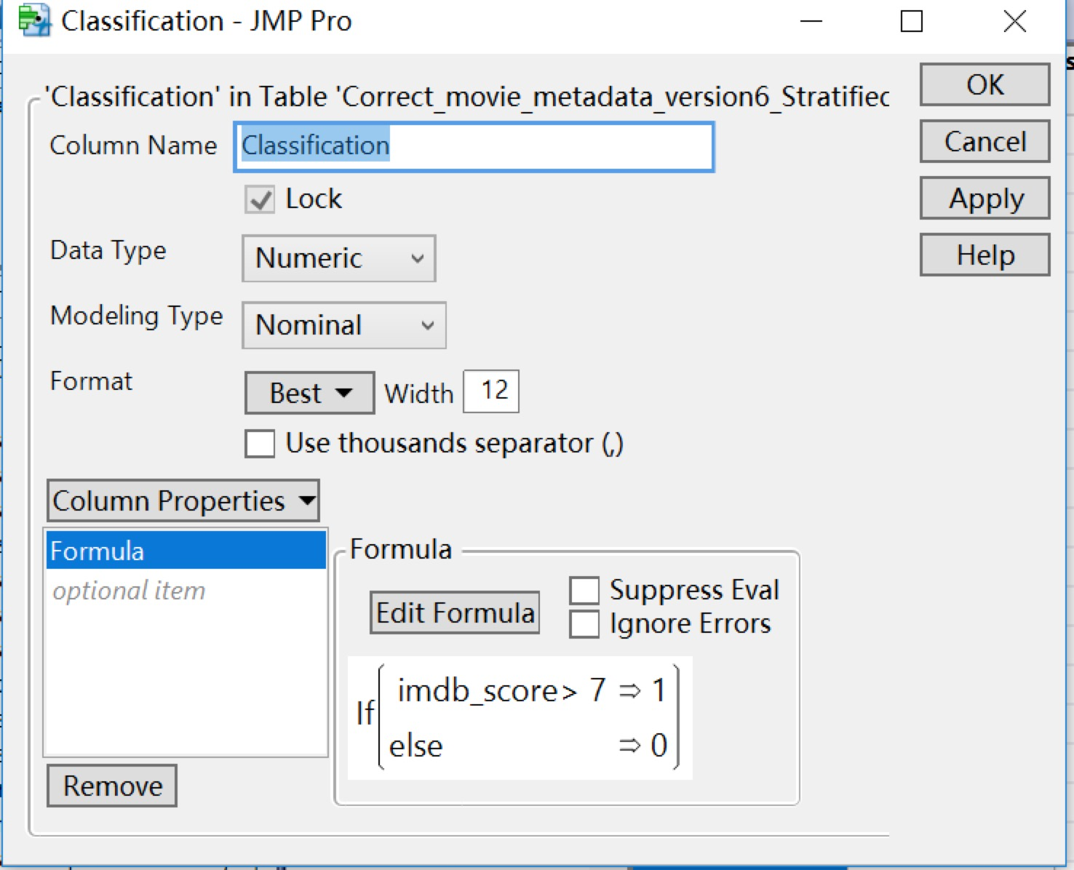

Following are the conventions used:

0 - bad

1 – good

*Note: bad and good will be denoted as 0 and 1 respectively in the rest of the document*

Hence, we used ‘Classification’ as the target variable for our classification model. The distribution of the ‘classification’ column is given below -

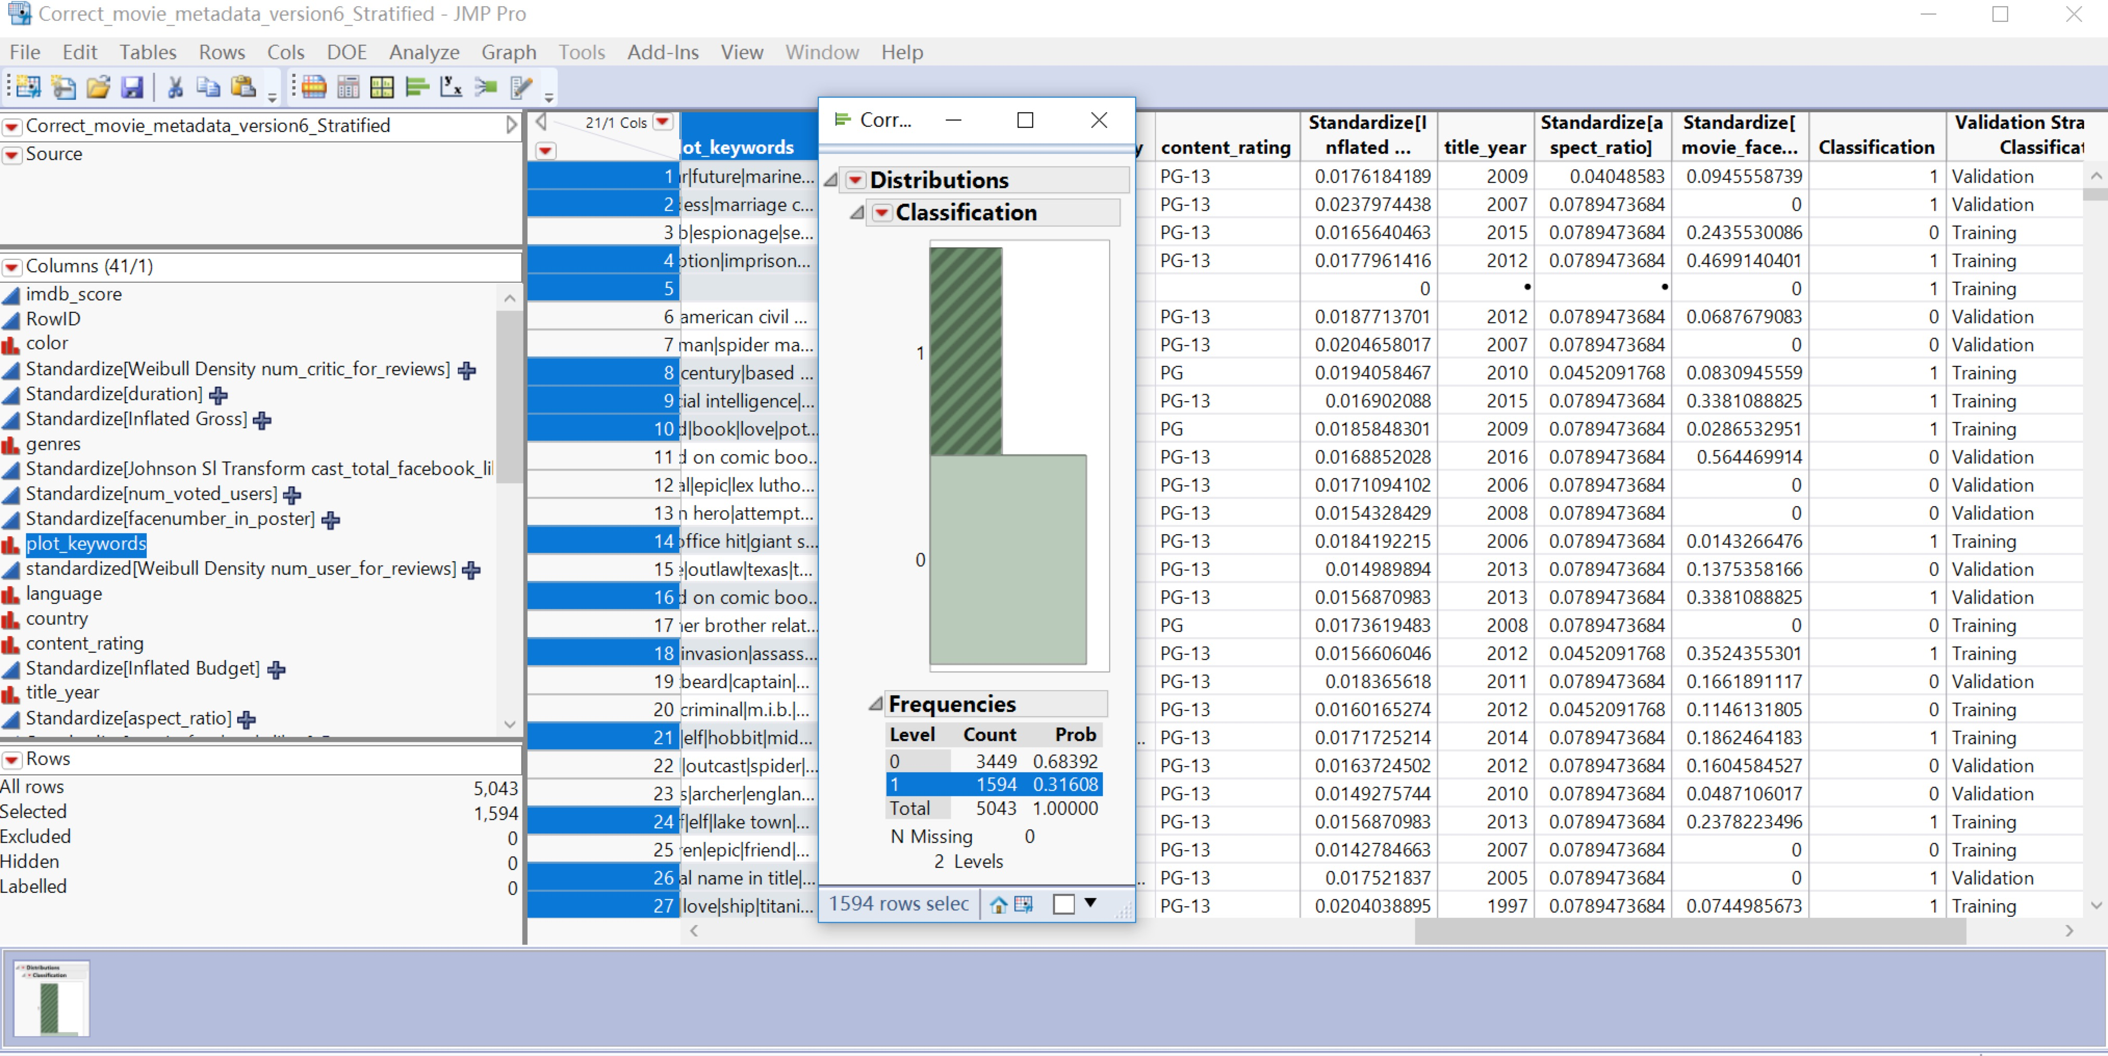

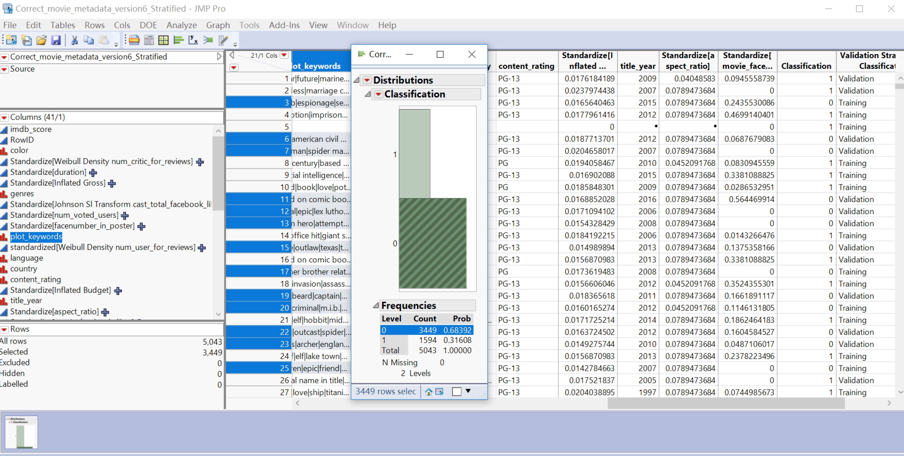

Before we start to build a model, we need to determine the training, validation and test dataset.

Since the size of the dataset is 5043 only, we decided divide the data as training and validation dataset only.

As observed in fig.(x- need to include the fig. number here), it is an unbalanced dataset. Thus, a balanced dataset needs to be obtained through stratified sampling for training the model.

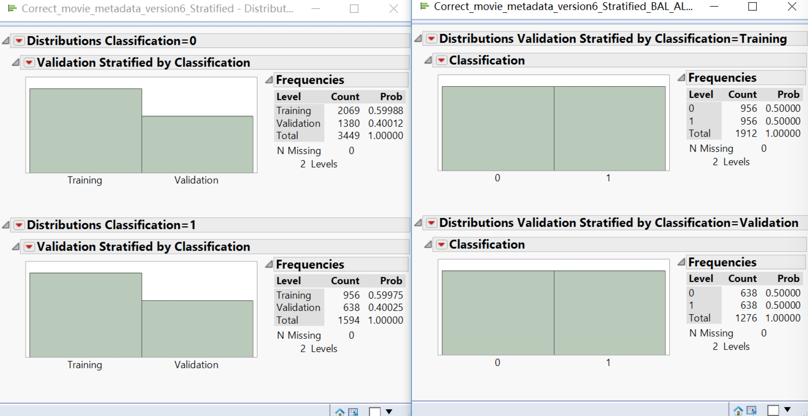

Analyze -> Fit Model

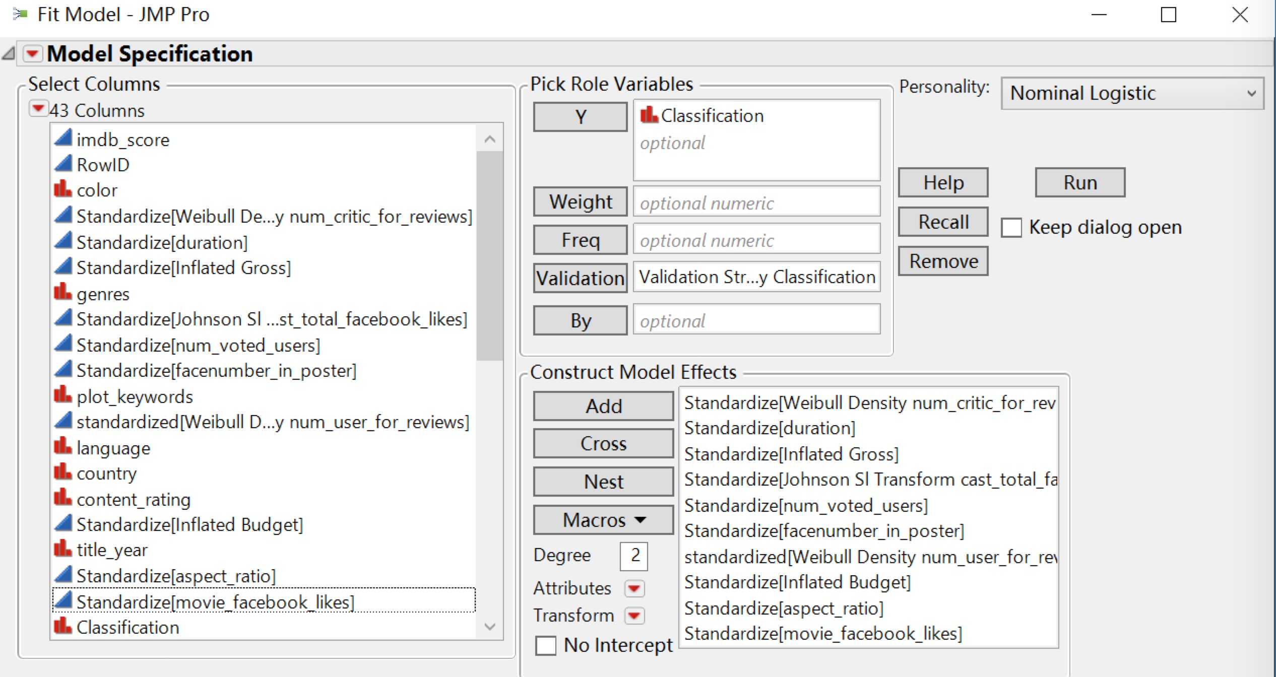

Select all the predictor variables and click “Add”, response variable ‘Classification’ under ‘Y and the ‘Validation Stratified Classification’ under ‘Validation’ column and then click ‘Run’.

From the ROC curve above it is observed that the model exactly euqally accurately classifies the movies as bad (0) as compared to the good (1) rated movies

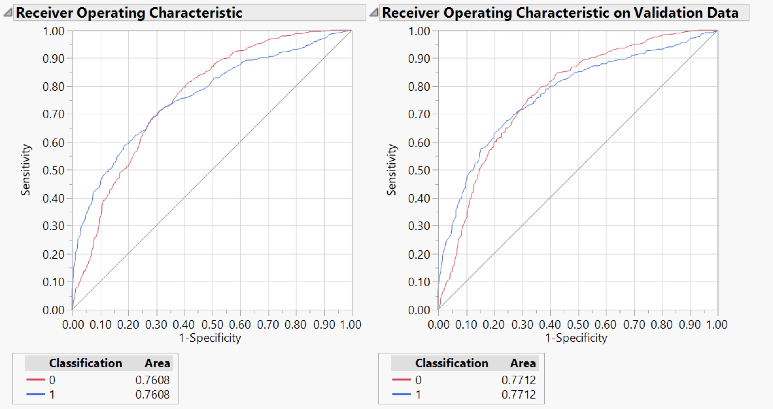

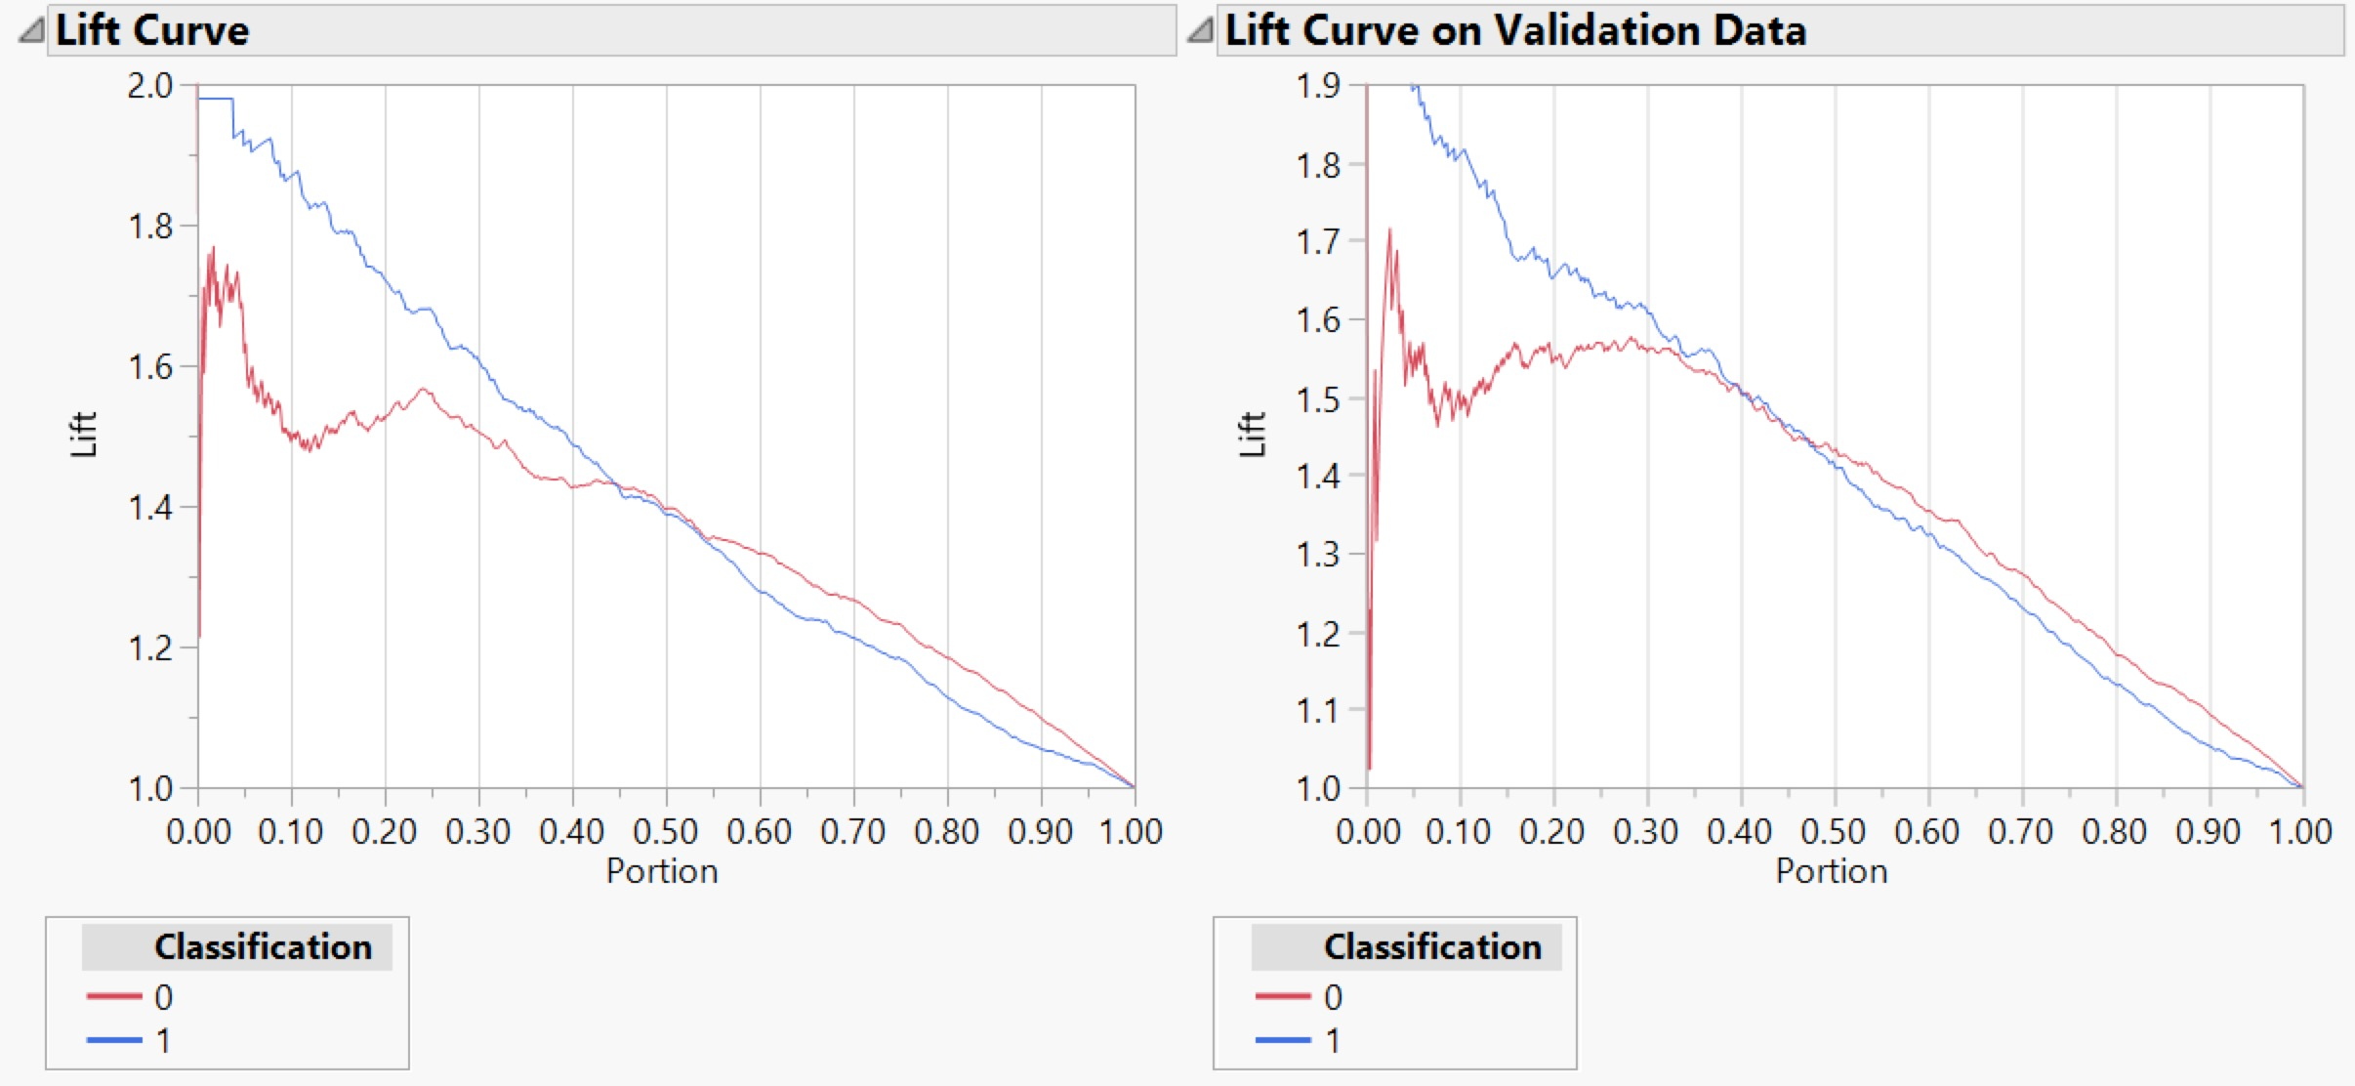

|  |  |  |
| --- | --- | --- |
| Classification | Training data | Validation data |
| 0 | The lift value is around 1.6 on an average across the first three decile and then constantly decreases across the other deciles | The lift value is constant for the third decile and then constantly decreases across the other deciles. It varies from 1.3 to 1.7 in the first decile. |
| 1 | The lift value is very high in the first decile but reduces consistently across all the other deciles | The lift value is more than 1.9 in the first decile but reduces consistently in all the other deciles |

The below figure shows the confusion rates for each prediction

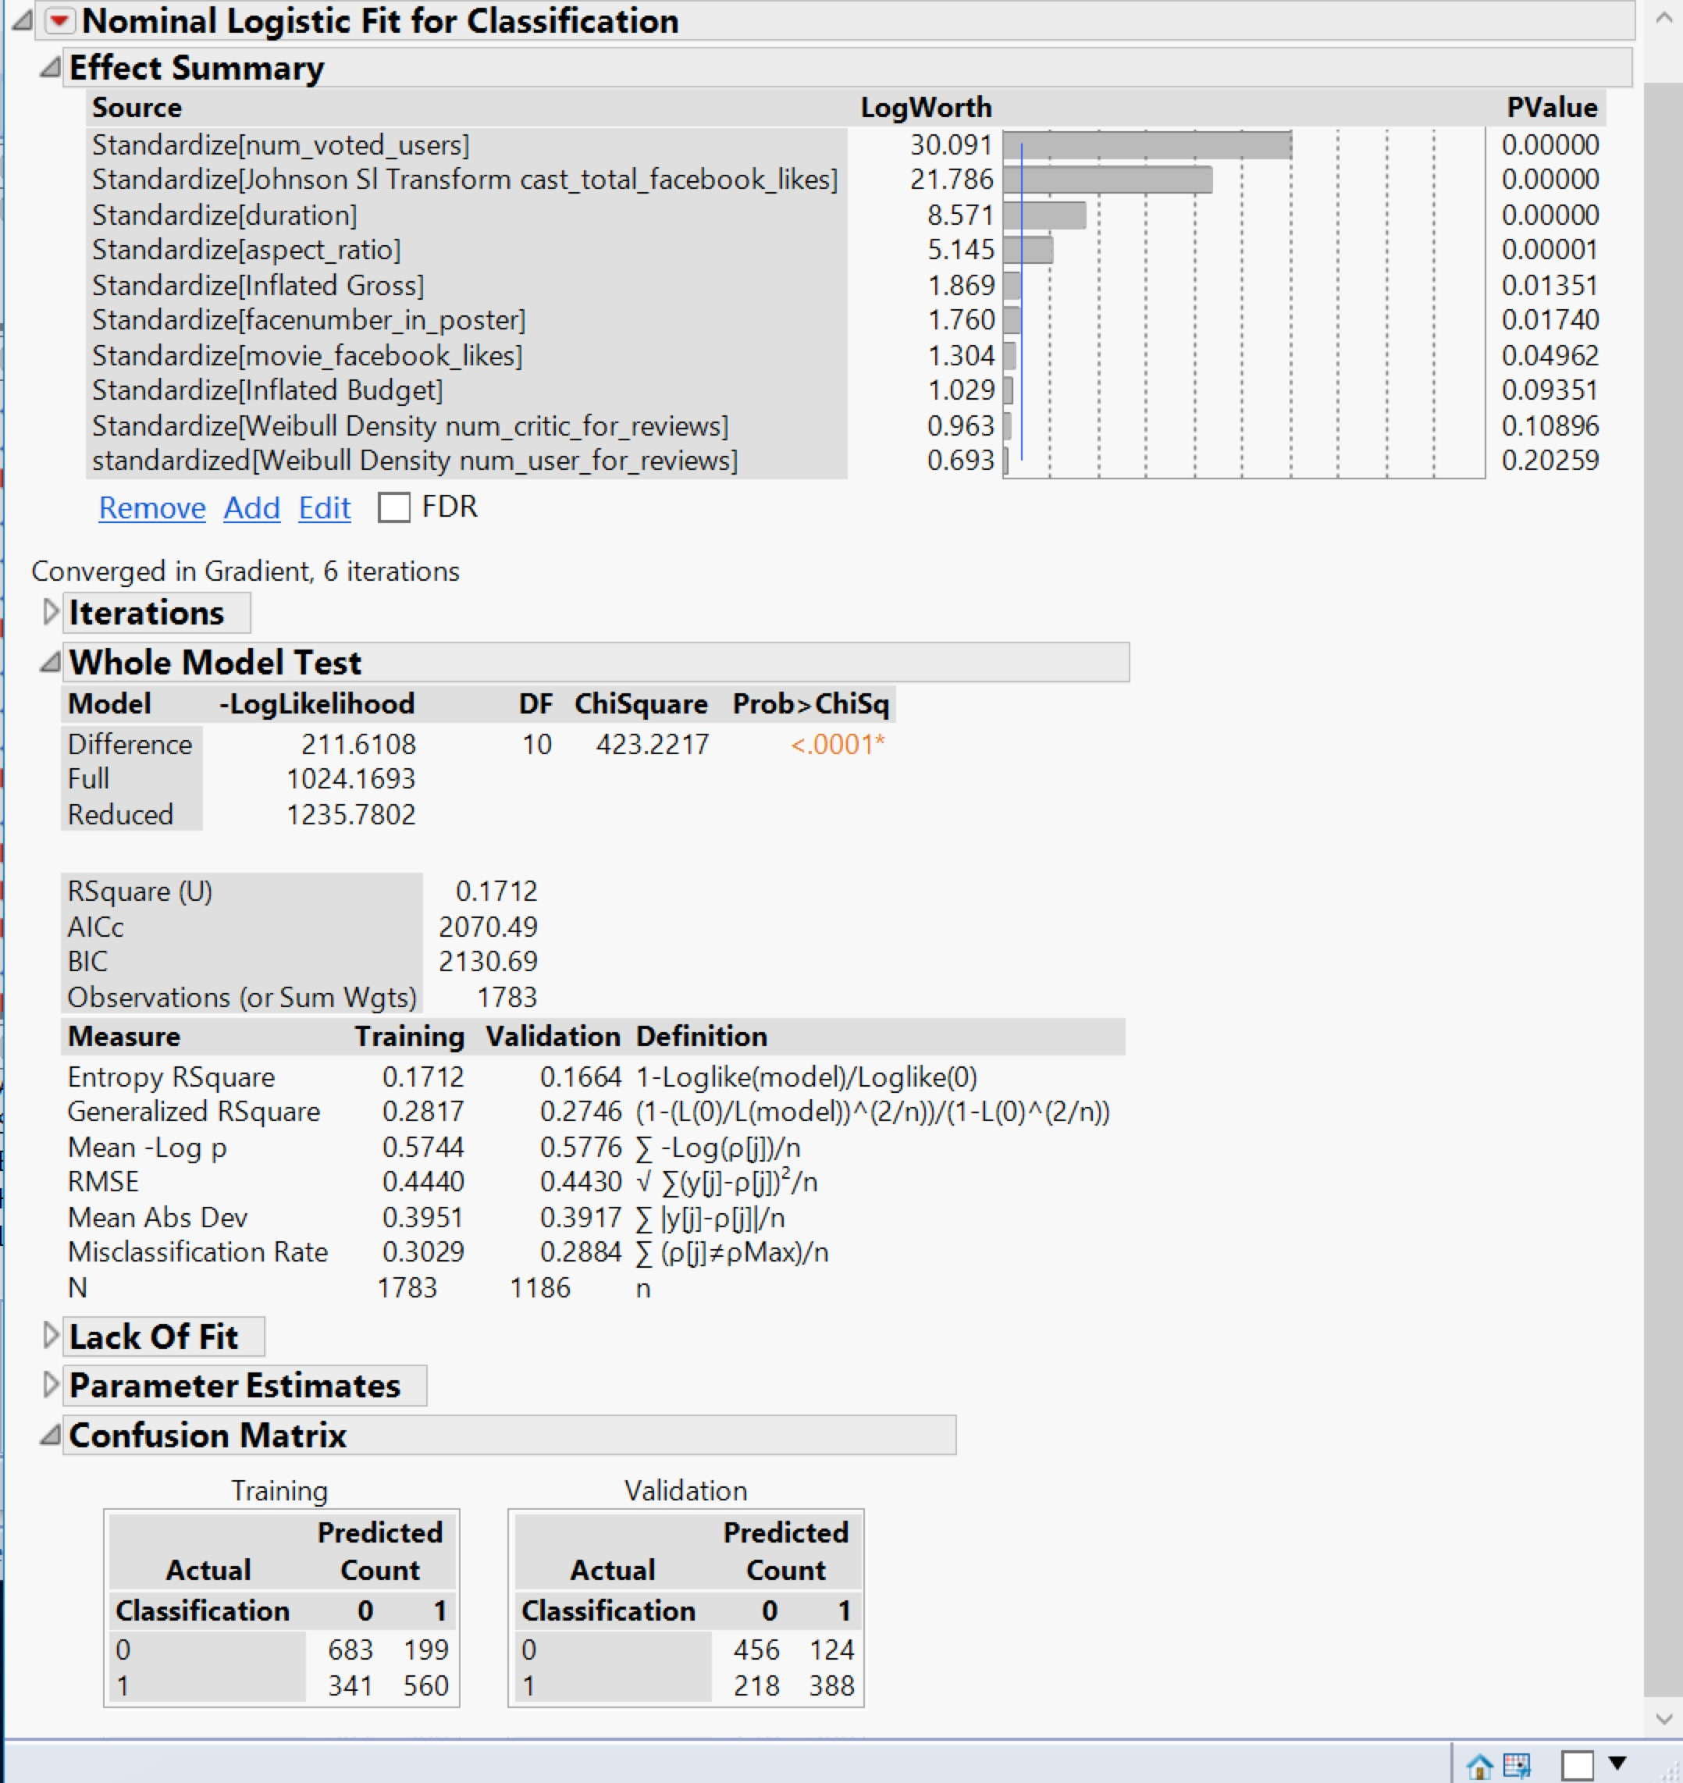

A manual split is done to check the misclassification rate at the end of each split and the predictor variable which is contributing the most to the target variable.

From the figure above it can be seen that the num_voted_user has the most influence on the target variable - hence the first split is on this variable. And duration as well as cast_total_facebook_likes also make important influence on the target variable. So the split begins from num_voted_user, duration and cast_total_facebook_likes.

The model performs almost approximately equally on the training and validation data with an accuracy of 72.1% and an error rate of 27.9%

**Dataset with title_year > 2004**

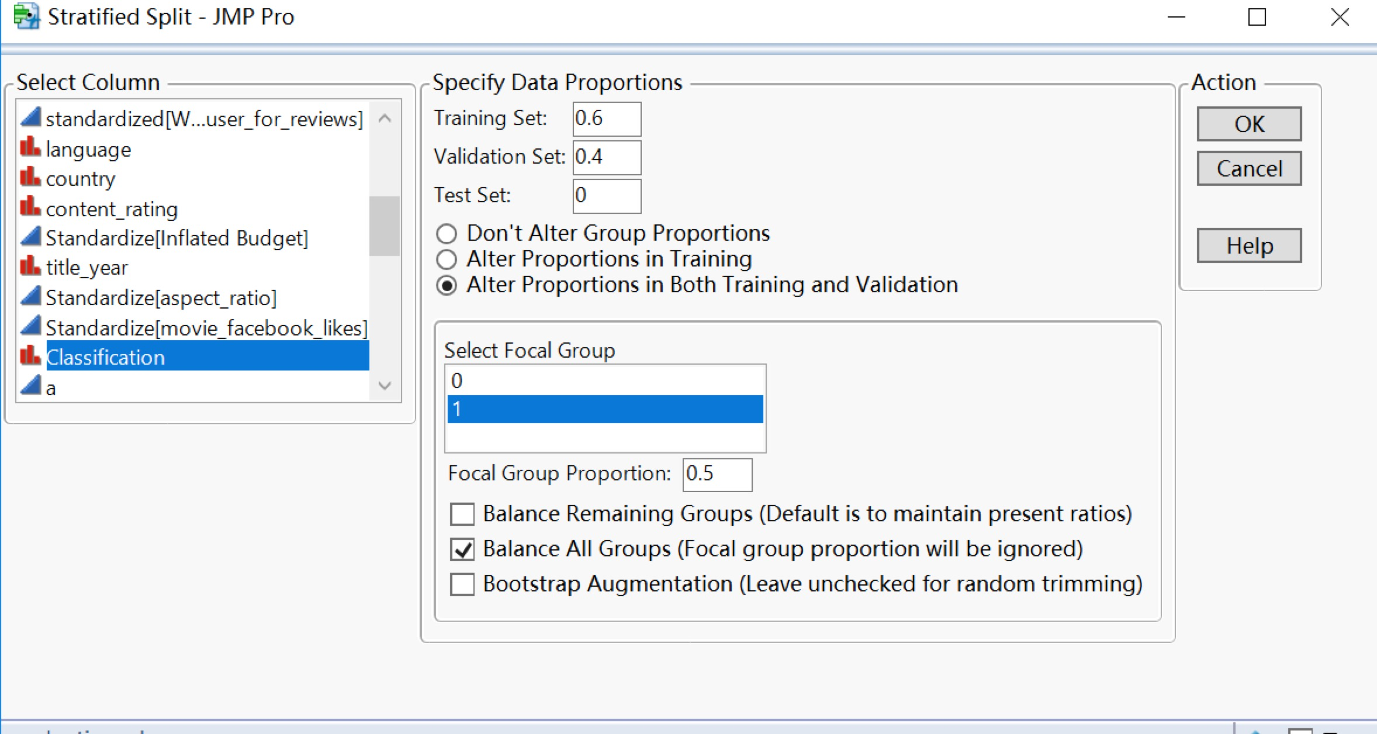

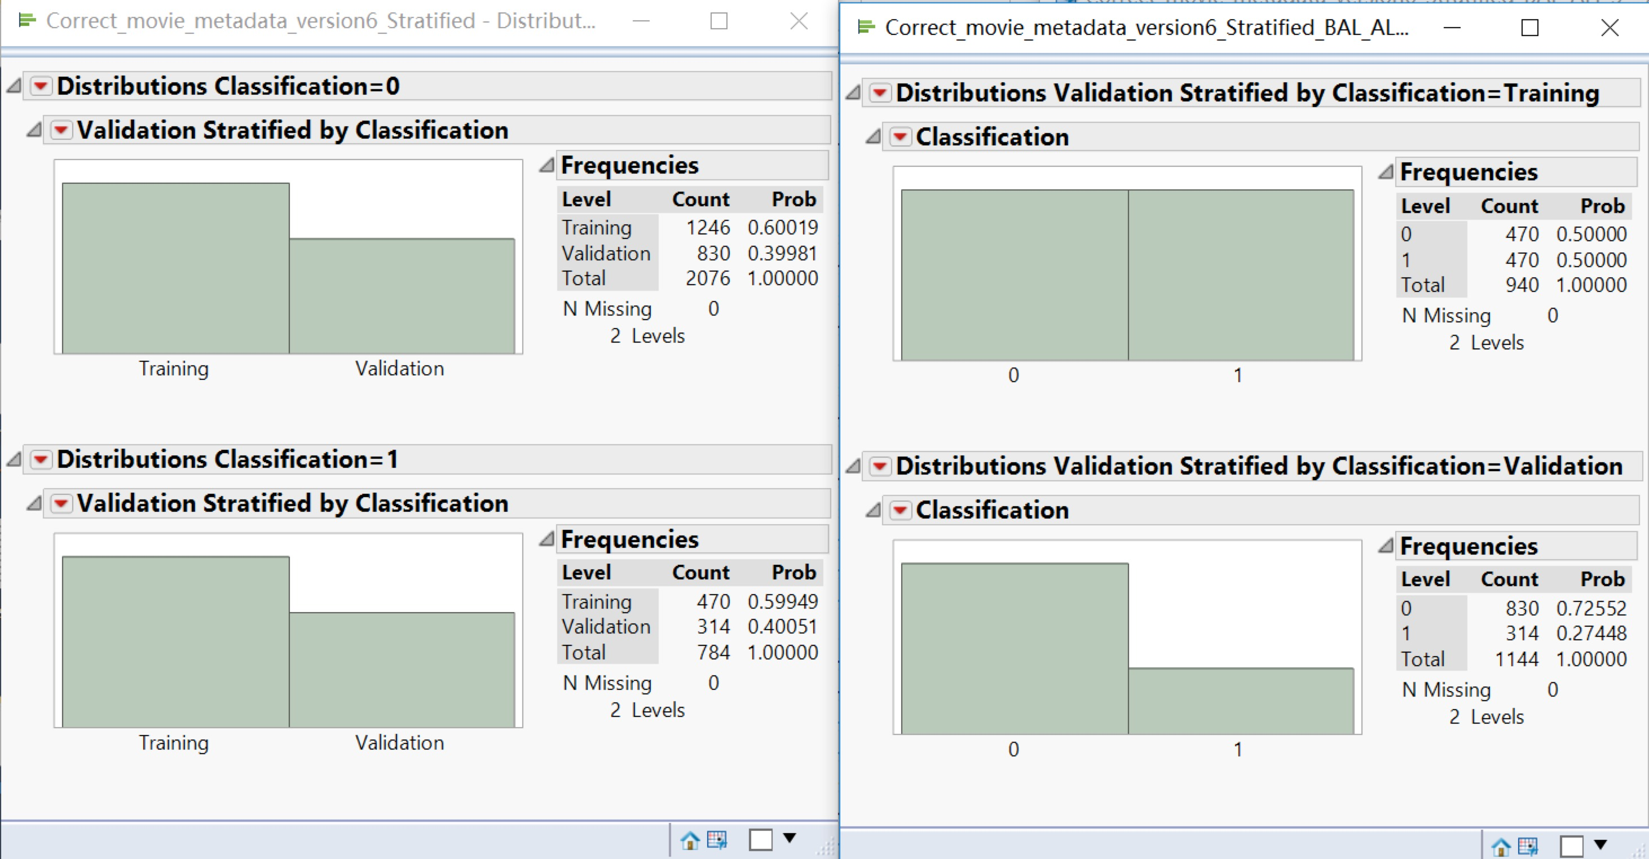

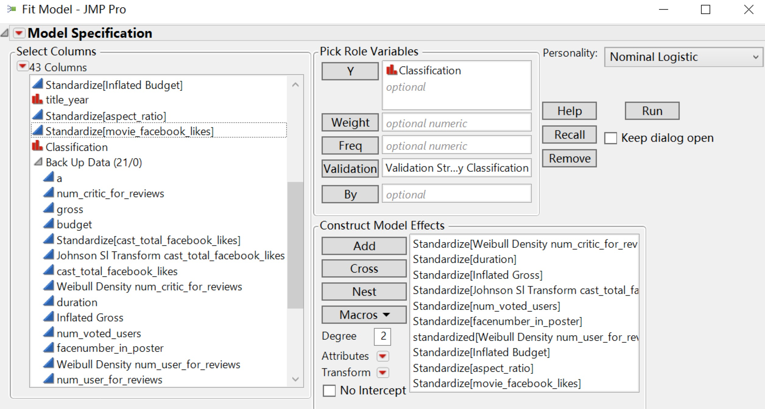

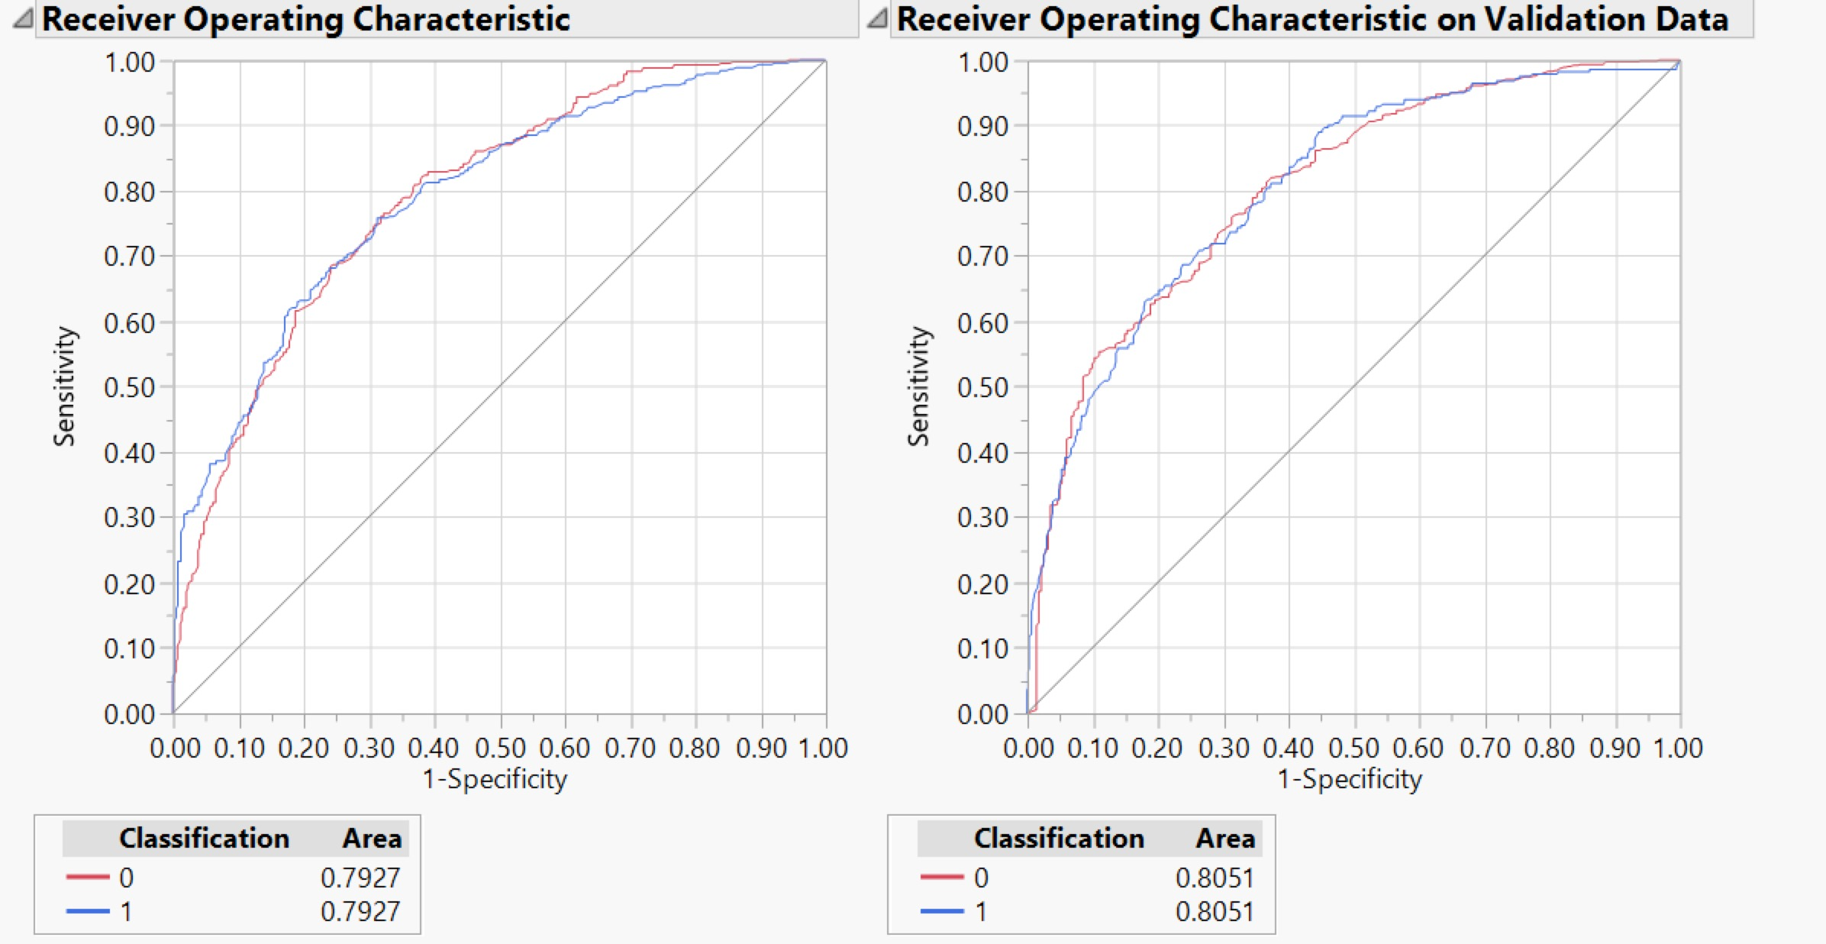

From the ROC curve above it is observed that the model exactly euqally accurately classifies the movies as bad (0) as compared to the good (1) rated movies

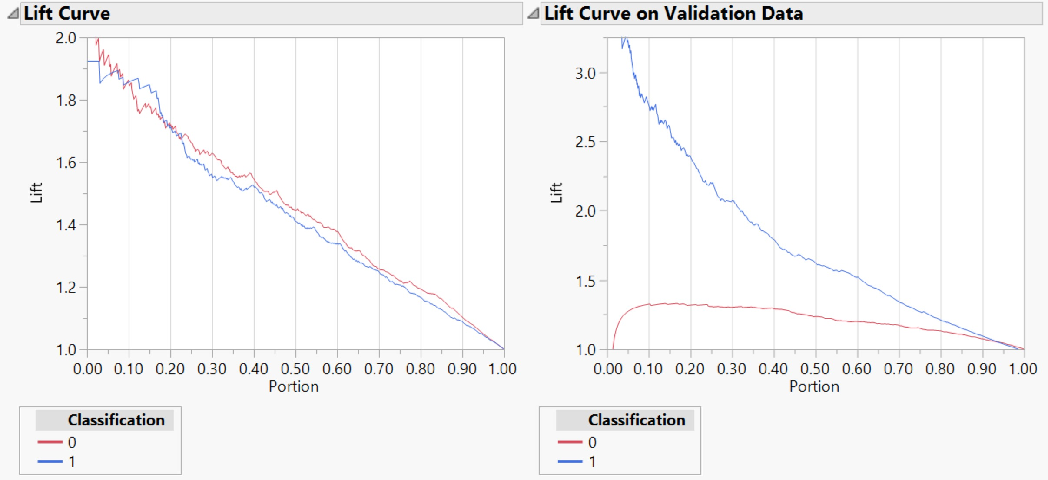

|  |  |  |
| --- | --- | --- |
| Classification | Training data | Validation data |
| 0 | The lift value constantly decreases across the other deciles from 2 to 1 | The lift value increases for the first decile and then constantly decreases across the other deciles. It varies from 1 to 1.3 in the first decile. |
| 1 | The lift value constantly decreases across the other deciles from 2 to 1，similar with the 0 | The lift value is more than 2.7 in the first decile and reduces consistently in all the other deciles |

The below figure shows the confusion rates for each predictions

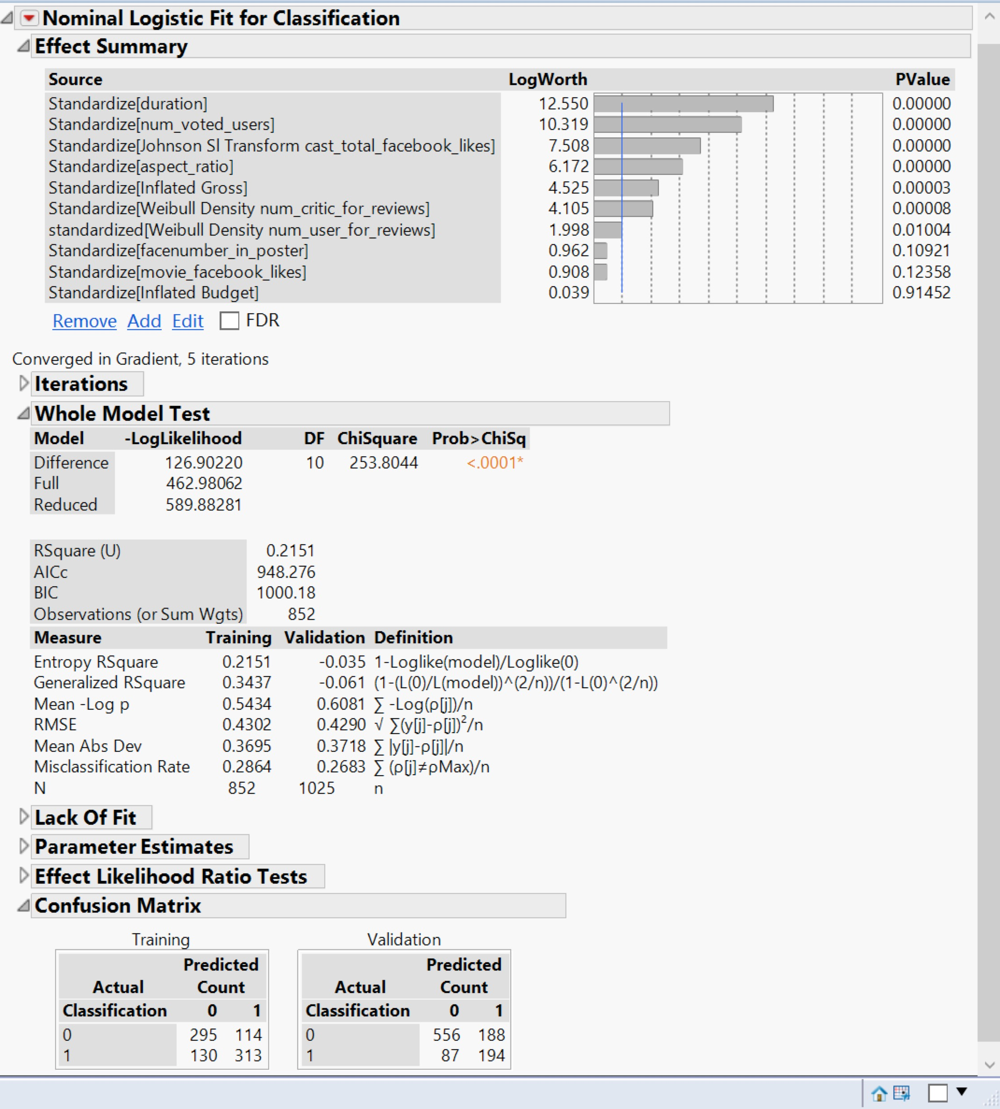

A manual split is done to check the misclassification rate at the end of each split and the predictor variable which is contributing the most to the target variable.

From the figure above it can be seen that the duration has the most influence on the target variable - hence the first split is on this variable. And num_voted_user as well as cast_total_facebook_likes also make important influence on the target variable. So the split begins from , duration , num_voted_user and cast_total_facebook_likes.

The model performs almost approximately equally on the training and validation data with an accuracy of 73.1% and an error rate of 26.9%

**Dataset with title_year < 2004**

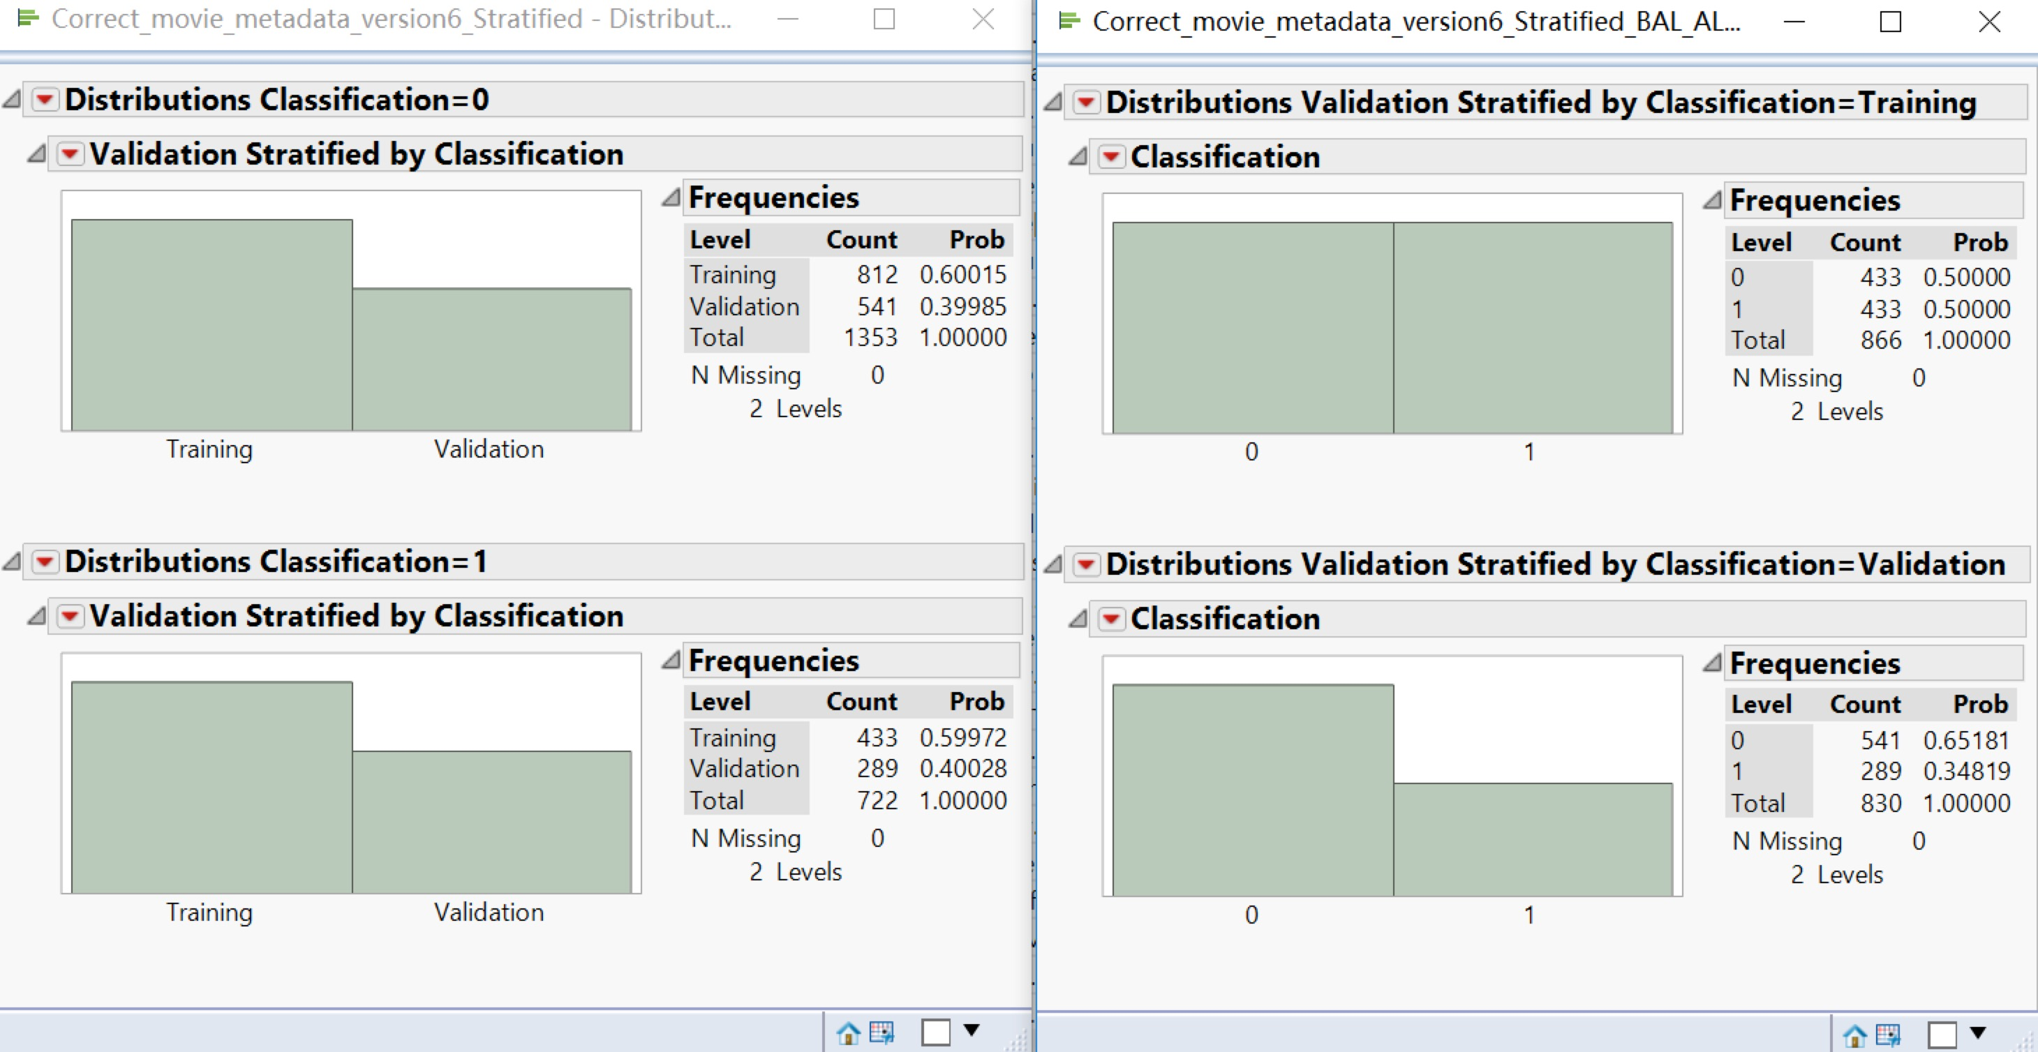



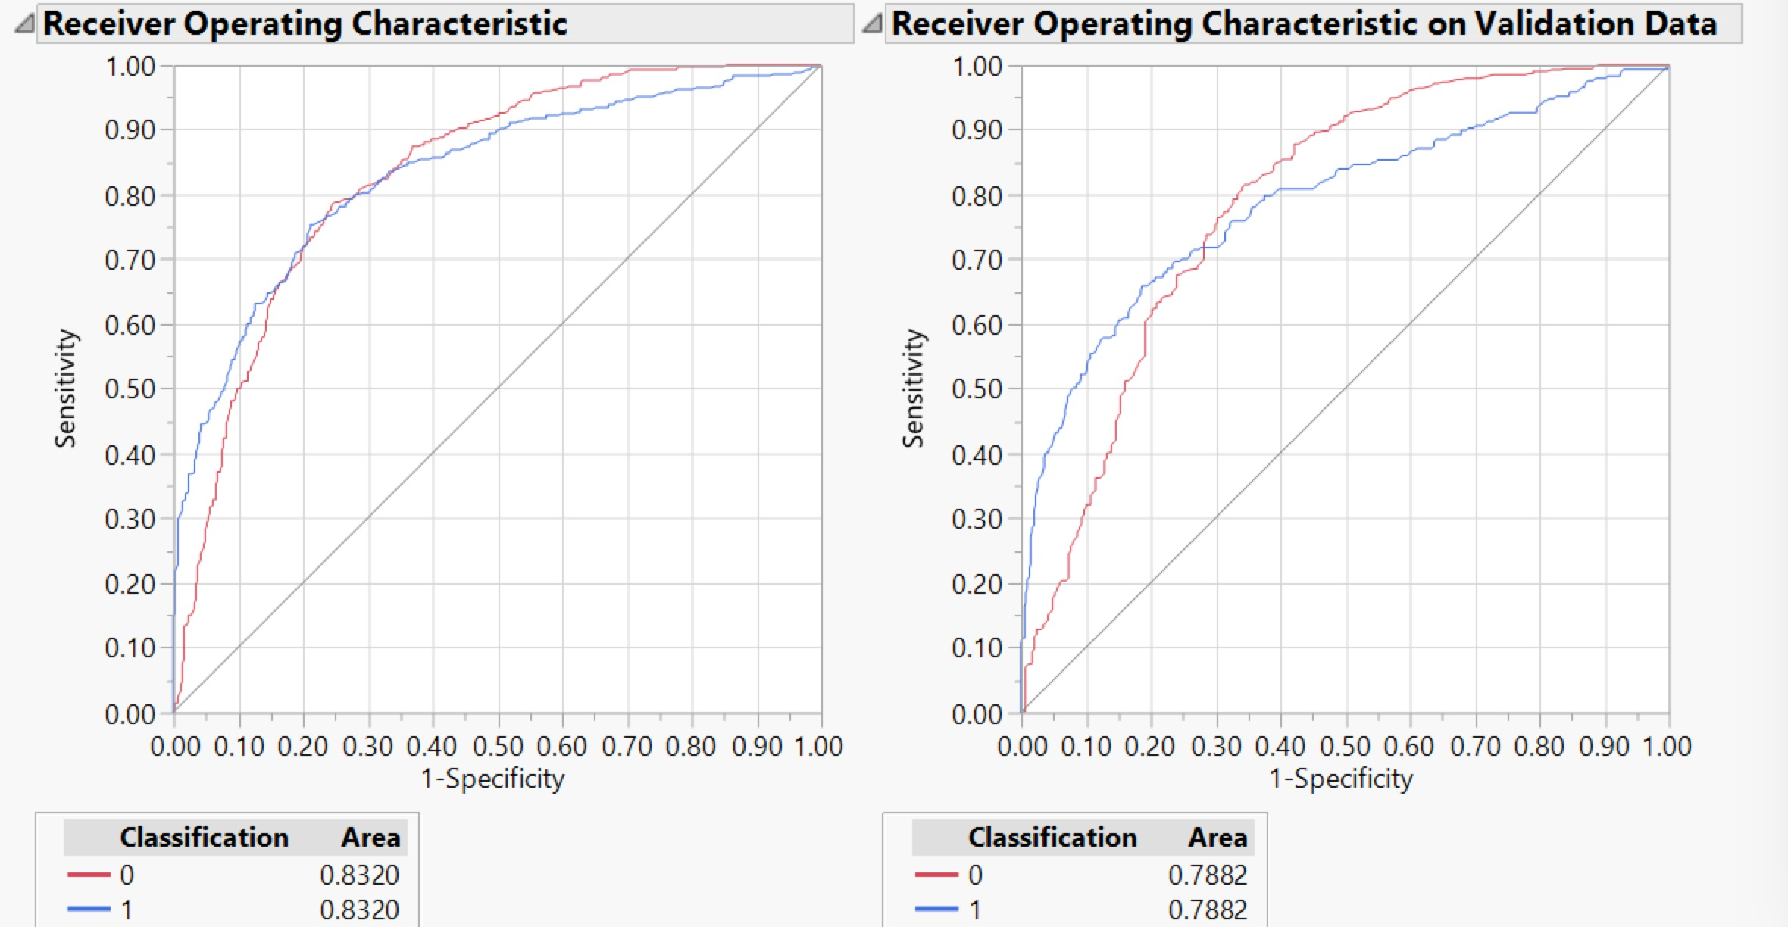

From the ROC curve above it is observed that the model exactly euqally accurately classifies the movies as bad (0) as compared to the good (1) rated movies

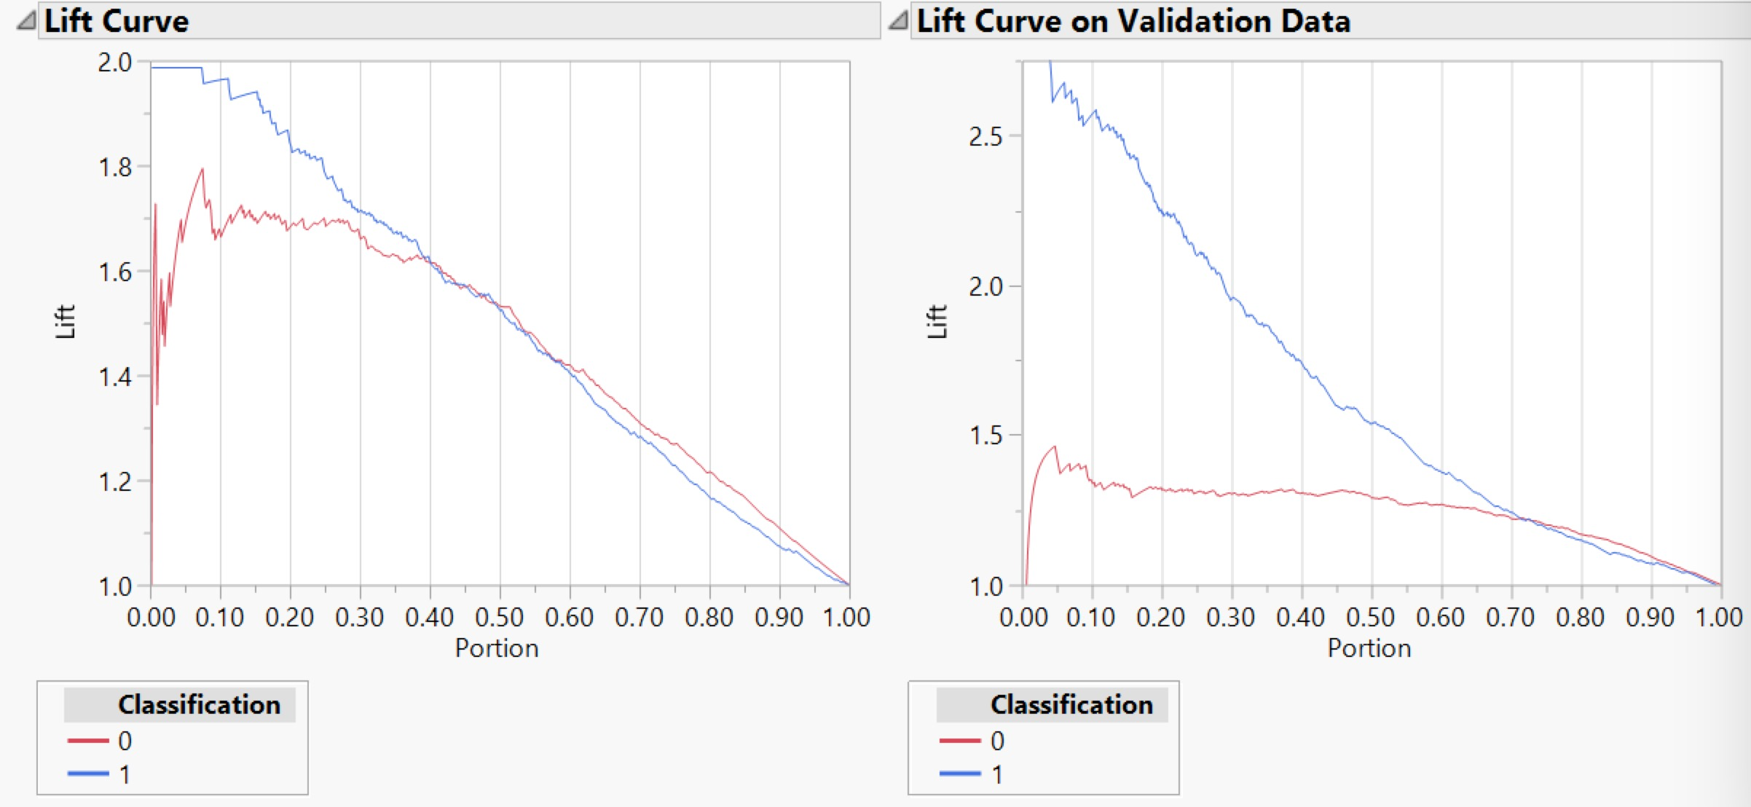

|  |  |  |
| --- | --- | --- |
| Classification | Training data | Validation data |
| 0 | The lift value is around 1.6 on an average across the first three decile and then constantly decreases across the other deciles | The lift value is constant for the third decile and then constantly decreases across the other deciles. It varies from 1.3 to 1.7 in the first decile. |
| 1 | The lift value is very high in the first decile but reduces consistently across all the other deciles | The lift value is more than 1.9 in the first decile but reduces consistently in all the other deciles |

The below figure shows the confusion rates for each predictions

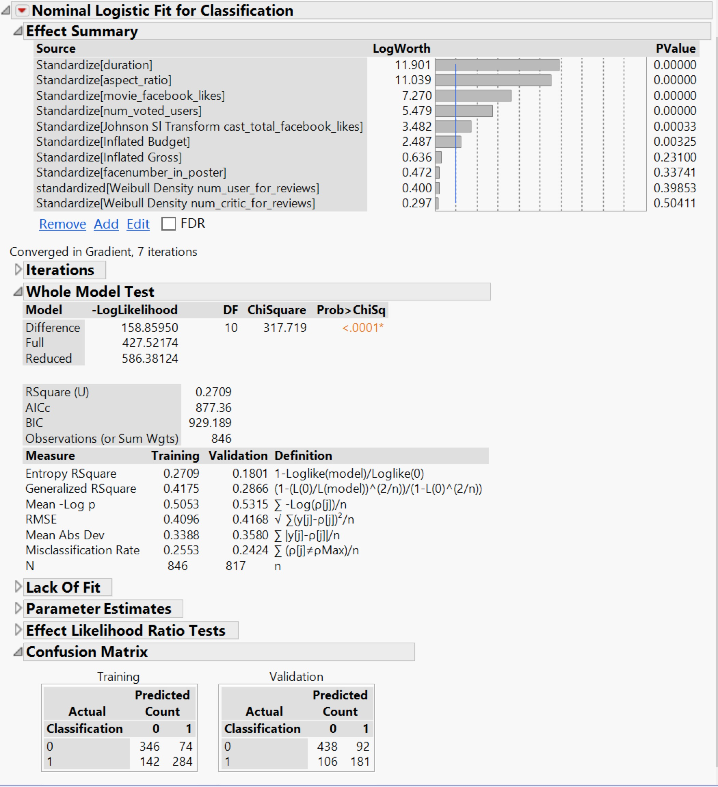

A manual split is done to check the misclassification rate at the end of each split and the predictor variable which is contributing the most to the target variable.

From the figure above it can be seen that the duration has the most influence on the target variable - hence the first split is on this variable. And aspect_ratio as well as movie_facebook_likes, num_voted_user also make important influence on the target variable. So the split begins from num_voted_user, duration and cast_total_facebook_likes.

The model performs almost approximately equally on the training and validation data with an accuracy of 75.8% and an error rate of 24.2%